Dream Lover (Bobby Darin, 1959) (C) – Version 2
Dream Lover by Bobby Darin (F) – C Tuning
2/2 – 132 BPM

Intro C | Am | C | Am |  C Am  __ Every night I hope and pray, __ a dream lover will come my way  C Am  __ A girl to hold in my arms __ and know the magic of her charms  C G7 C F  Because I want _ a girl _ to call _ my own  C Am F G C | G7  I want a _ dream lover so I don't have to dream a-lone.  C Am  __ Dream lover, where are you __ with a love oh so true,  C Am  __ And a hand that I can hold, __ to feel you near when I grow old?  C G7 C F  Because I want _ a girl _ to call _ my own  C Am F G C | C7  I want a dream lover so I don't have to dream a-lone.  Bridge  F C  __ Someday, I don't know how _ I hope she'll hear my plea  D7 G G7  __ Some way, I don't know how, __ She'll bring her love to me  C Am  __ Dream lover, until then, __ I'll go to sleep and dream again  C Am  __ That's the only thing to do, __ until my lovers dreams come true.  C G7 C F  Because I want _ a girl _ to call _ my own  C Am F G C | A7  I want a dream lover so I don't have to dream a-lone.  D Bm  __ Dream lover, until then, __ I'll go to sleep and dream again  D Bm  __ That's the only thing to do, __ until my lovers dreams come true  D A7 D G  Because I want _ a girl _ to call my own  D Bm G A D  I want a dream lover so I don't have to dream a-lone.  Bm D Bm D  Please don't make me dream alone. I beg you don't make me dream alone.  Bm D | ↓ ↓ ↓ D  No, I don't wanna dream alone. (Hold) | 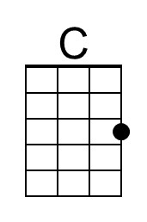 | 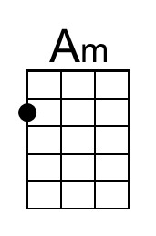
 | 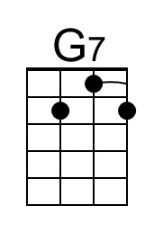 | 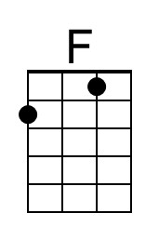
 | 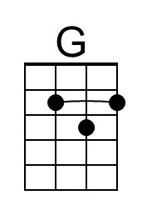 | 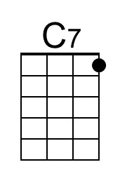
 | 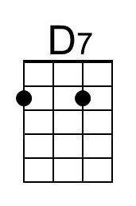 | 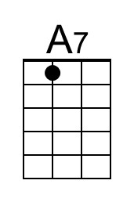
 | 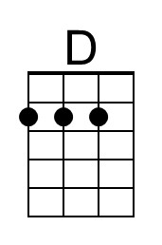 | 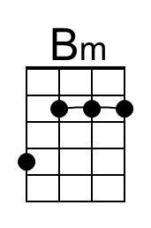
 | 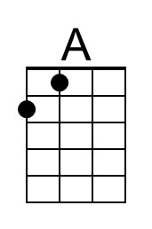

Dream Lover (Bobby Darin, 1959) (C) – Version 2
Dream Lover by Bobby Darin (F) – G Tuning
2/2 – 132 BPM

Intro C | Am | C | Am |  C Am  __ Every night I hope and pray, __ a dream lover will come my way  C Am  __ A girl to hold in my arms __ and know the magic of her charms  C G7 C F  Because I want _ a girl _ to call _ my own  C Am F G C | G7  I want a _ dream lover so I don't have to dream a-lone.  C Am  __ Dream lover, where are you __ with a love oh so true,  C Am  __ And a hand that I can hold, __ to feel you near when I grow old?  C G7 C F  Because I want _ a girl _ to call _ my own  C Am F G C | C7  I want a dream lover so I don't have to dream a-lone.  Bridge  F C  __ Someday, I don't know how _ I hope she'll hear my plea  D7 G G7  __ Some way, I don't know how, __ She'll bring her love to me  C Am  __ Dream lover, until then, __ I'll go to sleep and dream again  C Am  __ That's the only thing to do, __ until my lovers dreams come true.  C G7 C F  Because I want _ a girl _ to call _ my own  C Am F G C | A7  I want a dream lover so I don't have to dream a-lone.  D Bm  __ Dream lover, until then, __ I'll go to sleep and dream again  D Bm  __ That's the only thing to do, __ until my lovers dreams come true  D A7 D G  Because I want _ a girl _ to call my own  D Bm G A D  I want a dream lover so I don't have to dream a-lone.  Bm D Bm D  Please don't make me dream alone. I beg you don't make me dream alone.  Bm D | ↓ ↓ ↓ D  No, I don't wanna dream alone. (Hold) | 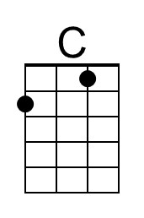 | 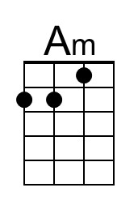
 | 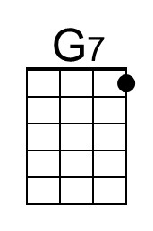 | 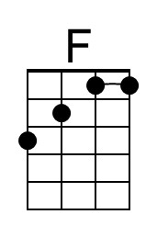
 | 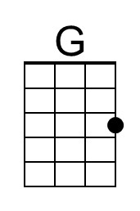 | 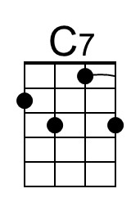
 | 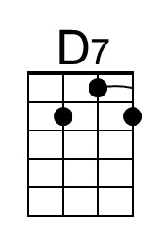 | 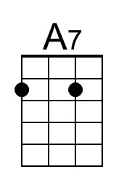
 | 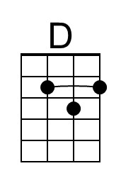 | 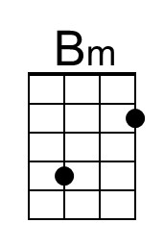
 | 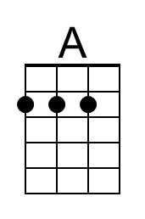

Dream Lover (Bobby Darin, 1959) (F) – Version 2
Dream Lover by Bobby Darin (F - 132 BPM) – C Tuning

Intro F | Dm | F | Dm |  F Dm  __ Every night I hope and pray, __ a dream lover will come my way  F Dm  __ A girl to hold in my arms __ and know the magic of her charms  F C7 F Bb  Because I want _ a girl _ to call _ my own  F Dm Bb C F | C7  I want a _ dream lover so I don't have to dream a-lone.  F Dm  __ Dream lover, where are you __ with a love oh so true,  F Dm  __ And a hand that I can hold, __ to feel you near when I grow old?  F C7 F Bb  Because I want _ a girl _ to call _ my own  F Dm Bb C F | F7  I want a dream lover so I don't have to dream a-lone.  Bridge  Bb F  __ Someday, I don't know how _ I hope she'll hear my plea  G7 C C7  __ Some way, I don't know how, __ She'll bring her love to me  F Dm  __ Dream lover, until then, __ I'll go to sleep and dream again  F Dm  __ That's the only thing to do, __ until my lovers dreams come true.  F C7 F Bb  Because I want _ a girl _ to call _ my own  F Dm Bb C F | D7  I want a dream lover so I don't have to dream a-lone.  G Em  __ Dream lover, until then, __ I'll go to sleep and dream again,  G Em  __ That's the only thing to do, __ until my lovers dreams come true.  G D7 G C  Because I want _ a girl _ to call _ my own  G Em C D G  I want a dream lover so I don't have to dream a-lone.  Em G Em G  Please don't make me dream alone. I beg you don't make me dream alone.  Em G | ↓ ↓ ↓ G  No, I don't wanna dream alone. (Hold) |  | 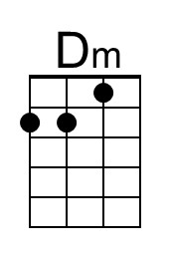
 |  | 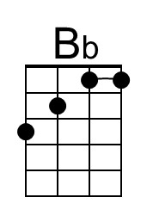
 |  | 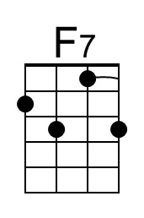
 |  | 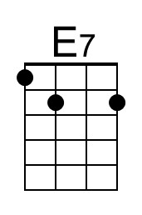

Dream Lover (Bobby Darin, 1959) (F) – Version 2
Dream Lover by Bobby Darin (F - 132 BPM) – G Tuning

Intro F | Dm | F | Dm |  F Dm  __ Every night I hope and pray, __ a dream lover will come my way  F Dm  __ A girl to hold in my arms __ and know the magic of her charms  F C7 F Bb  Because I want _ a girl _ to call _ my own  F Dm Bb C F | C7  I want a _ dream lover so I don't have to dream a-lone.  F Dm  __ Dream lover, where are you __ with a love oh so true,  F Dm  __ And a hand that I can hold, __ to feel you near when I grow old?  F C7 F Bb  Because I want _ a girl _ to call _ my own  F Dm Bb C F | F7  I want a dream lover so I don't have to dream a-lone.  Bridge  Bb F  __ Someday, I don't know how _ I hope she'll hear my plea  G7 C C7  __ Some way, I don't know how, __ She'll bring her love to me  F Dm  __ Dream lover, until then, __ I'll go to sleep and dream again  F Dm  __ That's the only thing to do, __ until my lovers dreams come true.  F C7 F Bb  Because I want _ a girl _ to call _ my own  F Dm Bb C F | D7  I want a dream lover so I don't have to dream a-lone.  G Em  __ Dream lover, until then, __ I'll go to sleep and dream again,  G Em  __ That's the only thing to do, __ until my lovers dreams come true.  G D7 G C  Because I want _ a girl _ to call _ my own  G Em C D G  I want a dream lover so I don't have to dream a-lone.  Em G Em G  Please don't make me dream alone. I beg you don't make me dream alone.  Em G | ↓ ↓ ↓ G  No, I don't wanna dream alone. (Hold) |  | 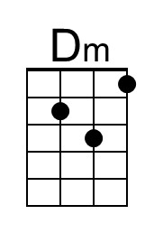
 |  | 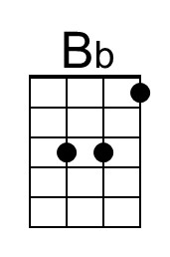
 |  | 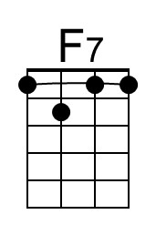
 |  | 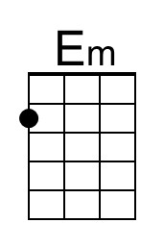

Dream Lover (Bobby Darin, 1959) (G) – Version 2
Dream Lover by Bobby Darin (F - 132 BPM) – C Tuning

Intro G | Em | G | Em |  G Em  __ Every night I hope and pray, __ a dream lover will come my way  G Em  __ A girl to hold in my arms __ and know the magic of her charms  G D7 G C  Because I want _ a girl _ to call _ my own  G Em C D G | D7  I want a _ dream lover so I don't have to dream a-lone.  G Em  __ Dream lover, where are you __ with a love oh so true,  G Em  __ And a hand that I can hold, __ to feel you near when I grow old?  G D7 G C  Because I want _ a girl _ to call _ my own  G Em C D G | G7  I want a dream lover so I don't have to dream a-lone.  Bridge  C G  __ Someday, I don't know how _ I hope she'll hear my plea.  A7 D D7  __ Some way, I don't know how, __ She'll bring her love to me.  G Em  __ Dream lover, until then, __ I'll go to sleep and dream again  G Em  __ That's the only thing to do, __ until my lovers dreams come true.  G D7 G C  Because I want _ a girl _ to call _ my own  G Em C D G | E7  I want a dream lover so I don't have to dream a-lone.  A F#m  __ Dream lover, until then, __ I'll go to sleep and dream again  A F#m  __ That's the only thing to do, __ until my lovers dreams come true  A E7 A D  Because I want _ a girl _ to call _ my own  A F#m D E A  I want a dream lover so I don't have to dream a-lone.  F#m A F#m A  Please don't make me dream alone. I beg you don't make me dream alone.  F#m A | ↓ ↓ ↓ A  No, I don't wanna dream alone. (Hold) |  | 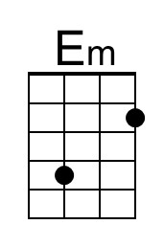
 |  | 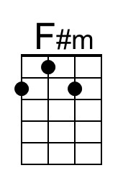
 | 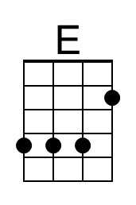

Dream Lover (Bobby Darin, 1959) (G) – Version 2
Dream Lover by Bobby Darin (F - 132 BPM) – G Tuning

Intro G | Em | G | Em |

G Em
__ Every night I hope and pray, __ a dream lover will come my way
G Em
__ A girl to hold in my arms __ and know the magic of her charms
G D7 G C
Because I want _ a girl _ to call _ my own
G Em C D G | D7
I want a _ dream lover so I don't have to dream a-lone.

G Em
__ Dream lover, where are you __ with a love oh so true,
G Em
__ And a hand that I can hold, __ to feel you near when I grow old?
G D7 G C
Because I want _ a girl _ to call _ my own
G Em C D G | G7
I want a dream lover so I don't have to dream a-lone.

Bridge
C G
__ Someday, I don't know how _ I hope she'll hear my plea.
A7 D D7
__ Some way, I don't know how, __ She'll bring her love to me.

G Em
__ Dream lover, until then, __ I'll go to sleep and dream again
G Em
__ That's the only thing to do, __ until my lovers dreams come true.
G D7 G C
Because I want _ a girl _ to call _ my own
G Em C D G | E7
I want a dream lover so I don't have to dream a-lone.

A F#m
__ Dream lover, until then, __ I'll go to sleep and dream again
A F#m
__ That's the only thing to do, __ until my lovers dreams come true
A E7 A D
Because I want _ a girl _ to call _ my own
A F#m D E A
I want a dream lover so I don't have to dream a-lone.

F#m A F#m A
Please don't make me dream alone. I beg you don't make me dream alone.
F#m A | ↓ ↓ ↓ A
No, I don't wanna dream alone. (Hold)
