**Dream Lover (Bobby Darin)**

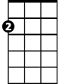

Am



C

**C Am**

Every night I hope and pra - y a dream lover will come my way

**C Am**

A girl to hold in my ar - ms and know the magic of her charms

**C G7 C F**

Cause I want - a girl - to call my own

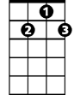

G7

F



**C Am F G7 C G7**

I want a dream lover so I don't have to dream alone

**C Am**

Dream lover where are you -u with a love that's oh, so true

C



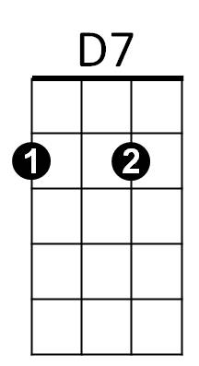**C Am**

And a hand that I can ho-ld, to feel you near as I grow old

**C G7 C F**

Cause I want - a girl - to call my own

**C Am F G7 C C7**

I want a dream lover so I don't have to dream alone

**F C**

Someday I don't know how I hope she'll hear my plea

**BARITONE**

**D7 G7**

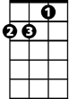

Am

C



Someway I don't know how she' ll bring her love to me

**C Am**

Dream lover until th – en I'll go to sleep and dream again

**C Am**

That's the only thing to do-o till all my lover’s dreams come true



F

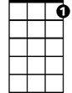

G7

**C G7 C F**

Cause I want - a girl - to call my own

**C Am F G7 C G7**

I want a dream lover so I don't have to dream alone

**(Repeat verse above) (Drop G7 at end)**



D7

**Am C Am**

Please don’t make me dream alone…

**C Am**

I beg you don’t make me dream alone

**C Am**

No I don’t wanna dream alone**…(Fade out)**