Dream Lover (Bobby Darin)
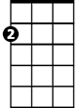
Am
C
C Am
Every night I hope and pra - y a dream lover will come my way
C Am
A girl to hold in my ar - ms and know the magic of her charms
C G7 C F
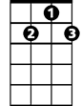Cause I want - a girl - to call my own
G7
F
C Am F G7 C G7
I want a dream lover so I don't have to dream alone

C Am
Dream lover where are you -u with a love that's oh, so true
C
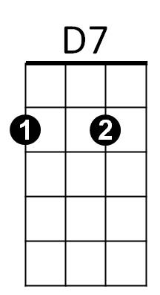
C Am
And a hand that I can ho-ld, to feel you near as I grow old
C G7 C F
Cause I want - a girl - to call my own
C Am F G7 C C7
I want a dream lover so I don't have to dream alone

F C
Someday I don't know how I hope she'll hear my plea
BARITONE
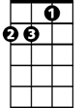D7 G7
Am
C
Someway I don't know how she' ll bring her love to me

C Am
Dream lover until th – en I'll go to sleep and dream again
C Am
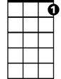That's the only thing to do-o till all my lover’s dreams come true
F
G7
C G7 C F
Cause I want - a girl - to call my own
C Am F G7 C G7
I want a dream lover so I don't have to dream alone

(Repeat verse above) (Drop G7 at end)
D7

Am C Am
Please don’t make me dream alone…
C Am
I beg you don’t make me dream alone
C Am
No I don’t wanna dream alone…(Fade out)

