Dream a Little Dream of Me (Fabian Andre, Gus Kahn & Wilbur Schwandt, 1931) (C)
Version 2
C B7 G#7 G7  Stars shining bright above you  C A7 Em7b5 A7  Night breezes seem to whisper "I love you"  F Fm7  Birds singing in a sycamore tree  C G#7 G7  Dre am a little dream of me  C B7 G#7 G7  Say nighty night and kiss me  C A7 Em7b5 A7  Just hold me tight and tell me you miss me  F Fm7  While I'm alone a nd blue as can be  C G#7 G7 C E7  Dream a little dream of me  Reprise:  A F#m7 Bm7 E7  Stars fading but I linger on dear  A F#m7 Bm7 E7  Still craving your kiss  A F#m7 Bm7 E7  I'm longing to linger till dawn dear  A G#7 G7  Just saying this |  |  |  |  | C B7 G#7 G7  Sweet dreams till sunbeams find you  C A7  Sweet dreams that leave all worries  Em7b5 A7  Be-hind you  F Fm7  But in your dreams whatever they be  C G#7 G7 C E7  Dream a little dream of me. Reprise  C B7 G#7 G7  Sweet dreams till sunbeams find you  C A7  Sweet dreams that leave all worries  Em7b5 A7  Be-hind you  F Fm7  But in your dreams whatever they be  C G#7 G7 C C7  Dream a little dream of me  F Fm7  But in your dreams whatever they be  C G#7 G7 C  Dream a little dream of me
 |  |  | 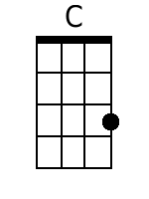 | 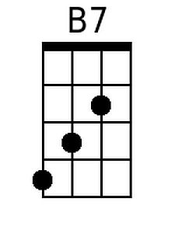 |  | 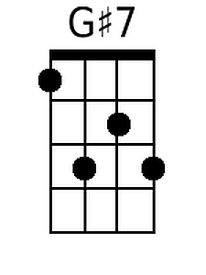 | 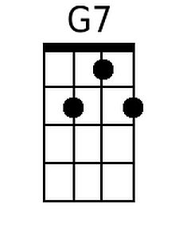 | 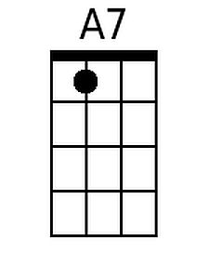 | 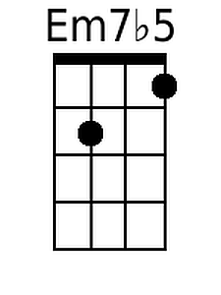
 |  |  | 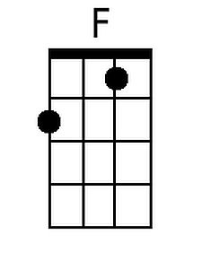 | 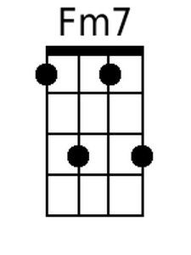 |  | 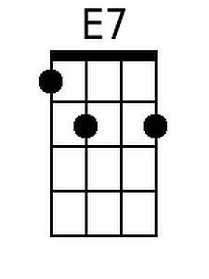 | 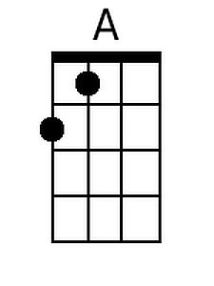 | 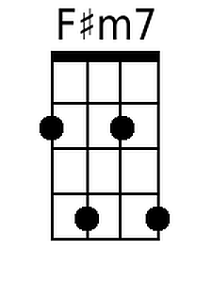 | 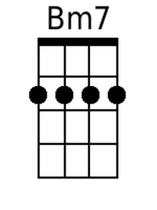
 |  | Bari | 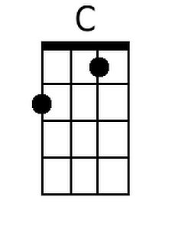 | 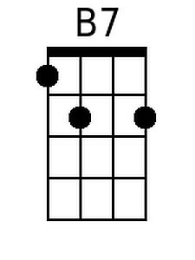 |  | 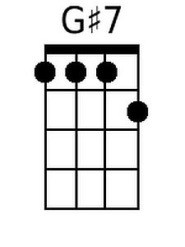 | 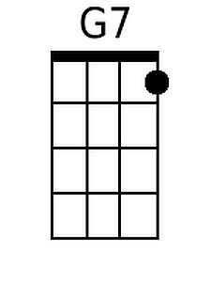 | 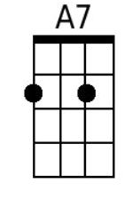 | 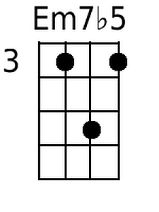
 |  |  | 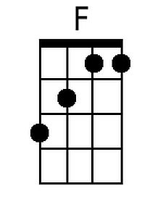 | 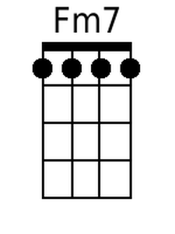 |  | 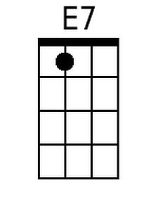 | 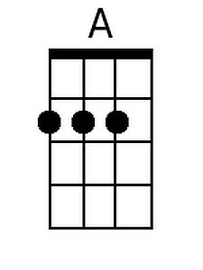 | 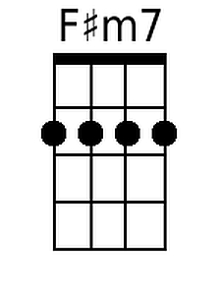 | 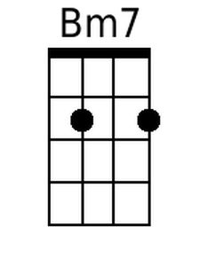

Dream a Little Dream of Me (Fabian Andre, Gus Kahn & Wilbur Schwandt, 1931) (G)
Version 2
G F#7 D#7 D7  Stars shining bright above you  G E7 Bm7b5 E7  Night breezes seem to whisper "I love you"  C Cm7  Birds singing in a sycamore tree  G D#7 D7  Dre am a little dream of me.  G F#7 D#7 D7  Sa y nighty night and kiss me  G E7 Bm7b5 E7  Just hold me tight and tell me you miss me  C Cm7  While I'm alone a nd blue as can be  G D#7 D7 G B7  Dream a little dream of me.  Reprise:  E C#m7 F#m7 B7  Stars fading but I linger on dear  E C#m7 F#m7 B7  Still craving your kiss  E C#m7 F#m7 B7  I'm longing to linger till dawn dear  E D#7 D7  Just saying this. |  |  |  |  | G F#7 D#7 D7  Sweet dreams till sunbeams find you  G E7  Sweet dreams that leave all worries  Bm7b5 E7  Be-hind you  C Cm7  But in your dreams whatever they be  G D#7 D7 G B7  Dream a little dream of me. Reprise  G F#7 D#7 D7  Sweet dreams till sunbeams find you  G E7  Sweet dreams that leave all worries  Bm7b5 E7  Be-hind you  C Cm7  But in your dreams whatever they be  G D#7 D7 G G7  Dream a little dream of me  C Cm7  But in your dreams whatever they be  G D#7 D7 G  Dream a little dream of me.
 |  |  | 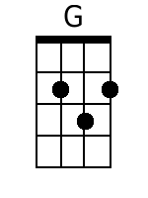 | 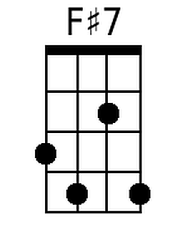 |  | 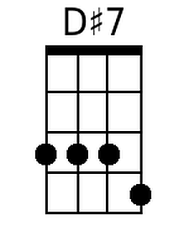 | 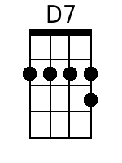 |  | 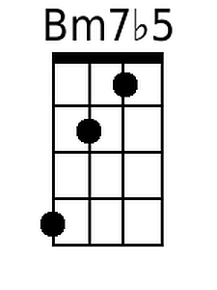
 |  |  |  | 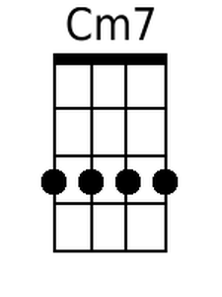 |  |  | 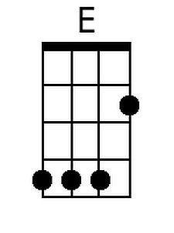 | 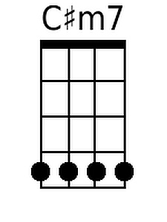
 |  | Bari | 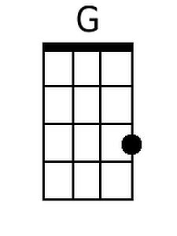 | 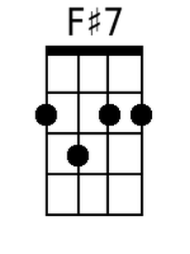 |  | 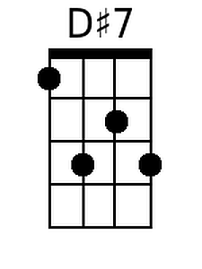 | 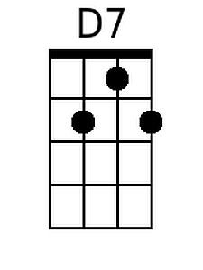 |  | 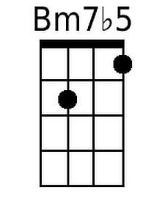
 |  |  |  | 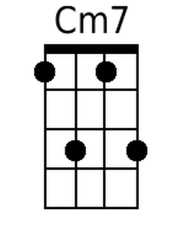 |  |  | 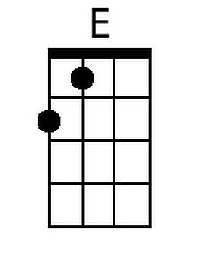 | 