**Dream a Little Dream of Me (Fabian Andre / Gus Kahn / Wilbur Schwandt)**

**F E7 C#7 C7**

Stars shining bright above you

**F D7 Am7-5 D7**

Night breezes seem to whisper "I love you"

**Bb Bbm7**

Birds singing in a sycamore tree

**F C#7 C7**

Dre am a little dream of me

**F E7 C#7 C7**

Sa y nighty night and kiss me

**F D7 Am7-5 D7**

Just hold me tight and tell me you miss me

**Bb Bbm7**

While I'm alone a nd blue as can be

**F C#7 C7 F A7**

Dream a little dream of me

**Reprise:**

**D Bm7 Em7 A7**

Stars fading but I linger on dear

**D Bm7 Em7 A7**

Still craving your kiss

**D Bm7 Em7 A7**

I'm longing to linger till dawn dear

**D C#7 C7**

Just saying this

**F E7 C#7 C7**

Sweet dreams till sunbeams find you

**F D7**

Sweet dreams that leave all worries

**Am7-5 D7**

Be-hind you



F

**Bb Bbm7**

But in your dreams whatever they be

**F C#7 C7 F A7**

Dream a little dream of me

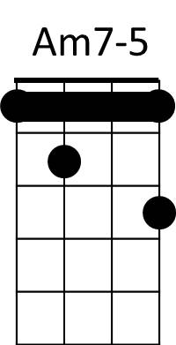**(Reprise)**

**F E7 C#7 C7**

Sweet dreams till sunbeams find you

**F D7**

Sweet dreams that leave all worries

**Am7-5 D7**

Be-hind you

**Bb Bbm7**

But in your dreams whatever they be

**F C#7 C7 F F7**

Dream a little dream of me

**Bb Bbm7**

But in your dreams whatever they be

**F C#7 C7 F**

Dream a little dream of me

F



E7

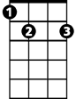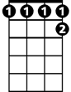

C#7

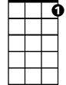

C7

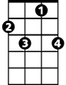

C7

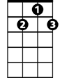

D7

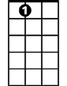

E7

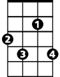

C#7

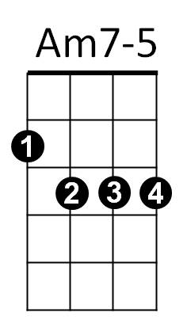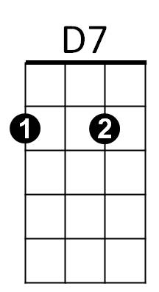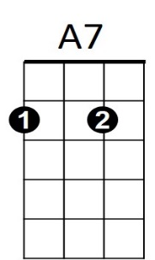

**BARITONE**

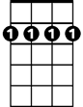

Bm7



A7

Em7

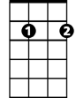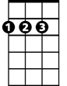

D



Bb

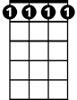

Bbm7

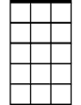

Em7

Bm7

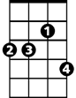

Bbm7

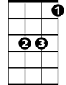

Bb



D