**Drive My Car (Lennon / McCartney) Key C**

**C7 F7**

Asked a girl what she wanted to be

**C7 F7**

She said baby, can't you see

**C7 F7**

I wanna be famous, a star on the screen

**G7**

But you can do something in between

**Chorus:**

**Am F7**

Baby you can drive my car

**Am F7**

Yes I'm gonna be a star

**Am D7**

Baby you can drive my car

**G C G**

And maybe I love you

**C7 F7**

I told that girl that my prospects were good

**C7 F7**

And she said baby, it's understood

**C7 F7**

Working for peanuts is all very fine

**G7**

But I can show you a better time

**(Chorus)**

**Instrumental Verse**

**(Chorus)**

**BARITONE**

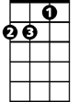

Am

**C7 F7**

I told that girl I can start right away

**C7 F7**

And she said listen babe I got something to say

**C7 F7**

I got no car and it's breaking my heart

**G7**

But I've found a driver and that's a start

**(Chorus)**

**(Repeat to fade)**

**G C7 F7**

Beep beep'm beep beep yeah

**C7 F7**

Beep beep'm beep beep yeah

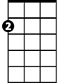

Am

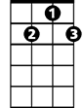

G7

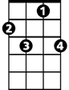

F7

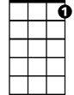

C7

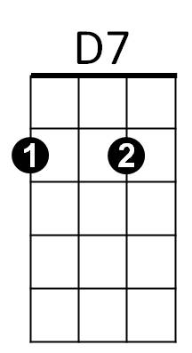



C



G



G



G7

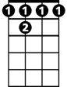

F7



C7

C



D7

**Drive My Car (Lennon / McCartney) Key D**

**D7 G7**

Asked a girl what she wanted to be

**D7 G7**

She said baby, can't you see

**D7 G7**

I wanna be famous, a star on the screen

**A7**

But you can do something in between

**Chorus:**

**Bm G7**

Baby you can drive my car

**Bm G7**

Yes I'm gonna be a star

**Bm E7**

Baby you can drive my car

**A D A**

And maybe I love you

**D7 G7**

I told that girl that my prospects were good

**D7 G7**

And she said baby, it's understood

**D7 G7**

Working for peanuts is all very fine

**A7**

But I can show you a better time

**(Chorus)**

**Instrumental Verse**

**(Chorus)**

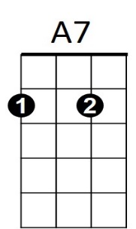

Bm

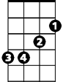

G7



D7

**D7 G7**

I told a girl I can start right away

**D7 G7**

And she said listen babe I got something to say

**D7 G7**

I got no car and it's breaking my heart

**A7**

But I've found a driver and that's a start

**(Chorus)**

**(Repeat to fade)**

**A D7 G7**

Beep beep'm beep beep yeah

**D7 G7**

Beep beep'm beep beep yeah



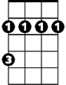

Bm

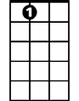

A7



G7

**BARITONE**

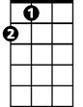

A

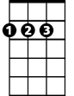

D

E7

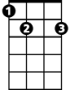

D



A



E7

**Drive My Car (Lennon / McCartney)**

**G7 C7**

Asked a girl what she wanted to be

**G7 C7**

She said baby, can't you see

**G7 C7**

I wanna be famous, a star on the screen

**D7**

But you can do something in between

**Chorus:**

**Em C7**

Baby you can drive my car

**Em C7**

Yes I'm gonna be a star

**Em A7**

Baby you can drive my car

**D G D**

And maybe I love you

**G7 C7**

I told that girl that my prospects were good

**G7 C7**

And she said baby, it's understood

**G7 C7**

Working for peanuts is all very fine

**D7**

But I can show you a better time

**(Chorus)**

**D G7**

Beep beep'm beep beep yeah

**Instrumental Verse**

**(Chorus)**



Em



D7



C7



G7

**G7 C7**

I told a girl I can start right away

**G7 C7**

And she said listen babe I got something to say

**G7 C7**

I got no car and it's breaking my heart

**D7**

But I've found a driver and that's a start

**(Chorus)**

**(Repeat to fade)**

**D G7 C7**

Beep beep'm beep beep yeah

**G7 C7**

Beep beep'm beep beep yeah

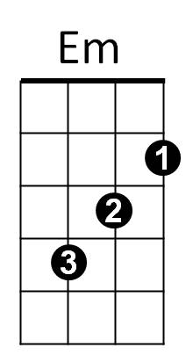



G7



C7

**BARITONE**



D



G



A7





D



G