**Drive (Ric Ocasek)**

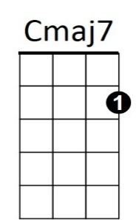**C Cmaj7 C Cmaj7**



C

Who's gonna tell you when - it's too late,

**C Cmaj7 C Cmaj7**

Who's gonna tell you things - aren't so great.

**Am D Am D**

You can't go on, thinkin', nothings' wrong,

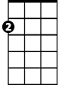

Am

**C Cmaj7 C** **Cmaj7**

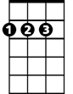

D

Who's gonna drive you home, tonight.?

**C Cmaj7 C** **Cmaj7**

Who's gonna pick you up, when you fall?

**C Cmaj7 C Cmaj7**

W ho's gonna hang it up, when you call?

**C Cmaj7 C Cmaj7**

Who's gonna pay attention, to your dreams?

**C Cmaj7 C Cmaj7**

And who's gonna plug their ears, w hen you scream?

**Am D Am D**

**BARITONE**

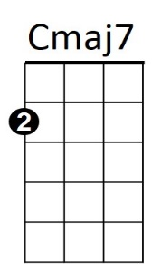You can't go on, thinkin', nothings' wrong,

C



**C Cmaj7 C Cmaj7**

Who's gonna drive you home, tonight.?

**C Cmaj7 C Cmaj7**

Who's gonna hold you down, when you shake?

**C Cmaj7 C Cmaj7**

Who's gonna come around, when you break?

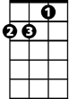

Am



D

**Am D Am D**

You can't go on, thinkin', nothings' wrong,

**C Cmaj7 C Cmaj7**

Who's gonna drive you home, tonight.?

**Am D Am D**

You can't go on, thinkin', nothings' wrong,

**C Cmaj7 C Cmaj7 C**

Who's gonna drive you home, tonight.?