Drunken Sailor (Traditional, Adapted by G. Millar & W. McDonald)
Drunken Sailor by The Irish Rovers (2012) – Key of Am

Intro (2 measures) Am

Am D  What will we do with a drunken sailor?  G Em  What will we do with a drunken sailor?  Am D  What will we do with a drunken sailor?  C G Am  Earl-ie in the morning?  Chorus  Am D  Weigh, hey and up she rises  G Em  Weigh, hey and up she rises  Am D  Weigh, hey and up she rises  C G Am  Earl-ie in the morning.  Am D  Shave his belly with a rusty razor,  G Em  Shave his belly with a rusty razor,  Am D  Shave his belly with a rusty razor,  C G Am  Earl-ie in the morning. Chorus  Am D  Put him in the long boat til he's sober,  G Em  Put him in the long boat til he's sober,  Am D  Put him in the long boat til he's sober,  C G Am  Earl-ie in the morning. Chorus |  |  |  | Instrumental Em D Em A D (2x)  Am D  Put him in the scuppers with a hose pipe on him,  G Em  Put him in the scuppers with a hose pipe on him,  Am D  Put him in the scuppers with a hose pipe on him,  C G Am  Earl-ie in the morning. Chorus  Am D  Put him in the bed with the Captain's daughter,  G Em  Put him in the bed with the Captain's daughter,  Am D  Put him in the bed with the Captain's daughter,  C G Am  Earl-ie in the morning. Chorus  Am D  That's what we'll do with a drunken sailor,  G Em  That's what we'll do with a drunken sailor,  Am D  That's what we'll do with a drunken sailor,  C G Am  Earl-ie in the morning. Chorus (2x)  Outro Em D Em A D (2x)
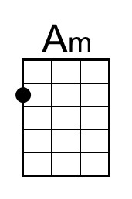 | 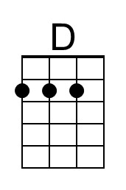 | 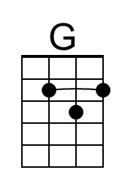 |  |  | Bari | 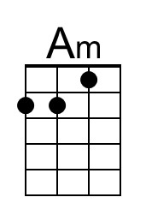 | 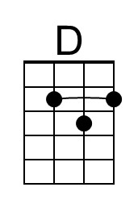
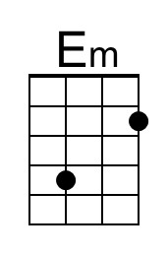 | 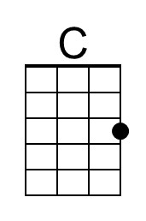 |  |  |  | 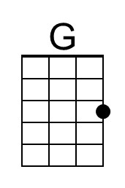 | 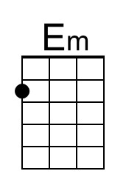 | 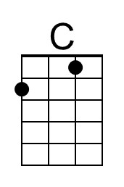

Drunken Sailor (Traditional, Adapted by G. Millar & W. McDonald)
Drunken Sailor by The Irish Rovers (2012) – Key of Em

Intro (2 measures) Em

Em A  What will we do with a drunken sailor?  D Bm  What will we do with a drunken sailor?  Em A  What will we do with a drunken sailor?  G D Em  Earl-ie in the morning?  Chorus  Em A  Weigh, hey and up she rises  D Bm  Weigh, hey and up she rises  Em A  Weigh, hey and up she rises  G D Em  Earl-ie in the morning.  Em A  Shave his belly with a rusty razor,  D Bm  Shave his belly with a rusty razor,  Em A  Shave his belly with a rusty razor,  G D Em  Earl-ie in the morning. Chorus  Em A  Put him in the long boat til he's sober,  D Bm  Put him in the long boat til he's sober,  Em A  Put him in the long boat til he's sober,  G D Em  Earl-ie in the morning. Chorus |  |  |  | Instrumental Em D Em A D (2x)  Em A  Put him in the scuppers with a hose pipe on him,  D Bm  Put him in the scuppers with a hose pipe on him,  Em A  Put him in the scuppers with a hose pipe on him,  G D Em  Earl-ie in the morning. Chorus  Em A  Put him in the bed with the Captain’s daughter,  D Bm  Put him in the bed with the Captain’s daughter,  Em A  Put him in the bed with the Captain’s daughter,  G D Em  Earl-ie in the morning. Chorus  Em A  That’s what we’ll do with a drunken sailor,  D Bm  That’s what we’ll do with a drunken sailor,  Em A  That’s what we’ll do with a drunken sailor,  G D Em  Earl-ie in the morning. Chorus (2x)  Outro Em D Em A D (2x)
 | 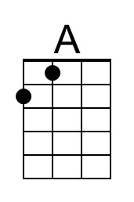 |  |  |  | Bari |  | 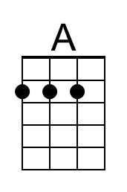
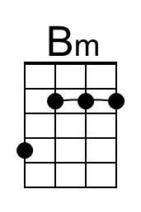 |  |  |  |  |  | 