Duke of Earl (C)
(Gene Chandler, Earl Edwards & Bernice Williams, 1961)
Duke of Earl by Gene Chandler (1961) (F) – Duke of Earl by Sha-Na-Na (at Woodstock)
4/4 – 101 BPM
Intro (2x)  C Am F  Duke, Duke, Duke, Duke of Earl. Duke, Duke, Duke of Earl.  G  Duke, Duke, Duke of Earl.  C Am F G  As I, I walk through this world, nothing can stop the Duke of Earl.  C Am F G  And you, you are my girl, and no one can hurt you, oh, no.  Chorus  C Am  Yes, I, oh, I'm gonna love you, oh, oh.  F  Come on let me hold you, darlin',  G  'Cause I'm the Duke of Earl.  G  So, yeah, yeah, yeah, yeah.  C Am F G  And when I hold you, you'll be my duchess, Duchess of Earl.  C Am F G  We'll walk through my dukedom, and a paradise we will share. Chorus  Instrumental (2x)  C | Am | F | G | Chorus  Outro (3x)  C | Am | F | G | | 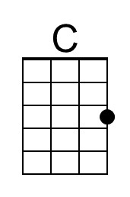
 | 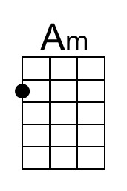
 | 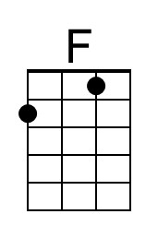
 | 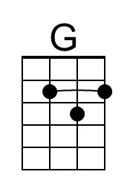
 | Bari
 | 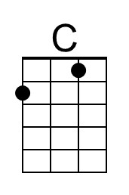
 | 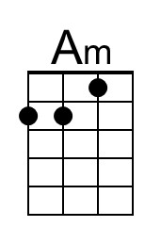
 | 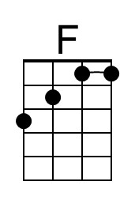
 | 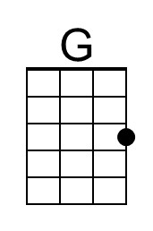

Duke of Earl (F)
(Gene Chandler, Earl Edwards & Bernice Williams, 1961)
Duke of Earl by Gene Chandler (1961) (F) – Duke of Earl by Sha-Na-Na (at Woodstock)
4/4 – 101 BPM
Intro (2x)
F Dm Bb
Duke, Duke, Duke, Duke of Earl. Duke, Duke, Duke of Earl.
C
Duke, Duke, Duke of Earl.

F Dm Bb C
As I, I walk through this world, nothing can stop the Duke of Earl.
F Dm Bb C
And you, you are my girl, and no one can hurt you, oh, no.

Chorus
F Dm
Yes, I, oh, I'm gonna love you, oh, oh.
Bb
Come on let me hold you, darlin',
C
'Cause I'm the Duke of Earl.
C
So, yeah, yeah, yeah, yeah.

F Dm Bb C
And when I hold you, you'll be my duchess, Duchess of Earl.
F Dm Bb C
We'll walk through my dukedom, and a paradise we will share. Chorus

Instrumental (2x)
F | Dm | Bb | C | Chorus

Outro (3x)
F | Dm | Bb | C |
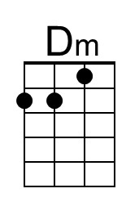
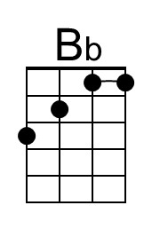
Bari
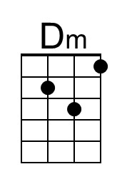
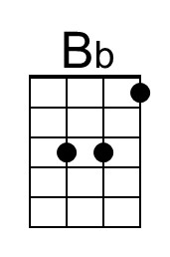

Duke of Earl (G)
(Gene Chandler, Earl Edwards & Bernice Williams, 1961)
Duke of Earl by Gene Chandler (1961) (F) – Duke of Earl by Sha-Na-Na (at Woodstock)
4/4 – 101 BPM
Intro (2x)
G Em C
Duke, Duke, Duke, Duke of Earl. Duke, Duke, Duke of Earl.
D
Duke, Duke, Duke of Earl.

G Em C D
As I, I walk through this world, nothing can stop the Duke of Earl.
G Em C D
And you, you are my girl, and no one can hurt you, oh, no.

Chorus
G Em
Yes, I, oh, I'm gonna love you, oh, oh.
C
Come on let me hold you, darlin',
D
'Cause I'm the Duke of Earl.
So, yeah, yeah, yeah, yeah.

G Em C D
And when I hold you, you'll be my duchess, Duchess of Earl.
G Em C D
We'll walk through my dukedom, and a paradise we will share. Chorus

Instrumental (2x)
G | Em | C | D | Chorus

Outro (3x)
G | Em | C | D |
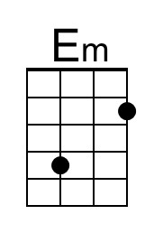
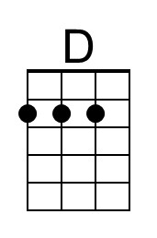
Bari
