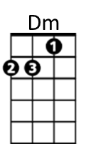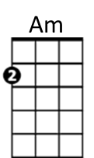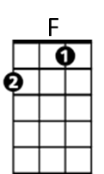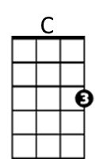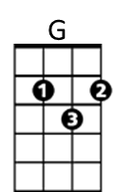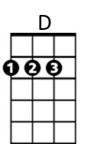**Dust in the Wind (Kerry Livgren, 1977)**

**Intro: C G Am F / C G Am F**

**C G Am G Dm Am**

I close my eyes - only for a moment and a moment´s gone.

**C G Am G Dm Am**

All my dreams - pass before my eyes are curiosity.

**D G Am D G Am Am / G /**

Dust in the wind, all we are is dust in the wind.

**C G Am G Dm Am**

Same old song, just a drop of water in the endless sea.

**C G Am G Dm Am**

All we do, crumbles to the ground though we refuse to see.

**D G Am D G Am G F Am**

Dust in the wind, all we are is dust in the wi -- nd ohh oh ohhh

**Am G Am F / Am G Am F / C Am C Am**

**C G Am G Dm Am**

Don't hang on, nothing lasts forever but the earth and sky.

**C G Am G Dm Am**

It slips away and all your money won´t another minute buy.

**D G Am D G Am**

Dust in the wind, all we are is dust in the wind

**D G Am D G Am**

Dust in the wind, all we are is dust in the wind

**Am G Am F / C G Am F (end on Am)**

**BARITONE**



D

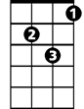

Dm



F

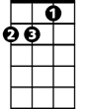

Am



G

C

