Dust in the Wind (Kerry Livgren, 1977) (G)

Intro: G D Em C / G D Em C  G D Em D Am Em  I close my eyes - only for a moment and a moment s gone.  G D Em D Am Em  All my dreams - pass before my eyes are curiosity.  A D Em A D Em Em / D /  Dust in the wind, all we are is dust in the wind.  G D Em D Am Em  Same old song, just a drop of water in the endless sea.  G D Em D Am Em  All we do, crumbles to the ground though we refuse to see.  A D Em A D Em D C Em  Dust in the wind, all we are is dust in the wi -- nd ohh oh ohhh  Em D Em C / Em D Em C / G Em G Em  G D Em D Am Em  Don't hang on, nothing lasts forever but the earth and sky.  G D Em D Am Em  It slips away and all your money won t another minute buy.  A D Em A D Em  Dust in the wind, all we are is dust in the wind  A D Em A D Em  Dust in the wind, all we are is dust in the wind  Em D Em C / G D Em C (end on Em) |  |  |  |  |  |  | 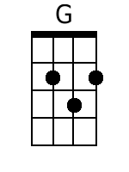 | 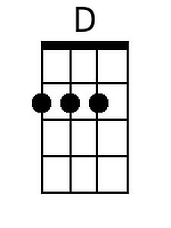
 |  |  |  |  |  |  | 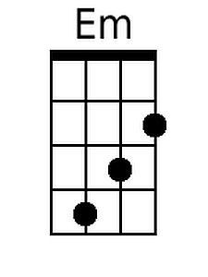 | 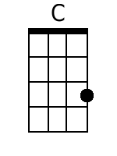
 |  |  |  |  |  |  | 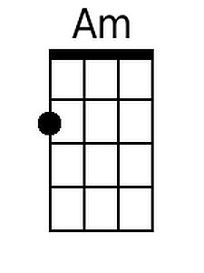 | 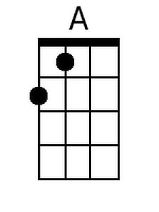
Bari
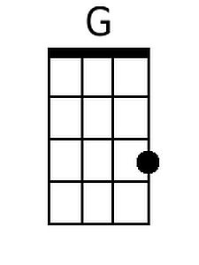 | 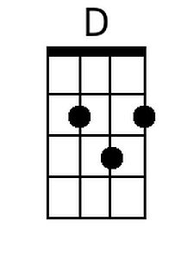 | 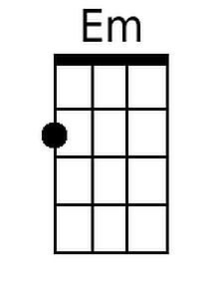 | 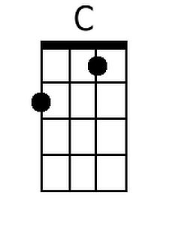 | 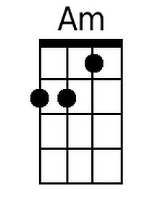 | 