Dust in the Wind (Kansas) (C)

Intro: C G Am F / C G Am F  C G Am G Dm Am  I close my eyes only for a moment and a moment´s gone.  C G Am G Dm Am  All my dreams pass before my eyes are curiosity.  D G Am D G Am Am / G /  Dust in the wind, all we are is dust in the wind.  C G Am G Dm Am  Same old song, just a drop of water in the endless sea.  C G Am G Dm Am  All we do, crumbles to the ground though we refuse to see.  D G Am D G Am G F Am  Dust in the wind, all we are is dust in the wi -- nd ohh oh ohhh  Am G Am F / Am G Am F / C Am C Am  C G Am G Dm Am  Don't hang on, nothing lasts forever but the earth and sky.  C G Am G Dm Am  It slips away and all your money won´t another minute buy.  D G Am D G Am  Dust in the wind, all we are is dust in the wind  D G Am D G Am  Dust in the wind, all we are is dust in the wind  Am G Am F / C G Am F (Repeat To Fade or end on Am) |  |  |  |  |  |  | 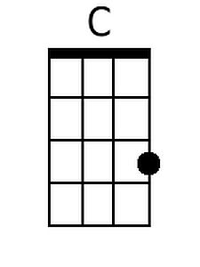
 |  |  |  |  |  |  | 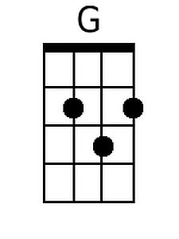
 |  |  |  |  |  |  | 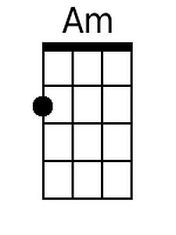
 |  |  |  |  |  |  | 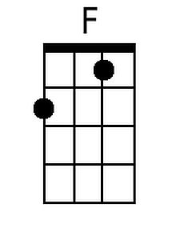
 |  |  |  |  |  |  | 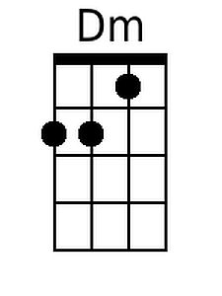
 |  |  |  |  |  |  | 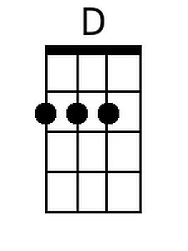
Bari
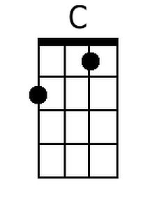 | 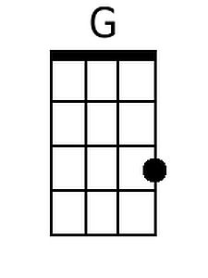 | 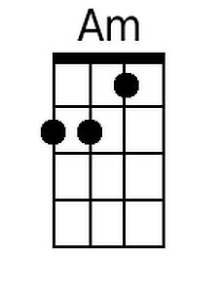 | 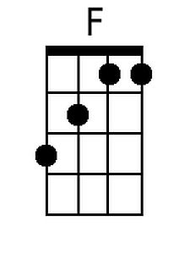 | 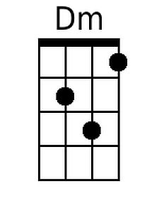 | 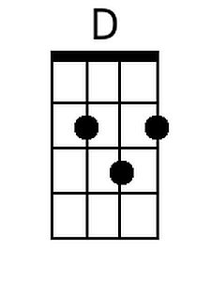

Dust in the Wind (Kansas) (G)

Intro: G D Em C / G D Em C

G D Em D Am Em
I close my eyes only for a moment and a moment s gone.
G D Em D Am Em
All my dreams pass before my eyes are curiosity.

A D Em A D Em Em / D /
Dust in the wind, all we are is dust in the wind.

G D Em D Am Em
Same old song, just a drop of water in the endless sea.
G D Em D Am Em
All we do, crumbles to the ground though we refuse to see.

A D Em A D Em D C Em
Dust in the wind, all we are is dust in the wi -- nd ohh oh ohhh

Em D Em C / Em D Em C / G Em G Em

G D Em D Am Em
Don't hang on, nothing lasts forever but the earth and sky.
G D Em D Am Em
It slips away and all your money won t another minute buy.

A D Em A D Em
Dust in the wind, all we are is dust in the wind
A D Em A D Em
Dust in the wind, all we are is dust in the wind

G D Em C / G D Em C (Repeat To Fade or end on Em)

 |  |  |  |  |  |  | 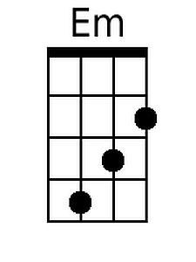
 |  |  |  |  |  |  | 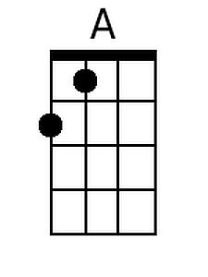
Bari
 |  | 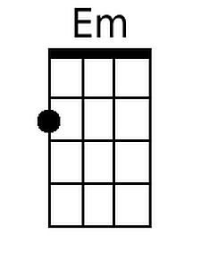 |  |  | 