**Early Mornin' Rain (Gordon Lightfoot)**

Em

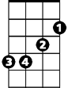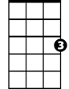

C

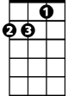

Dm

**C Em Dm G7 C**

In the early mornin' rain, with a dollar in my hand,

**Dm G7 C**

With an achin' in my heart, and my pockets full of sand.

**Dm G7 C**

I'm a long way from home, and I miss my loved ones so,

**Em Dm G7 C**

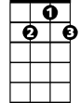

G7

In the early mornin' rain, with no place to go.

**C Em Dm G7 C**

Out on runway number nine, big seven-o-seven set to go,

**Dm G7 C**

But I'm stuck here in the grass, where the cold wind blows.

**Dm G7 C**

Now the liquor tasted good, and the women all were fast,

**Em Dm G7 C**

Well there she goes, my friend, she's rollin' now at last.

**BARITONE**

**C Em Dm G7 C**

C

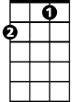

Hear the mighty engines roar, see the silver bird on high,

**Dm G7 C**

She's away and westward bound, far above the clouds she'll fly,

**Dm G7 C**

Where the mornin' rain don't fall, and the sun always shines,

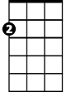

Em

**Em Dm G7 C**

She'll be flying o'er my home, in about three hours’ time.

**C Em Dm G7 C**

This old airport's got me down, it's no earthly good to me,

**Dm G7 C**

'Cause I’m stuck here on the ground, as cold and drunk as I can be.

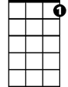

G7

**Dm G7 C**

You can't jump a jet plane, like you can a freight train,

**Em Dm G7 C**

So I'd best be on my way, in the early mornin' rain.

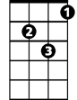

Dm

**(Repeat verse 1)**

**C Em Dm G7 C**

So I'd best be on my way, in the early mornin' rain.