Early Mornin' Rain (Gordon Lightfoot) (G)

G Bm Am D7 G  In the early mornin' rain, with a dollar in my hand,  Am D7 G  With an achin' in my heart, and my pockets full of sand.  Am D7 G  I'm a long way from home, and I miss my loved ones so,  Bm Am D7 G  In the early mornin' rain, with no place to go.  G Bm Am D7 G  Out on runway number nine, big seven-o-seven set to go,  Am D7 G  But I'm stuck here in the grass, where the cold wind blows.  Am D7 G  Now the liquor tasted good, and the women all were fast,  Bm Am D7 G  Well there she goes, my friend, she's rollin' now at last.  G Bm Am D7 G  Hear the mighty engines roar, see the silver bird on high,  Am D7 G  She's away and westward bound, far above the clouds she'll fly,  Am D7 G  Where the mornin' rain don't fall, and the sun always shines,  Bm Am D7 G  She'll be flying o'er my home, in about three hours' time.  G Bm Am D7 G  This old airport's got me down, it's no earthly good to me,  Am D7 G  'Cause I'm stuck here on the ground, as cold and drunk as I can be.  Am D7 G  You can't jump a jet plane, like you can a freight train,  Bm Am D7 G  So I'd best be on my way, in the early mornin' rain.  (Repeat Verse 1)  G Bm Am D7 G  So I'd best be on my way, in the early mornin' rain. | 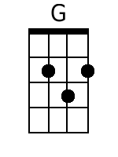 | 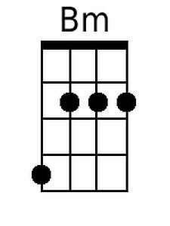
 | 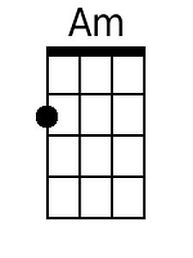 | 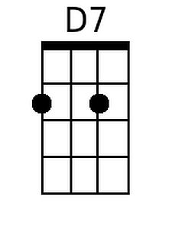
 | Bari
 | 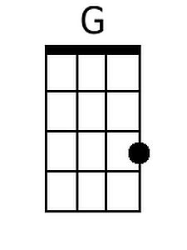 | 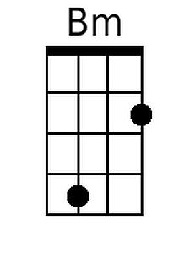
 | 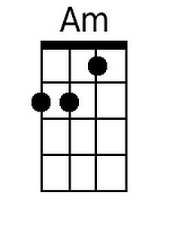 | 