Earth Angel (Jesse Belvin, Gaynel Hodge & Curtis Williams, 1954) (C)
Earth Angel by The Penguins (1954) (A♭)
4/4 – 69 BPM
Intro (x2) C Am | Dm7 G7 |  C Am Dm7 G7  Earth angel, earth angel, ___will you be mine?  C Am Dm7 G7  _ My darling dear, love you all the time.  C Am Dm7 G7 C Am | Dm7 G7  _ I'm just a fool, ___a fool in love with you.  C Am Dm7 G7  Earth angel, earth angel, ___the one I a-dore.  C Am Dm7 G7  _ Love you for-ever and ever more.  C Am Dm7 G7 C | C7  _ I'm just a fool, ___a fool in love with you.  Chorus  F Fm C Dm7 G7 C  I fell for you _ and I knew the vision of your love’s loveli-ness,  F Fm C Am  I hope and I pray _ that some day,  D7 G#7 G7  I'll be the vision of your hap- happiness, oh  C Am Dm7 G7  Earth angel, earth angel, ___please be mine.  C Am Dm7 G7  _ My darling dear, love you all the time.  C Am Dm7 G7 C Am | Dm7 G7  _ I'm just a fool, ___a fool in love with you.  C Dm7 C  You, you, you. |  |  |  |  |  |  |  |  | 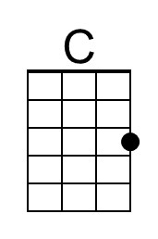
 |  |  |  |  |  |  |  |  | 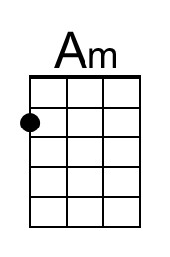
 |  |  |  |  |  |  |  |  | 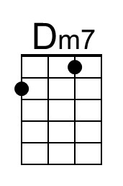
 |  |  |  |  |  |  |  |  | 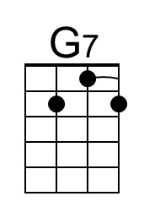
 |  |  |  |  |  |  |  |  | 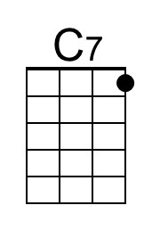
 |  |  |  |  |  |  |  |  | 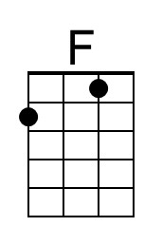
 |  |  |  |  |  |  |  |  | 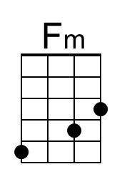
Bari | 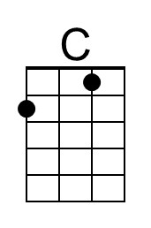 | 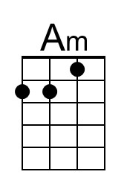 | 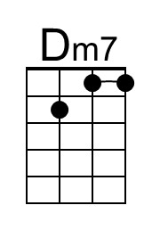 | 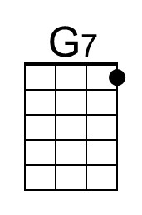 | 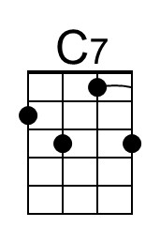 | 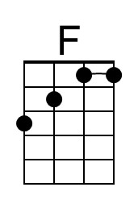 | 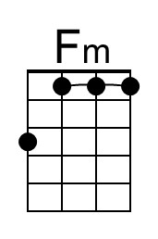 | 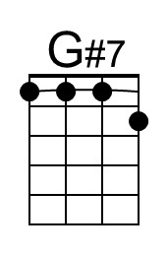 | 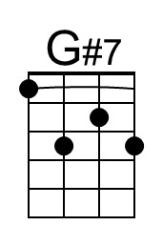

Earth Angel (Jesse Belvin, Gaynel Hodge & Curtis Williams, 1954) (D)
Earth Angel by The Penguins (1954) (A♭)
4/4 – 69 BPM
Intro (x2) D Bm | Em7 A7 |  D Bm Em7 A7  Earth angel, earth angel, ___will you be mine?  D Bm Em7 A7  _ My darling dear, love you all the time.  D Bm Em7 A7 D Bm | Em7 A7  _ I'm just a fool, ___a fool in love with you.  D Bm Em7 A7  Earth angel, earth angel, ___the one I a-dore.  D Bm Em7 A7  _ Love you for-ever and ever more.  D Bm Em7 A7 D Bm7 | Em7 A7  _ I'm just a fool, ___a fool in love with you.  Chorus  G Gm D Em7 A7 D  I fell for you _ and I knew the vision of your love’s loveli-ness,  G Gm D Bm  I hope and I pray _ that some day,  E7 A#7 A7  I'll be the vision of your hap- happiness, oh  D Bm Em7 A7  Earth angel, earth angel, ___please be mine.  D Bm Em7 A7  _ My darling dear, love you all the time.  D Bm Em7 A7 D Bm | Em7 A7  _ I'm just a fool, ___a fool in love with you.  D Em7 D  You, you, you. |  |  |  |  |  |  |  |  |  | 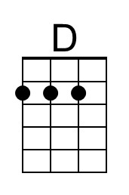
 |  |  |  |  |  |  |  |  |  | 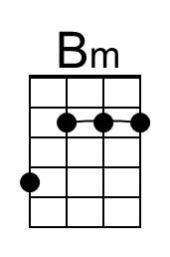
 |  |  |  |  |  |  |  |  |  | 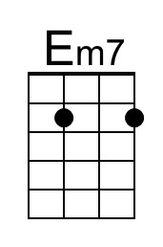
 |  |  |  |  |  |  |  |  |  | 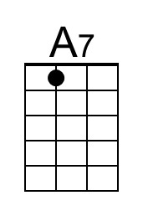
 |  |  |  |  |  |  |  |  |  | 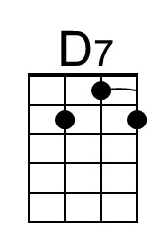
 |  |  |  |  |  |  |  |  |  | 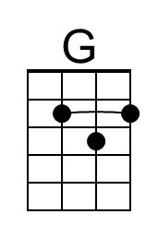
 |  |  |  |  |  |  |  |  |  | 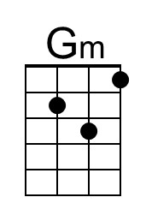
Bari | 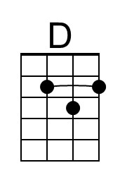 | 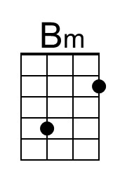 | 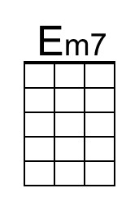 | 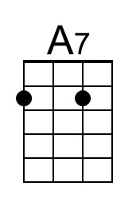 |  | 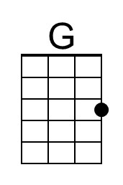 | 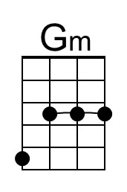 | 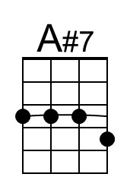 | 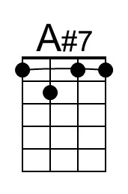

Earth Angel (Jesse Belvin, Gaynel Hodge & Curtis Williams, 1954) (G)
Earth Angel by The Penguins (1954) (A♭)
4/4 – 69 BPM
Intro (x2) G Em | Am7 D7 |

G Em Am7 D7
Earth angel, earth angel, ___will you be mine?
G Em Am7 D7
_ My darling dear, love you all the time.
G Em Am7 D7 G Em | Am7 D7
_ I'm just a fool, ___a fool in love with you.

G Em Am7 D7
Earth angel, earth angel, ___the one I a-dore.
G Em Am7 D7
_ Love you for-ever and ever more.
G Em Am7 D7 G | G7
_ I'm just a fool, ___a fool in love with you.

Chorus
C Cm G Am7 D7 G
I fell for you _ and I knew the vision of your love’s loveli-ness,
C Cm G Em
I hope and I pray _ that some day,
A7 D#7 D7
I'll be the vision of your hap- happiness, oh

G Em Am7 D7
Earth angel, earth angel, ___please be mine.
G Em Am7 D7
_ My darling dear, love you all the time.
G Em Am7 D7 G Em | Am7 D7
_ I'm just a fool, ___a fool in love with you.
G Am7 G
You, you, you.
 |  |  |  |  |  |  |  |  |  | 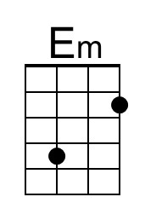
 |  |  |  |  |  |  |  |  |  | 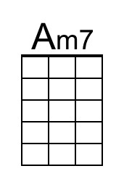
 |  |  |  |  |  |  |  |  |  | 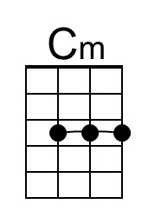
Bari |  | 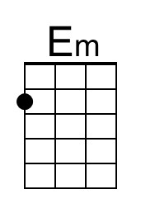 | 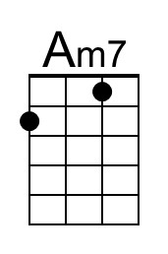 |  |  |  | 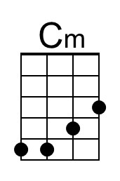 | 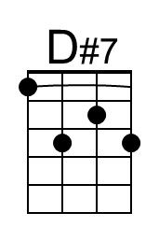 | 