Earth Angel (Jesse Belvin, Gaynel Hodge & Curtis Williams, 1954) (C)
Earth Angel by The Penguins (1954) (#8 on the pop charts; #1 on R & B charts)
4/4 – 69 BPM

Intro (x2) C | Am | Dm7 | G7  C Am Dm7 G7  Earth angel, earth angel, will you be mine?  C Am Dm7 G7  My darling dear, love you all the time.  C Am Dm7 G7 C Am F G7  I'm just a fool, a fool in love with you.  C Am Dm7 G7  Earth angel, earth angel, the one I a-dore.  C Am Dm7 G7  Love you for-ever and ever more.  C Am Dm7 G7 C  I'm just a fool, a fool in love with you.  Chorus  Dm7 C Dm7 C  I fell for you and I knew the vision of your love loveliness,  Dm7 C  I hope and I pray that some day,  Dm Dm7  I'll be the vision of your hap-happiness, oh  Repeat First Verse Chorus  Repeat First Verse  Outro  You, you, you. |  |  |  |  |  |  | 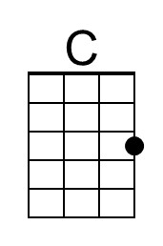
 |  |  |  |  |  |  | 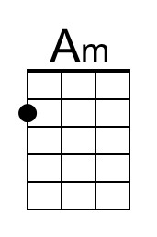
 |  |  |  |  |  |  | 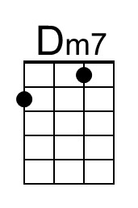
 |  |  |  |  |  |  | 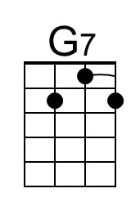
 |  |  |  |  |  |  | 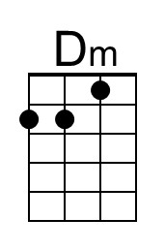
Bari | 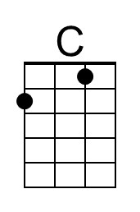 | 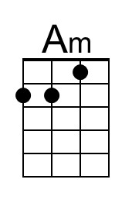 | 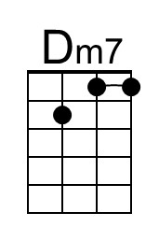 | 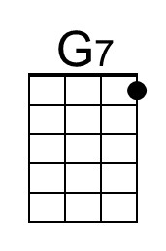 | 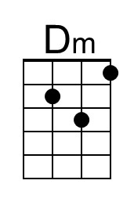
Earth Angel (Jesse Belvin, Gaynel Hodge & Curtis Williams, 1954) (D)
Earth Angel by The Penguins (1954) (#8 on the pop charts; #1 on R & B charts)
4/4 – 69 BPM

Intro (x2) D | Bm | Em | A7  D Bm Em7 A7  Earth angel, earth angel, will you be mine?  D Bm Em7 A7  My darling dear, love you all the time.  D Bm Em7 A7 D Bm G A7  I'm just a fool, a fool in love with you.  D Bm Em7 A7  Earth angel, earth angel, the one I a-dore.  D Bm Em7 A7  Love you for-ever and ever more.  D Bm Em7 A7 D  I'm just a fool, a fool in love with you.  Chorus  Em7 D Em7 D  I fell for you and I knew the vision of your love loveliness,  Em7 D  I hope and I pray that some day,  Em Em7  I'll be the vision of your hap-happiness, oh  Repeat First Verse Chorus  Repeat First Verse  Outro  You, you, you. |  |  |  |  |  |  | 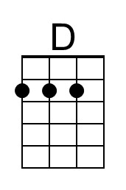
 |  |  |  |  |  |  | 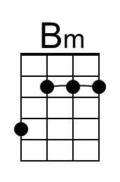
 |  |  |  |  |  |  | 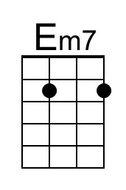
 |  |  |  |  |  |  | 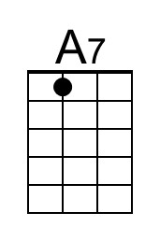
 |  |  |  |  |  |  | 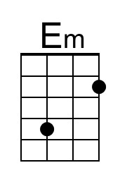
Bari | 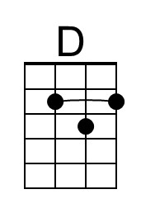 | 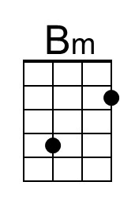 | 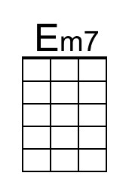 | 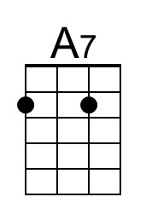 | 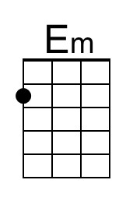
Earth Angel (Jesse Belvin, Gaynel Hodge & Curtis Williams, 1954) (G)
Earth Angel by The Penguins (1954) (#8 on the pop charts; #1 on R & B charts)
4/4 – 69 BPM
Intro (x2) G | Em | Am7 | D7  G Em Am7 D7  Earth angel, earth angel, will you be mine?  G Em Am7 D7  My darling dear, love you all the time.  G Em Am7 D7 G Em C D7  I'm just a fool, a fool in love with you.  G Em Am7 D7  Earth angel, earth angel, the one I a-dore.  G Em Am7 D7  Love you for-ever and ever more.  G Em Am7 D7 G  I'm just a fool, a fool in love with you.  Chorus  Am7 G Am7 G  I fell for you and I knew the vision of your love loveliness,  Am7 G  I hope and I pray that some day,  Am Am7  I'll be the vision of your hap-happiness, oh  Repeat First Verse Chorus  Repeat First Verse  Outro  You, you, you. |  |  |  |  |  |  | 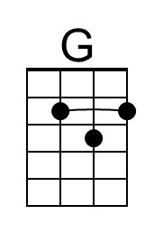
 |  |  |  |  |  |  | 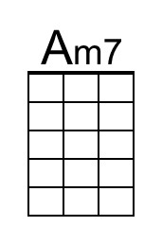
 |  |  |  |  |  |  | 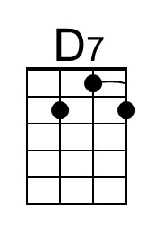
Bari | 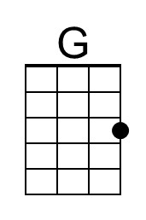 |  | 