
Easter Parade (Irving Berlin, 1933) (F)
Featured in “Holiday Inn” and “Easter Parade”

C7 F Dm Bb C7 F - C7  Never saw you look quite so pretty be-fore  F C7 F - F7no5  Never saw you dressed quite so handsome, what’s more  Bb C7 F Bb Gm F C  I could hardly wait to keep our date this lovely Easter morning  F G7 C C7#5  And my heart beat fast, as I came through the door…..for  F C7 F F7no5 Bb Bdim7  In your Easter bonnet, ____ with all the frills u-pon it  F C7 F Dm G7 Gm - C7  You’ll be the grandest lady in the Easter pa-rade  F C7 F F7no5 Bb Bdim7  I’ll be all in clover, ____ and when they look you over  F C7 F Dm G7 C7 F - F7no5  I’ll be the proudest fellow in the Easter __ pa-rade  F9 Bb6  On the avenue, Fifth Avenue  Dm G7  The photographers will snap us  C Bb Am C C7#5  And you’ll find that you’re in the rotogra-vure, Oh,  F C7 F F7no5 Bb Bdim7  I could write a sonnet _____ a-bout your Easter bonnet  F C7 F Dm G7 C7 F  And of the girl I’m taking to the Easter __ pa-rade. |  |  |  |  |  | 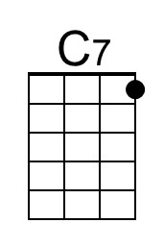 | 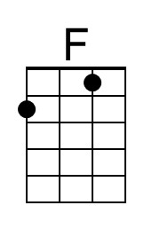
 |  |  |  |  |  | 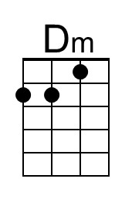 | 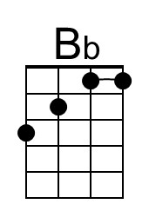
 |  |  |  |  |  | 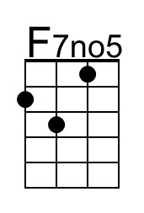 | 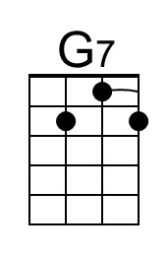
 |  |  |  |  |  | 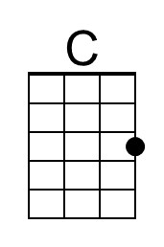 | 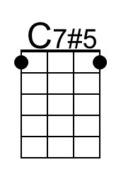
 |  |  |  |  |  | 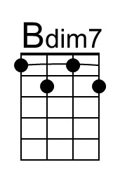 | 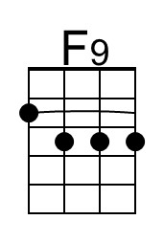
 |  |  |  |  |  | 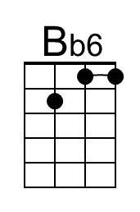 | 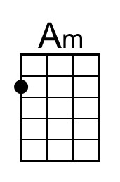
 | Bari | 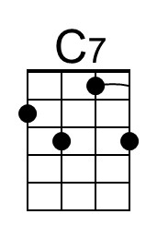 | 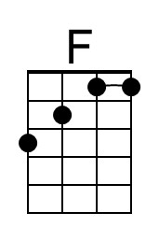 | 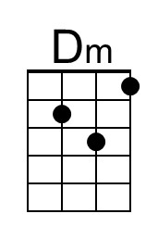 | 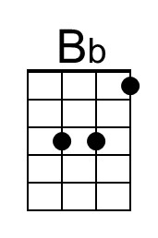 | 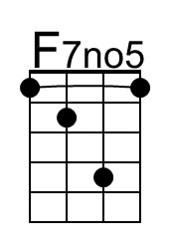 | 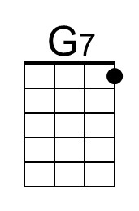
 |  | 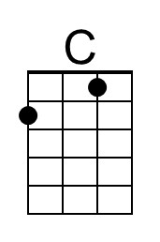 | 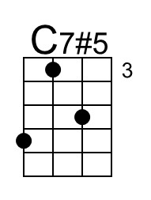 | 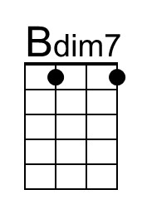 | 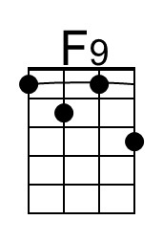 | 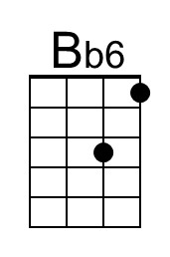 | 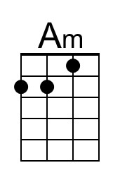

Easter Parade (Irving Berlin, 1933) (C)
Featured in “Holiday Inn” and “Easter Parade”

G7 C Am F G7 C - G7
Never saw you look quite so pretty be-fore
C G7 C - C7no5
Never saw you dressed quite so handsome, what’s more
F G7 C F Dm C G
I could hardly wait to keep our date this lovely Easter morning
C D7 G G7#5
And my heart beat fast, as I came through the door…..for

C G7 C C7no5 F F#dim7
In your Easter bonnet, _____ with all the frills u-pon it
C G7 C Am D7 Dm - G7
You’ll be the grandest lady in the Easter pa-rade
C G7 C C7no5 F F#dim7
I’ll be all in clover, _____ and when they look you over
C G7 C Am D7 G7 C - C7no5
I’ll be the proudest fellow in the Easter __ pa-rade

C9 F6
On the avenue, Fifth Avenue
Am D7
The photographers will snap us
G F Em G G7#5
And you’ll find that you’re in the rotogra-vure, Oh,

C G7 C C7no5 F F#dim7
I could write a sonnet _____ a-bout your Easter bonnet
C G7 C Am D7 G7 C
And of the girl I’m taking to the Easter __ pa-rade.

 |  |  |  |  |  | 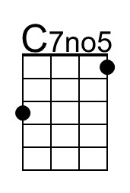 | 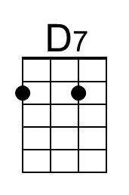
 |  |  |  |  |  | 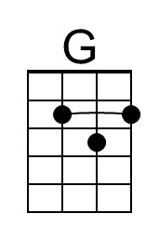 | 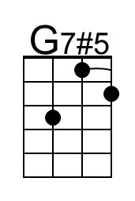
 |  |  |  |  |  | 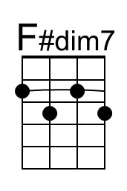 | 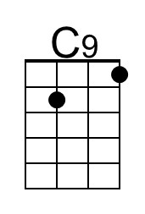
 |  |  |  |  |  | 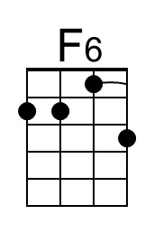 | 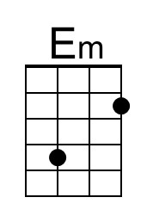
 | Bari |  |  |  |  | 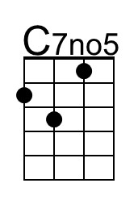 | 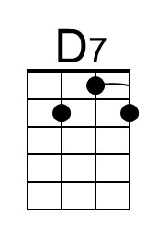
 |  | 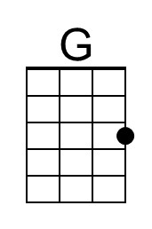 | 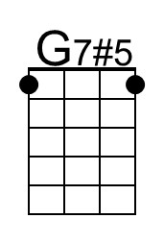 | 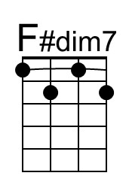 | 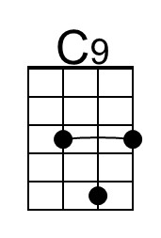 | 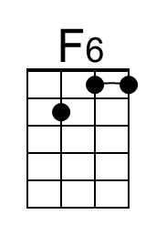 | 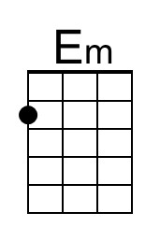

Easter Parade (Irving Berlin, 1933) (G)
Featured in “Holiday Inn” and “Easter Parade”

D7 G Em C D7 G - D7
Never saw you look quite so pretty be-fore
G D7 G - G7no5
Never saw you dressed quite so handsome, what’s more
C D7 G C Am G D
I could hardly wait to keep our date this lovely Easter morning
G A7 D D7#5
And my heart beat fast, as I came through the door…..for

G D7 G G7no5 C C#dim7
In your Easter bonnet, _____ with all the frills u-pon it
G D7 G Em A7 Am - D7
You’ll be the grandest lady in the Easter pa-rade
G D7 G G7no5 C C#dim7
I’ll be all in clover, _____ and when they look you over
G D7 G Em A7 D7 G - G7no5
I’ll be the proudest fellow in the Easter __ pa-rade

G9 C6
On the avenue, Fifth Avenue,
Em A7
The photographers will snap us
D C Bm D D7#5
And you’ll find that you’re in the rotogra-vure, Oh,

G D7 G G7no5 C C#dim7
I could write a sonnet _____ a-bout your Easter bonnet
G D7 G Em A7 D7 G
And of the girl I’m taking to the Easter __ pa-rade.

 |  |  |  |  |  | 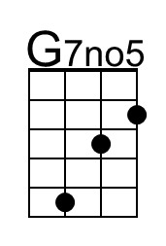 | 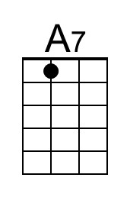
 |  |  |  |  |  | 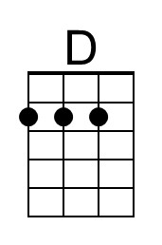 | 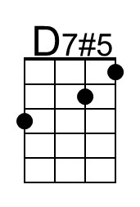
 |  |  |  |  |  | 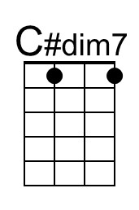 | 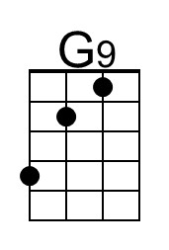
 |  |  |  |  |  | 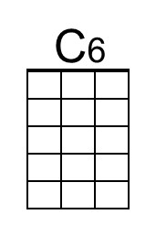 | 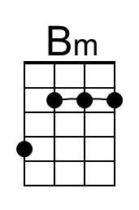
 | Bari |  |  |  |  | 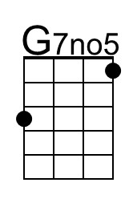 | 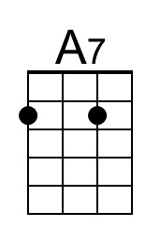
 |  | 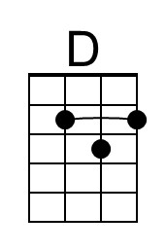 | 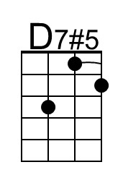 | 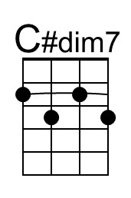 | 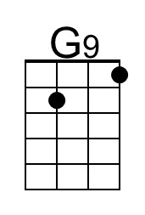 | 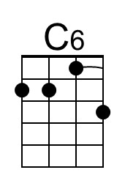 | 