**Easy To Be Hard (James Rado / Galt Mac Dermot) Key C**

**INTRO: Cmaj7 A7 (x2)**

**Cmaj7 A7**

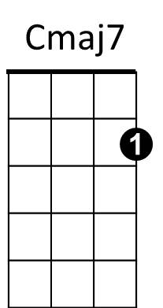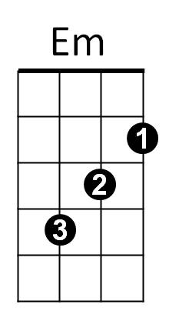How can people be so heartless..

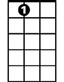

A7

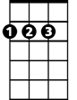

D

**Cmaj7 A7**

How can people be so cruel?

**D Em A D D7**

Eas-y to be hard - easy to be cold.

**Cmaj7 A7**



G

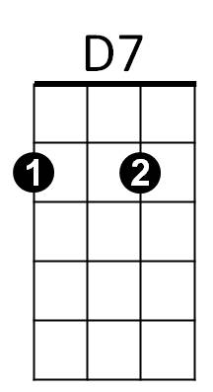How can people have no feelings.

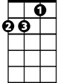

Dm

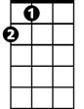

A

**Cmaj7 A7**

How can they ignore their friends?

**D Em A D D7**

Eas-y to be proud - easy to say no.

**CHORUS:**

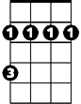

Bm

**G Dm G Dm**

Especially people who care about strangers..

**G Dm G Dm**

who care about evil and social injustice.

**Em A7 Em A7**

Do you only care about the bleeding crowds?

**Em A7 D Cmaj7 A7**

**BARITONE**

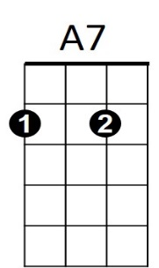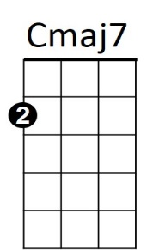How about a needed friend..**I need a friend**.



D



A

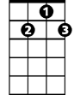

D7

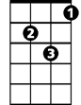

Dm



G

**Cmaj7 A7**

How can people be so heartless..

**Cmaj7 A7**

You know I'm hung up on you.

**D Em A D D7**

Eas-y to be proud - easy to say no.

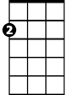

Em

**(CHORUS) Change end of last line – “We all need a friend”**

**(Repeat last Verse, Drop D7 at end play Outro)**

**OUTRO:**

**Em A D Em A D**

Bm

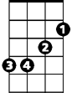

Ea.- sy to be cold.- ea..- sy to say no.

**Em A D Em A D**

Come on, ea.-.sy to give in - ea.-.sy to say no.

**Em A D Em A D**

Ea.- sy to be cold.- ea..- sy to say no.

**Em A Bm (hold)**

Much too easy to say no**..**