
Eddystone Light (G)
Traditional English (Burl Ives, The Weavers, Peter, Paul, and Mary)

Chorus  A A7 D7  Yo ho ho, the wind blows free  D D7 G  Oh, for a life on the rolling sea  D7 G  Oh, me father was the keeper of the Eddystone  C D G Light  And he courted a mermaid one fine night  G  From this union there came three  C D G  A porpoise and a porgy and the other was me.  Chorus  G  One night, while I was trimming of the glim  C D G  Singing a verse from the evening hymn  G  A voice from the starboard shouted, "Ahoy"  C D G  And there was me mother, a-sitting on the buoy  (Don't be ridiculous a boy is a juvenile male  C D G  No, a buoy, it guides the ships to sail)  Chorus  G  Tell me what has become of my children of  C D G three?  My mother she did ask of me  G  One was exhibited as a talking fish  C D G  And the other was served on a chafing dish  Chorus |  |  |  | G  Then the phosphorous flashed in her seaweed  C D G hair  I looked a-gain me mother wasn't there  G  Her voice came echoing out of the night  C D  "Well, the devil take keeper  G  of the Eddystone Light", Chorus  D7 G  Oh, the moral of the story  you'll learn when you find  C D  To leave God's creatures for what  G  nature had in mind,  G  For fishes are for cookin',  and mermaids are for tales,  C D  And seaweed is for sushi, and  G  protectin' is for whales. Chorus
 |  |  |  |  | 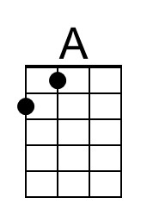 | 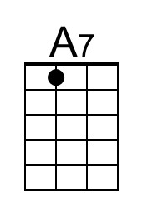 | 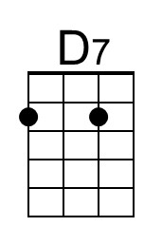
 |  |  |  |  | 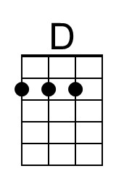 | 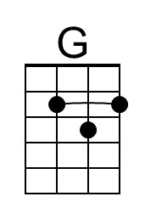 | 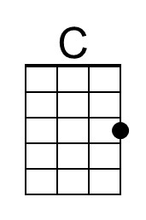
 | Bari | 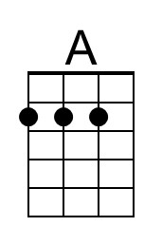 | 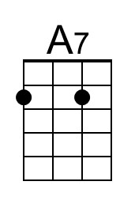 | 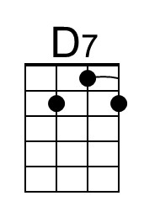 | 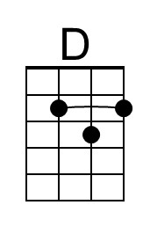 | 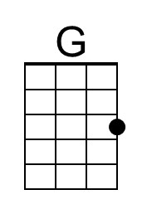 | 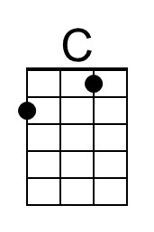

Eddystone Light (Traditional English) (Bb)
Eddystone Light by The Weavers

Sailor Hornpipe Intro
Bb Eb / Cm F / /
A--------1-----------1-------------|-------3-----------3-----0--------|
E-----1-----1-----1-----1--3-------|----3-----3-----3-----3-----1--1--|
C--2-----------2--------------3--3-|-3-----------3--------------------|
G----------------------------------|----------------------------------|

F Bb  Oh, me father was the keeper of the Eddystone  Eb F Bb Light  And he courted a mermaid one fine night  Bb  From this union there came three  Eb F Bb  A porpoise and a porgy and the other was me.  Chorus  C C7 F  Yo ho ho, the wind blows free  F F7 Bb  Oh, for a life on the rolling sea  Bb  One night, while I was trimming of the glim  Eb F Bb  Singing a verse from the evening hymn  Bb  A voice from the starboard shouted, "Ahoy"  Eb F Bb  And there was me mother, a-sitting on the buoy  Chorus  Bb  Tell me what has become of my children of  Eb F Bb three?  My mother she did ask of me  Bb  One was exhibited as a talking fish  Eb F Bb  And the other was served on a chafing dish.  Chorus |  |  |  | Bb  Then the phosphorous flashed in her seaweed  Eb F Bb hair  I looked a-gain me mother wasn't there  Bb  Her voice came echoing out of the night  Eb F  "Well, the devil take the keeper  Bb  of the Eddystone Light", Chorus  Bb  Oh, the moral of the story  you'll learn when you find  Eb F  To leave God's creatures for what  Bb  nature had in mind,  Bb  For fishes are for cookin',  and mermaids are for tales,  Eb F  And seaweed is for sushi,  Bb  and protectin' is for whales. Chorus
 |  |  |  |  | 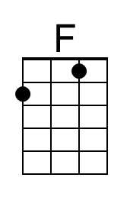 | 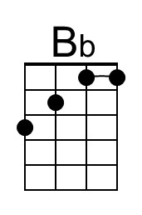 | 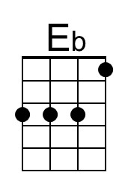
 |  |  |  |  |  | 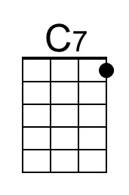 | 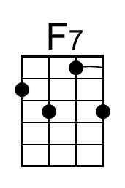
 | Bari | 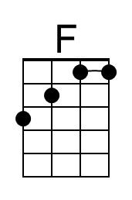 | 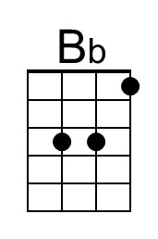 | 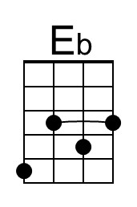 |  | 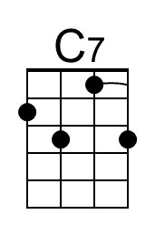 | 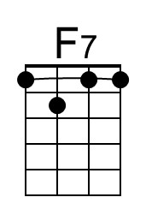

Eddystone Light (F)
Traditional English (Burl Ives, The Weavers, Peter, Paul, and Mary)

Chorus  G G7 C7  Yo ho ho, the wind blows free  C C7 F  Oh, for a life on the rolling sea  C7 F  Oh, me father was the keeper of the Eddystone  Bb C F Light  And he courted a mermaid one fine night  F  From this union there came three  Bb C F  A porpoise and a porgy and the other was me  Chorus  F  One night, while I was trimming of the glim  Bb C F  Singing a verse from the evening hymn  F  A voice from the starboard shouted, "Ahoy"  Bb C F  And there was me mother, a-sitting on the buoy  (Don't be ridiculous a boy is a juvenile male  Bb C F  No, a buoy, it guides the ships to sail)  Chorus  F  Tell me what has become of my children of  Bb C F three?  My mother she did ask of me  F  One was exhibited as a talking fish  Bb C F  And the other was served on a chafing dish  Chorus |  |  |  | F  Then the phosphorous flashed  in her seaweed hair  Bb C F  I looked a-gain me mother wasn't there  F  Her voice came echoing out of the night  Bb C  "Well, the devil take the keeper  F  of the Eddystone Light", Chorus  F  Oh, the moral of the story you'll  learn when you find  Bb C  To leave God's creatures for what  F  nature had in mind,  F  For fishes are for cookin', and  mermaids are for tales,  Bb C  And seaweed is for sushi,  F  and protectin' is for whales.  Chorus
 |  |  |  |  |  | 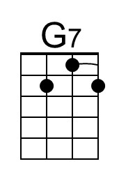
 | Bari |  | 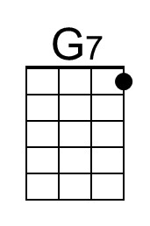

A “glim” is a candle or lantern
A “glim” is a candle or lantern
A “glim” is a candle or lantern

