**Edelweiss Key G**

**(Robin Spielberg / Richard Rodgers / Oscar Hammerstein)**

**C G C F**

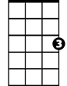

C

F

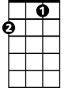

G

Edelweiss, edelweiss

**C Am Dm G7**

D7

Every morning you greet me

**C G C F**

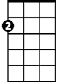

Am

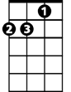

Dm

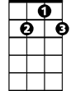

G7

Small and white, clean and bright

**C G7 C**

You look happy to meet me

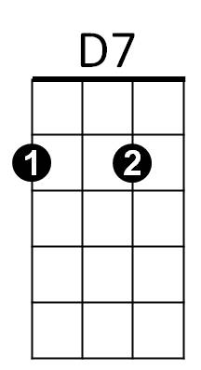**G C**

Blossom of snow may you bloom and grow

**F D7 G G7**

Bloom and grow, forever

**C G C F**

Edelweiss, edelweiss

**C G7 C**

Bless my homeland forever

**Repeat entire song, extend last line**

**BARITONE**

C



Am

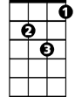

Dm

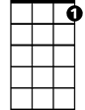

G7



D7



G

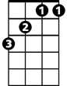

F

**Edelweiss Key G**

**(Robin Spielberg / Richard Rodgers / Oscar Hammerstein)**

**G D G C**



C

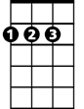

D



G

**BARITONE**

Edelweiss, edelweiss

**G Em Am D7**

Every morning you greet me

**G D G C**



Am

Em

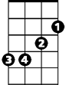

Small and white, clean and bright

**G D7 G**

You look happy to meet me

**D G**

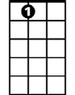

A7

Blossom of snow may you bloom and grow

**C A7 D D7**

Bloom and grow, forever

**G D G C**

Edelweiss, edelweiss

**G D7 G**

Bless my homeland forever

**Repeat entire song, extend last line**

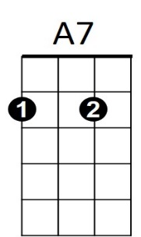



Em



D7



Am

C



D



G