**Eight Days A Week ( Lennon/McCartney) Key C**

**Intro: C D7 F C**



C

**BARITONE**

**C D7**

Ooh I need your love babe,

**F C**

Guess you know it's true.

**C D7**

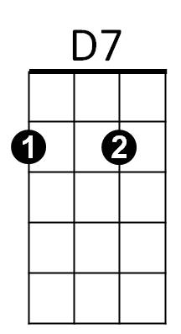Hope you need my love babe,

**F C**

Just like I need you.

**Chorus:**

**Am F Am D7**

Hold me, love me, hold me, love me.

F



**C D7**

I ain't got nothin' but love babe,

**F C**

Eight days a week.

**C D7**

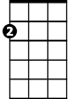

Am

Love you ev'ry day girl,

**F C**

Always on my mind.

**C D7**

One thing I can say girl,

**F C**

Love you all the time.



G

**(Chorus)**

**Bridge:**

**G**

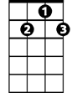

G7

Eight days a week –

**Am**

I lo – o - ve you.

**D7**

Eight days a week

**F G7**

Is not enough to show I care.

**C D7**

Ooh I need your love babe,

**F C**

Guess you know it's true.

**C D7**

Hope you need my love babe,

**F C**

Just like I need you.

C



**(Chorus)**

**(Bridge)**

**C D7**

Love you ev'ry day girl,



D7

**F C**

Always on my mind.

**C D7**

One thing I can say girl,

**F C**

Love you all the time.



F

**(Chorus)**

**(Outro)**

**F C**

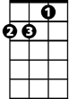

Am

Eight days a week,

**F C**

Eight days a week.

**C D7 F C**



G

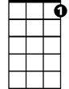

G7

**Eight Days A Week ( Lennon/McCartney) Key D**

**Intro: D E7 G D**

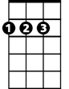

D

**BARITONE**

**D E7**

Ooh I need your love babe,

**G D**

Guess you know it's true.

**D E7**

Hope you need my love babe,

E7

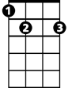

**G D**

Just like I need you.

**Chorus:**

**Bm G Bm E7**

Hold me, love me, hold me, love me.



G

**D E7**

I ain't got nothin' but love babe,

**G D**

Eight days a week.

**D E7**

Love you ev'ry day girl,

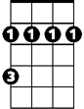

Bm

**G D**

Always on my mind.

**D E7**

One thing I can say girl,

**G D**

Love you all the time.

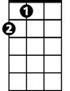

A

**(Chorus)**

**Bridge:**

**A**

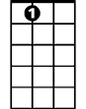

A7

Eight days a week –

**Bm**

I lo – o - ve you.

**E7**

Eight days a week

**G A7**

Is not enough to show I care.

**D E7**

Ooh I need your love babe,

**G D**

Guess you know it's true.

**D E7**

Hope you need my love babe,

**G D**

Just like I need you.



D

**(Chorus)**

**(Bridge)**

**D E7**



E7

Love you ev'ry day girl,

**G D**

Always on my mind.

**D E7**

One thing I can say girl,

**G D**



G

Love you all the time.

**(Chorus)**

**(Outro)**

Bm

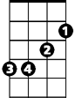

**G D**

Eight days a week,

**G D**

Eight days a week.

**D E7 G D**

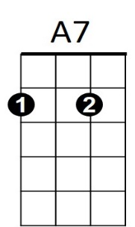



A

**Eight Days A Week ( Lennon/McCartney) Key D**

**Intro: G A7 C G**



G

**G A7**

Ooh I need your love babe,

**C G**

Guess you know it's true.

**G A7**



A7

Hope you need my love babe,

**C G**

Just like I need you.

**Chorus:**

**Em C Em A7**

Hold me, love me, hold me, love me.

**G A7**



C

I ain't got nothin' but love babe,

**C G**

Eight days a week.

**G A7**

Love you ev'ry day girl,

Em



**C G**

Always on my mind.

**G A7**

One thing I can say girl,

**C G**

Love you all the time.



D

**(Chorus)**

**Bridge:**

**D**

Eight days a week –

**Em**

I lo – o - ve you.

**A7**

Eight days a week

**C D7**

Is not enough to show I care.

**G A7**

Ooh I need your love babe,

**C G**

Guess you know it's true.

**G A7**

Hope you need my love babe,

**C G**

**BARITONE**

Just like I need you.



Em

C



G

**(Chorus)**

**(Bridge)**

**G A7**

Love you ev'ry day girl,

**C G**

Always on my mind.

**G A7**

One thing I can say girl,

**C G**

Love you all the time.

**(Chorus)**

**(Outro)**

**C G**

Eight days a week,

**C G**

Eight days a week.

**G A7 C G**



D7



D