End of the Line (Charlie T. Wilbury, Jr.) (G)
End Of The Line by Traveling Wilburys (1988) (G)
2/2 Time; Tempo ∫ = 84
*Echo = “at the end of the line”

Intro (8 measures) _C | C G G G | _C | C D G G | _ C | C D C D | G | G  G | G D C  Well it's all right, __ riding a-round in the breeze, well  G | G D G  Well it's all right, __ if you live the life you please, well  G | G D C  Well it's all right, __ doing the best you can, well  G | G D G | G  Well it's all right, __ as long as you lend a hand.  C G | G  _ You can sit around and wait for the phone to ring. (Echo)  C G | G  _ Waiting for someone to tell you everything. (Echo)  C G | G  _ Sit around and wonder what to-morrow will bring. (Echo)  D | D  _ _ Maybe a diamond ring.  G | G D C  Well it's all right, __ even if they say you're wrong, well  G | G D G  Well it's all right, __ sometimes you gotta be strong.  G | G D C  Well it's all right, __ as long as you got somewhere to lay, well  G | G D G | G  Well it's all right, __ every day is Judgment Day.  C G | G  _ Maybe somewhere down the road a ways (Echo)  C G | G  _ You'll think of me, wonder where I am these days (Echo)  C G | G  _ Maybe somewhere down the road when some-body plays (Echo)  D | D  _ _ Purple Haze. | 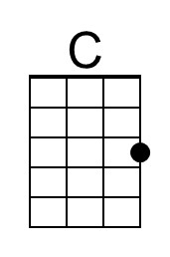
 | 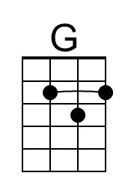
 | 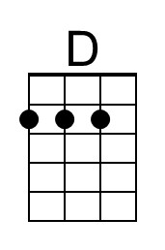
 | Bari
 | 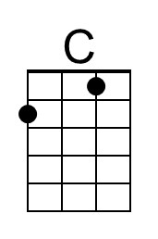
 | 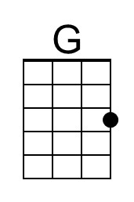
 | 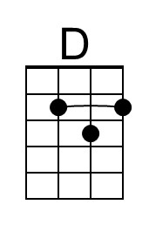

End of the Line (G) – Page 2
*Echo = “at the end of the line”

G | G D C
Well it's all right, __ even when push comes to shove.
G | G D G
Well it's all right, __ if you’ve got someone to love.
G | G D C
Well it's all right, __ everything'll work out fine.
G | G D G | G
Well it's all right, __ we're going to the end of the line.

C G | G
_ Don't have to be ashamed of the car I drive. (Echo)
C G | G
_ I'm just glad to be here, happy to be alive. (Echo)
C G | G
_ It don't matter if you're by my side. (Echo)
D | D
_ _ I'm satisfied.

G | G D C
Well it's all right, __ even if you're old and gray, well
G | G D G
Well it's all right, __ you still got something to say.
G | G D C
Well it's all right, __ remember to live and let live, well
G | G D G
Well it's all right, __ the best you can do is for-give.

G | G D C
Well it's all right, __ riding a-round in the breeze, well
G | G D G
Well it's all right, __ if you live the life you please.
G | G D C
Well it's all right, __ even if the sun don't shine, well
G | G D G | G
Well it's all right, __ we're going to the end of the line.

Outro (8 measures) _C | C G G G | _C | C D G G | _ C | C D C D | G | G

End of the Line (Charlie T. Wilbury, Jr.) (C)
End Of The Line by Traveling Wilburys (1988) (G)
2/2 Time; Tempo ∫ = 84
*Echo = “at the end of the line”

Intro (8 measures) _F | F C C C | _F | F G C C | _ F | F G F G | C | C  C | C G F  Well it's all right, __ riding a-round in the breeze, well  C | C G C  Well it's all right, __ if you live the life you please, well  C | C G F  Well it's all right, __ doing the best you can, well  C | C G C | C  Well it's all right, __ as long as you lend a hand.  F C | C  _ You can sit around and wait for the phone to ring. (Echo)  F C | C  _ Waiting for someone to tell you everything. (Echo)  F C | C  _ Sit around and wonder what to-morrow will bring. (Echo)  G | G  _ _ Maybe a diamond ring.  C | C G F  Well it's all right, __ even if they say you're wrong, well  C | C G C  Well it's all right, __ sometimes you gotta be strong.  C | C G F  Well it's all right, __ as long as you got somewhere to lay, well  C | C G C | C  Well it's all right, __ every day is Judgment Day.  F C | C  _ Maybe somewhere down the road a ways (Echo)  F C | C  _ You'll think of me, wonder where I am these days (Echo)  F C | C  _ Maybe somewhere down the road when some-body plays (Echo)  G | G  _ _ Purple Haze. | 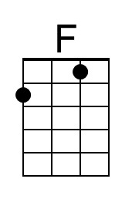
 | Bari
 | 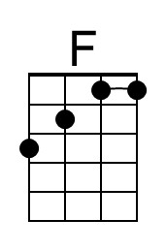

End of the Line (C) – Page 2
*Echo = “at the end of the line”

C | C G F
Well it's all right, __ even when push comes to shove.
C | C G C
Well it's all right, __ if you’ve got someone to love.
C | C G F
Well it's all right, __ everything'll work out fine.
C | C G C | C
Well it's all right, __ we're going to the end of the line.

F C | C
_ Don't have to be ashamed of the car I drive. (Echo)
F C | C
_ I'm just glad to be here, happy to be alive. (Echo)
F C | C
_ It don't matter if you're by my side. (Echo)
G | G
_ _ I'm satisfied.

C | C G F
Well it's all right, __ even if you're old and gray, well
C | C G C
Well it's all right, __ you still got something to say.
C | C G F
Well it's all right, __ remember to live and let live, well
C | C G C
Well it's all right, __ the best you can do is for-give.

C | C G F
Well it's all right, __ riding a-round in the breeze, well
C | C G C
Well it's all right, __ if you live the life you please.
C | C G F
Well it's all right, __ even if the sun don't shine, well
C | C G C | C
Well it's all right, __ we're going to the end of the line.

Outro (8 measures) _C | F C C C | _F | F G C C | _ F | F G F G | C | C

End of the Line (Charlie T. Wilbury, Jr.) (D)
End Of The Line by Traveling Wilburys (1988) (G)
2/2 Time; Tempo ∫ = 84
*Echo = “at the end of the line”

Intro (8 measures) _G | G D D D | _G | G A D D | _ G | G A G A | D | D

D | D A G
Well it's all right, __ riding a-round in the breeze, well
D | D A D
Well it's all right, __ if you live the life you please, well
D | D A G
Well it's all right, __ doing the best you can, well
D | D A D | D
Well it's all right, __ as long as you lend a hand.

G D | D
_ You can sit around and wait for the phone to ring. (Echo)
G D | D
_ Waiting for someone to tell you everything. (Echo)
G D | D
_ Sit around and wonder what to-morrow will bring. (Echo)
A | A
_ _ Maybe a diamond ring.

D | D A G
Well it's all right, __ even if they say you're wrong, well
D | D A D
Well it's all right, __ sometimes you gotta be strong.
D | D A G
Well it's all right, __ as long as you got somewhere to lay, well
D | D A D | D
Well it's all right, __ every day is Judgment Day.

G D | D
_ Maybe somewhere down the road a ways (Echo)
G D | D
_ You'll think of me, wonder where I am these days (Echo)
G D | D
_ Maybe somewhere down the road when some-body plays (Echo)
A | A
_ _ Purple Haze.
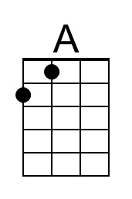
Bari
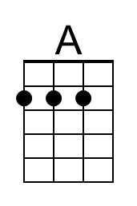

End of the Line (D) – Page 2
*Echo = “at the end of the line”

D | D A G
Well it's all right, __ even when push comes to shove.
D | D A D
Well it's all right, __ if you’ve got someone to love.
D | D A G
Well it's all right, __ everything'll work out fine.
D | D A D | D
Well it's all right, __ we're going to the end of the line.

G D | D
_ Don't have to be ashamed of the car I drive. (Echo)
G D | D
_ I'm just glad to be here, happy to be alive. (Echo)
G D | D
_ It don't matter if you're by my side. (Echo)
A | A
_ _ I'm satisfied.

D | D A G
Well it's all right, __ even if you're old and gray, well
D | D A D
Well it's all right, __ you still got something to say.
D | D A G
Well it's all right, __ remember to live and let live, well
D | D A D
Well it's all right, __ the best you can do is for-give.

D | D A G
Well it's all right, __ riding a-round in the breeze, well
D | D A D
Well it's all right, __ if you live the life you please.
D | D A G
Well it's all right, __ even if the sun don't shine, well
D | D A D | D
Well it's all right, __ we're going to the end of the line.

Outro (8 measures) _G | G D D D | _G | G A D D | _ G | G A G A | D | D

End of the Line (Charlie T. Wilbury, Jr.) (F)
End Of The Line by Traveling Wilburys (1988) (G)
2/2 Time; Tempo ∫ = 84
*Echo = “at the end of the line”

Intro (8 measures)  _ Bb | Bb F F F | _Bb | Bb C F F | _ Bb | Bb C Bb C | F | F  F | F C Bb  Well it's all right, __ riding a-round in the breeze, well  F | F C F  Well it's all right, __ if you live the life you please, well  F | F C Bb  Well it's all right, __ doing the best you can, well  F | F C F | F  Well it's all right, __ as long as you lend a hand.  Bb F | F  _ You can sit around and wait for the phone to ring. (Echo)  Bb F | F  _ Waiting for someone to tell you everything. (Echo)  Bb F | F  _ Sit around and wonder what to-morrow will bring. (Echo)  C | C  _ _ Maybe a diamond ring.  F | F C Bb  Well it's all right, __ even if they say you're wrong, well  F | F C F  Well it's all right, __ sometimes you gotta be strong.  F | F C Bb  Well it's all right, __ as long as you got somewhere to lay, well  F | F C F | F  Well it's all right, __ every day is Judgment Day.  Bb F | F  _ Maybe somewhere down the road a ways (Echo)  Bb F | F  _ You'll think of me, wonder where I am these days (Echo)  Bb F | F  _ Maybe somewhere down the road when some-body plays (Echo)  C | C  _ _ Purple Haze. | 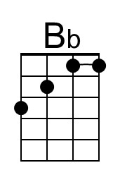
 | Bari
 | 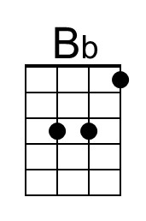

End of the Line (F) – Page 2
*Echo = “at the end of the line”

F | F C Bb
Well it's all right, __ even when push comes to shove.
F | F C F
Well it's all right, __ if you’ve got someone to love.
F | F C Bb
Well it's all right, __ everything'll work out fine.
F | F C F | F
Well it's all right, __ we're going to the end of the line.

Bb F | F
_ Don't have to be ashamed of the car I drive. (Echo)
Bb F | F
_ I'm just glad to be here, happy to be alive. (Echo)
Bb F | F
_ It don't matter if you're by my side. (Echo)
C | C
_ _ I'm satisfied.

F | F C Bb
Well it's all right, __ even if you're old and gray, well
F | F C F
Well it's all right, __ you still got something to say.
F | F C Bb
Well it's all right, __ remember to live and let live, well
F | F C F
Well it's all right, __ the best you can do is for-give.

F | F C Bb
Well it's all right, __ riding a-round in the breeze, well
F | F C F
Well it's all right, __ if you live the life you please.
F | F C Bb
Well it's all right, __ even if the sun don't shine, well
F | F C F | F
Well it's all right, __ we're going to the end of the line.

Outro (8 measures) _ Bb | Bb F F F | _Bb | Bb C F F | _ Bb | Bb C Bb C | F | F

