End of the Line (Charlie T. Wilbury, Jr.)
End Of The Line by Traveling Wilburys (1988)
2/2 Time; Tempo ∫ = 84
*Echo = “at the end of the line”

Intro (8 measures) C | C G G G | C | C D G G | C | C D C D | G | G  G | G D C  Well it's all right, __ riding a-round in the breeze  G | G D G  Well it's all right, __ if you live the life you please  G | G D C  Well it's all right, __ doing the best you can  G | G D G | G  Well it's all right, __ as long as you lend a hand  C G | G  _ You can sit around and wait for the phone to ring (Echo)  C G | G  _ Waiting for someone to tell you everything (Echo)  C G | G  _ Sit around and wonder what to-morrow will bring (Echo)  D | D  _ _ Maybe a diamond ring  G | G D C  Well it's all right, __ even if they say you're wrong  G | G D G  Well it's all right, __ sometimes you gotta be strong  G | G D C  Well it's all right, __ as long as you got somewhere to lay  G | G D G | G  Well it's all right, __ every day is Judgment Day  C G | G  _ Maybe somewhere down the road a ways (Echo)  C G | G  _ You'll think of me, wonder where I am these days (Echo)  C G | G  _ Maybe somewhere down the road when some-body (Echo)  D | D  _ _ Plays Purple Haze | 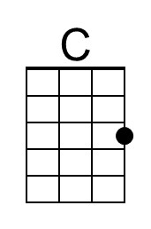
 | 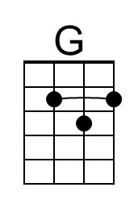
 | 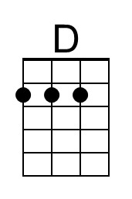
 | Bari
 | 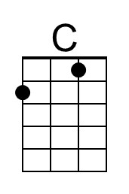
 | 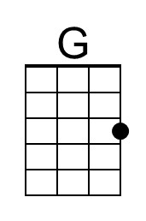
 | 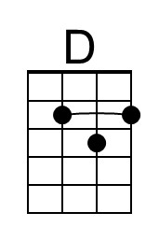

End of the Line – Page 2

*Echo = “at the end of the line”

G | G D C
Well it's all right, __ even when push comes to shove
G | G D G
Well it's all right, __ if you’ve got someone to love
G | G D C
Well it's all right, __ everything'll work out fine
G | G D G | G
Well it's all right, __ we're going to the end of the line

C G | G
_ Don't have to be ashamed of the car I drive (Echo)
C G | G
_ I'm just glad to be here, happy to be alive (Echo)
C G | G
_ It don't matter if you're by my side (Echo)
D | D
_ _ I'm satisfied

G | G D C
Well it's all right, __ even if you're old and gray
G | G D G
Well it's all right, __ you still got something to say
G | G D C
Well it's all right, __ remember to live and let live
G | G D G
Well it's all right, __ the best you can do is for-give

G | G D C
Well it's all right, __ riding a-round in the breeze
G | G D G
Well it's all right, __ if you live the life you please
G | G D C
Well it's all right, __ even if the sun don't shine
G | G D G | G
Well it's all right, __ we're going to the end of the line

Outro C | G | C | G | C | D C | G

