End of the Line (Charlie T. Wilbury, Jr.)
End Of The Line by Traveling Wilburys (1988) (G)
2/2 Time; Tempo ∫ = 84
*Echo = “at the end of the line”

Intro (8 measures) _C | C G G G | _C | C D G G | _ C | C D C D | G | G  G | G D C  Well it's all right, __ riding a-round in the breeze, well  G | G D G  Well it's all right, __ if you live the life you please, well  G | G D C  Well it's all right, __ doing the best you can, well  G | G D G | G  Well it's all right, __ as long as you lend a hand.  C G | G  _ You can sit around and wait for the phone to ring. (Echo)  C G | G  _ Waiting for someone to tell you everything. (Echo)  C G | G  _ Sit around and wonder what to-morrow will bring. (Echo)  D | D  _ _ Maybe a diamond ring.  G | G D C  Well it's all right, __ even if they say you're wrong, well  G | G D G  Well it's all right, __ sometimes you gotta be strong.  G | G D C  Well it's all right, __ as long as you got somewhere to lay, well  G | G D G | G  Well it's all right, __ every day is Judgment Day.  C G | G  _ Maybe somewhere down the road a ways (Echo)  C G | G  _ You'll think of me, wonder where I am these days (Echo)  C G | G  _ Maybe somewhere down the road when some-body plays (Echo)  D | D  _ _ Purple Haze. | 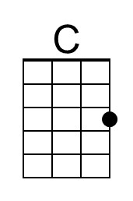
 | 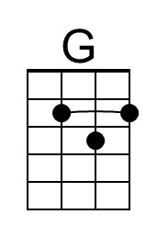
 | 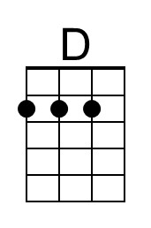
 | Bari
 | 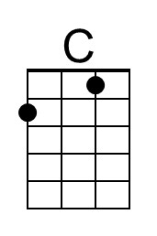
 | 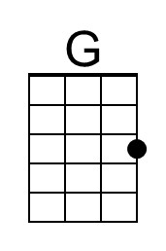
 | 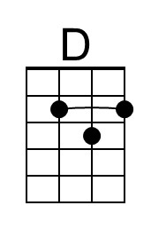

End of the Line – Page 2

*Echo = “at the end of the line”

G | G D C
Well it's all right, __ even when push comes to shove.
G | G D G
Well it's all right, __ if you’ve got someone to love.
G | G D C
Well it's all right, __ everything'll work out fine.
G | G D G | G
Well it's all right, __ we're going to the end of the line.

C G | G
_ Don't have to be ashamed of the car I drive. (Echo)
C G | G
_ I'm just glad to be here, happy to be alive. (Echo)
C G | G
_ It don't matter if you're by my side. (Echo)
D | D
_ _ I'm satisfied.

G | G D C
Well it's all right, __ even if you're old and gray, well
G | G D G
Well it's all right, __ you still got something to say.
G | G D C
Well it's all right, __ remember to live and let live, well
G | G D G
Well it's all right, __ the best you can do is for-give.

G | G D C
Well it's all right, __ riding a-round in the breeze, well
G | G D G
Well it's all right, __ if you live the life you please.
G | G D C
Well it's all right, __ even if the sun don't shine, well
G | G D G | G
Well it's all right, __ we're going to the end of the line.

Outro (8 measures) _C | C G G G | _C | C D G G | _ C | C D C D | G | G

