Enjoy Yourself (Carl Sigman and Herb Magidson) (C)

Chorus:  C G7  En-joy yourself, it's later than you think.  C  Enjoy yourself, while you're still in the pink.  C C7 F  The years go by, as quickly as a wink.  F C Dm G7 C  Enjoy yourself, en-joy yourself, it's later than you think!  C G7  You work and work for years and years, you're always on the go  G7 C  You never take a minute off, too busy makin' dough  C C7 F  Some-day, you say, you'll have your fun, when you're a million-aire  F C Dm G7 C  But tell me how much fun you'll have in your old rockin' chair. Chorus  C G7  You're gonna take that ocean trip, no matter, come what may  G7 C  You've got your reservations made, but you just can't get a-way  C C7 F  Next year for sure, you'll see the world, you'll really get a-round  F C Dm G7 C  But how far can you travel when you're six feet under-ground? Chorus |  |  |  |  |  |  | 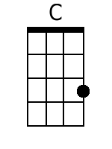
 |  |  |  |  |  |  | 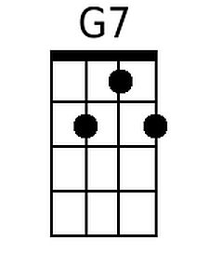
 |  |  |  |  |  |  | 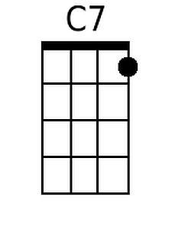
 |  |  |  |  |  |  | 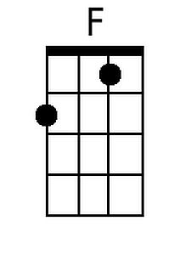
 |  |  |  |  |  |  | 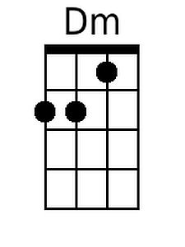
Baritone
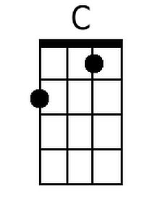 | 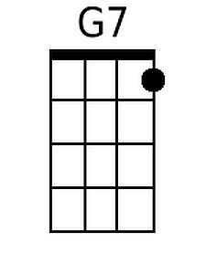 | 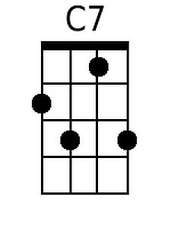 | 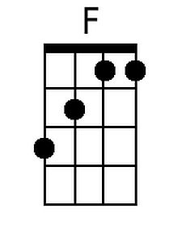 | 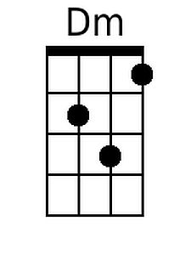

Enjoy Yourself (C) – Page 2

C G7
Your heart of hearts, your dream of dreams, your ravishing brunette
G7 C
She's left you and she's now become somebody else's pet
C C7 F
Lay down that gun, don't try, my friend, to reach the great be-yond
F C Dm G7 C
You'll have more fun by reaching for a red head or a blonde. Chorus

C G7
You never go to nightclubs and you just don't care to dance;
G7 C
You don't have time for silly things like moonlight and ro-mance.
C C7 F
You only think of dollar bills tied neatly in a stack;
F C Dm G7 C
But when you kiss a dollar bill, it doesn't kiss you back. Chorus

C G7
You love somebody very much, you'd like to set the date
G7 C
But money doesn't grow on trees so you decide to wait
C C7 F
You're so afraid that you will bite off more than you can chew
F C Dm G7 C
Don't be afraid, you won't have teeth when you reach nine - ty two. Chorus

Enjoy Yourself (Carl Sigman and Herb Magidson) (G)

Chorus:  G D7  En-joy yourself, it's later than you think.  G  Enjoy yourself, while you're still in the pink.  G G7 C  The years go by, as quickly as a wink.  C G Am D7 G  Enjoy yourself, en-joy yourself, it's later than you think!  G D7  You work and work for years and years, you're always on the go  D7 G  You never take a minute off, too busy makin' dough  G G7 C  Some-day, you say, you'll have your fun, when you're a million-aire  C G Am D7 G  But tell me how much fun you'll have in your old rockin' chair. Chorus  G D7  You're gonna take that ocean trip, no matter, come what may  D7 G  You've got your reservations made, but you just can't get a-way  G G7 C  Next year for sure, you'll see the world, you'll really get a-round  C G Am D7 G  But how far can you travel when you're six feet under-ground? Chorus |  |  |  |  |  |  | 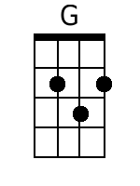
 |  |  |  |  |  |  | 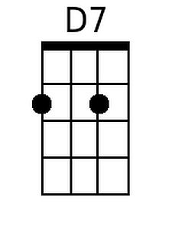
 |  |  |  |  |  |  | 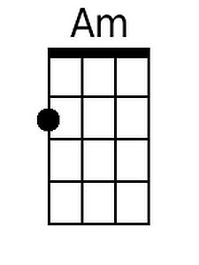
Baritone
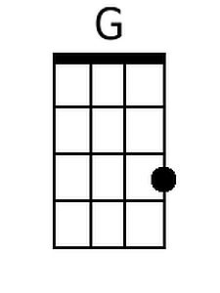 | 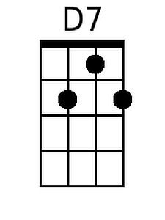 |  |  | 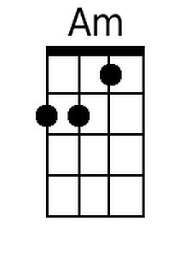

Enjoy Yourself (G) – Page 2

G D7
Your heart of hearts, your dream of dreams, your ravishing brunette
D7 G
She's left you and she's now become somebody else's pet
G G7 C
Lay down that gun, don't try, my friend, to reach the great be-yond
C G Am D7 G
You'll have more fun by reaching for a red head or a blonde. Chorus

G D7
You never go to nightclubs and you just don't care to dance;
D7 G
You don't have time for silly things like moonlight and ro-mance.
G G7 C
You only think of dollar bills tied neatly in a stack;
C G Am D7 G
But when you kiss a dollar bill, it doesn't kiss you back. Chorus

G D7
You love somebody very much, you'd like to set the date
D7 G
But money doesn't grow on trees so you decide to wait
G G7 C
You're so afraid that you will bite off more than you can chew
C G Am D7 G
Don't be afraid, you won't have teeth when you reach nine - ty two. Chorus

