Every Breath You Take (Sting, 1983) (C)
Every Breath You Take by The Police (C# – 117 bpm)

Intro | C | C | Am | Am | F | G | C  C Am  _ Every breath you take, and every move you make,  F Gsus4 | Am  Every bond you break, _ every step you take, ____ I'll be watching you.  G7sus4 C Am  Every single day and every word you say. Every game you play,  F G Gsus4 | C  _ Every night you stay, __ I'll be watching you.  Bridge  C F Dm7 C  _ Oh can't you see you belong to me?  D7 G  How my poor heart aches with every step you take.  G7sus4 C Am  Every move you make, every vow you break, Every smile you fake,  F G Gsus4 | Am  _ Every claim you stake, _ I'll be watch - ing you.  Ab  _ Since you've gone, I've been lost without a trace.  Bb  _ I dream at night I can only see your face.  Ab  _ I look around but it's you I can't replace.  Bb  _ I feel so cold and I long for your embrace.  Ab  _ I keep crying, baby, baby, please.  Instrumental | E | E | C#m | C#m | A | B | C#m | Repeat Bridge  F G | Am  Every move you make, _ every step you take, _ I'll be watching you.  F C F C  _ I'll be watching you. __ I'll be watching you.  F C F C  _ I'll be watching you. __ I'll be watching you. |  |  |  |  |  |  |  |  | 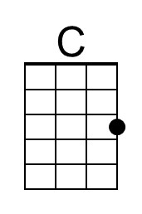 |  | 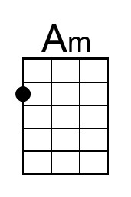
 |  |  |  |  |  |  |  |  | 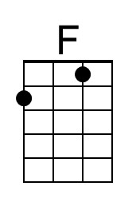 |  | 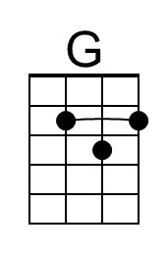
 |  |  |  |  |  |  |  |  | 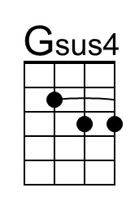 |  | 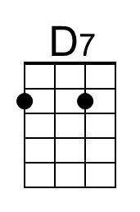
 |  |  |  |  |  |  |  |  | 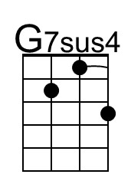 |  | 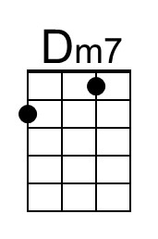
 |  |  |  |  |  |  |  |  | 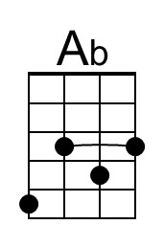 |  | 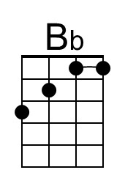
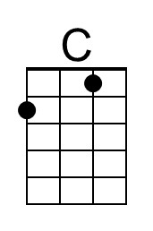 | 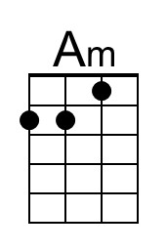 | 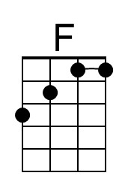 | 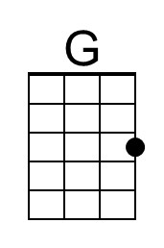 | 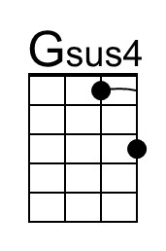 | 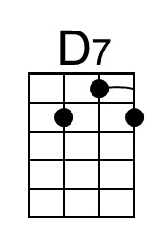 | 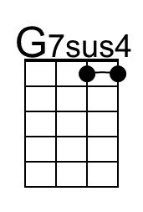 | 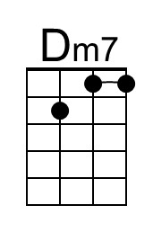 | 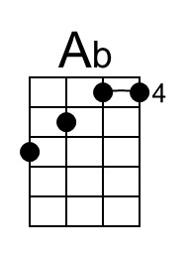 |  | 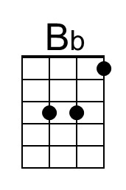

Every Breath You Take (Sting, 1983) (G)
Every Breath You Take by The Police (C# – 117 bpm)

Intro | G | G | Em | Em | C | D | G  G Em  _ Every breath you take, and every move you make,  C Dsus4 | Em  Every bond you break, _ every step you take, ____ I'll be watching you.  D7sus4 G Em  Every single day and every word you say. Every game you play,  C D Dsus4 | G  _ Every night you stay, __ I'll be watching you.  Bridge  G C Am7 G  _ Oh can't you see you belong to me?  A7 D  How my poor heart aches with every step you take.  D7sus4 G Em  Every move you make, every vow you break, Every smile you fake,  C D Dsus4 | Em  _ Every claim you stake, _ I'll be watch - ing you.  Eb  _ Since you've gone, I've been lost without a trace.  F  _ I dream at night I can only see your face.  Eb  _ I look around but it's you I can't replace.  F  _ I feel so cold and I long for your embrace.  Eb  _ I keep crying, baby, baby, please.  Instrumental | G | G | Em | Em | C | D | Em | Repeat Bridge  C D | Em  Every move you make, _ every step you take, _ I'll be watching you.  C G C G  _ I'll be watching you. __ I'll be watching you.  C G C G  _ I'll be watching you. __ I'll be watching you. |  |  |  |  |  |  |  |  |  |  | 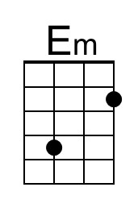
 |  |  |  |  |  |  |  |  |  |  | 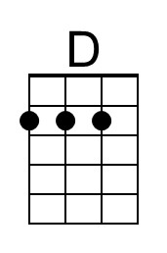
 |  |  |  |  |  |  |  |  | 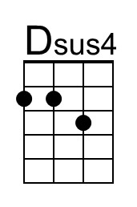 |  | 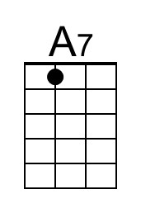
 |  |  |  |  |  |  |  |  | 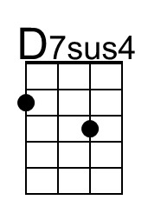 |  | 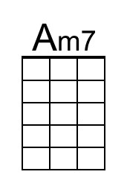
 |  |  |  |  |  |  |  |  | 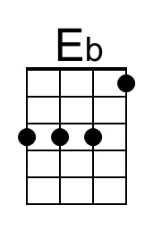
 | 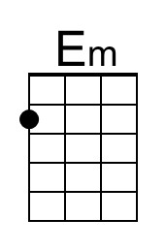 |  | 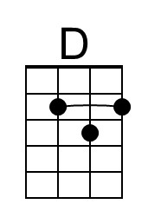 | 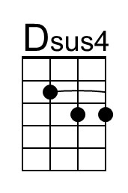 | 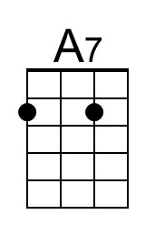 | 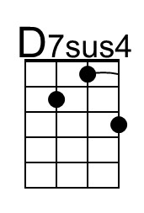 | 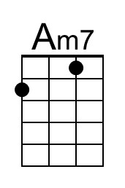 | 