**Every Breath You Take (Sting)**

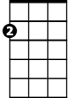

Am



C

**Intro: C Am F G Am**

**C** **Am**

Every breath you take every move you make

**F** **G Am**

Every bond you break every step you take, I'll be watching you

**C** **Am**

Every single day every word you say

**F** **G C**

Every game you play every night you stay, I'll be watching you

**Chorus:**

**F**  **C**

Oh, can' t you see, you belong to me

**Am D7** **G G7**

How my poor heart aches, with every step you take

**C** **Am**

Every move you make, every vow you break

**F** **G** **Am**

Every smile you fake every claim you stake, I'll be watching you

**Bridge:**

**G# Bb**

Since you've gone, I've been lost without a trace

**G#**

I dream at night I can only see your face

**Bb**

I look around but it's you I can't replace

**G#**

I feel so cold and I long for your embrace

**Bb Dm C G**

I keep crying baby, baby pl - ea - se

**(Intro) + (Chorus)**

**C** **Am**

Every move you make, every vow you break

**F** **G** **Am**

Every smile you fake every claim you stake, I'll be watching you

**F** **G** **Am**

Every move you make, every step you take, I'll be watching you

**(Hold 4 beats)**

**C**

I'll be watching you (Every move you make,



G

F



**Am F**

Every vow you break, every step you take)

**G**  **C**

I'll be watching you (Every move you make,

**Am F**

Every vow you break, every step you take)

**G**  **C**  **Am**

I'll be watching you, I'll be watching you,

**F** **G** **C**

Every move you make, every step you take, I'll be watching you



Bb

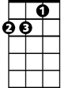

Dm

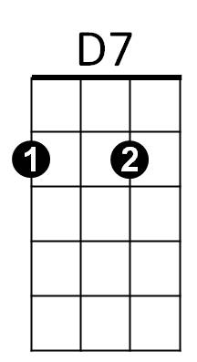

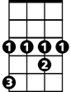

G#

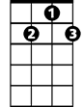

G7

C



D7



F



G



Am

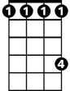

G#

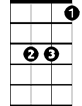

Bb

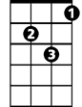

Dm

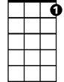

G7

**BARITONE**