**Everybody's Working for the Weekend (Paul Dean / Matthew Frenette / Mike Reno) Key A**

**Intro: Asus4 A**

**A F A**

Everyone's watching to see what you will do

**A F#m G**

Everyone's looking at you... Oh

**A F A**

Everyone's wondering will you come out tonight?

**A F#m G**

Everyone's trying to get it right, get it right

**Chorus:**

**C F**

Everybody's working for the weekend

**C F**

Everybody wants a new romance

**C F**

Everybody's going off the dee p end

**C F**

Everybody needs a second chance, Whoa oh

**TACET Asus4 A**

You wanna piece of my heart?

**Asus4 A**

You better start from the start

**Asus4 A**

You wannna be in the show?

**F**

Come on baby, let's go!

**F C / F C / F C A**

**A F A**

Everyone's looking to see if it was you

**A F#m G**

Everyone wants you to come through

**A F A**

Everyone's hoping it'll all work out

**A F#m G**

Everyone's waiting, they're holding out!

**(Chorus)**

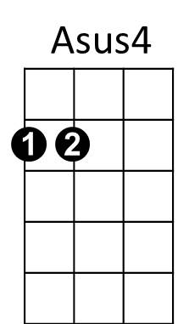



G

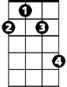

F#m

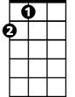

A

F



**TACET Asus4 A**

You wanna piece of my heart?

**Asus4 A**

You better start from the start

**Asus4 A**

You wannna be in the show?

**F F Am F Am**

Come on baby, let's go!

**F C / F C / F C A**

Hey!

**Asus4 A**

You wanna piece of my heart?

**Asus4 A**

You better start from the start

**Asus4 A**

You wannna be in the show?

**Asus4 A**

Come on baby, let's go

**Asus4 A**

You wanna piece of my heart?

**Asus4 A**

You better start from the start

**Asus4 A**

You wannna be in the show?

**F**

Come on baby, let's go!

**F C / F C / F C A**

**BARITONE**

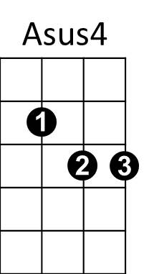



F

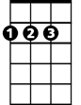

A

C



G

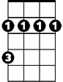

F#m



C