**Everyone’s Gone to the Moon (Kenneth King)**

**C F G 2x**

Em

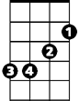

C

F



G

**C G F G**

Streets full of people all alone

**C G F G**

Roads full of houses never home

**F C F C**

Church full of singing out of tune

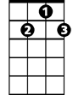

G7

**F G C F G**

Everyone's gone to the moon

**C G F G**

Eyes full of sor row, never wet

**C G F G**

Hands full of money, all in debt

**F C F C**

Sun coming out in the middle of June

**F G C F G**

Everyone's gone to the moon



G



F

**BARITONE**

C



**G**

Long time ago, life had begun

**F Em G G7**

Everyone went to the sun

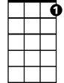

G7

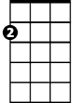

Em

**C G F G**

Parks full of motors, painted green

**C G F G**

Mouths full of chocolate, covered cream

**F C F C**

Arms that can only lift a spoon

**F G C F G**

Everyone's gone to the moon

**F G C F G**

Everyone's gone to the moon

**F G C**

Everyone's gone to the moon

**Everyone’s Gone to the Moon (Kenneth King)**

**G C D 2x**

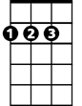

D



G



C

**G D C D**

Streets full of people all alone

**G D C D**

Roads full of houses never home

**C G C G**

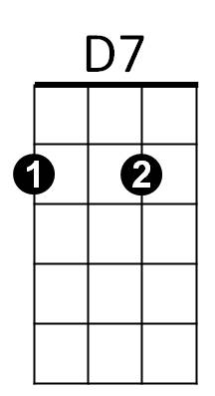Church full of singing out of tune

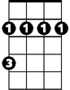

Bm

**C D G C D**

Everyone's gone to the moon

**G D C D**

Eyes full of sor row, never wet

**G D C D**

Hands full of money, all in debt

**C G C G**

Sun coming out in the middle of June

**C D G C D**

Everyone's gone to the moon



G

C



D

**BARITONE**

**D**

Long time ago, life had begun

**C Bm D D7**

Everyone went to the sun

**G D C D**



D7

Bm



Parks full of motors, painted green

**G D C D**

Mouths full of chocolate, covered cream

**C G C G**

Arms that can only lift a spoon

**C D G C D**

Everyone's gone to the moon

**C D G C D**

Everyone's gone to the moon

**C D G**

Everyone's gone to the moon