**Faithless Love (John David Souther)**

**Intro: C Eb Ab G**

**C F C**

Faithless love like a river flows

**Am G F**

Raindrops fal - ling on a broken rose

**C F**

Down in some valley where nobody goes

**C G F**

And the night blows in

**C G F**

Like the cold dark wind

**C Eb Ab G**

Faithless love

**C Eb Ab G**

Like a river flows

**C F C**

Faithless love where did I go wrong

**Am G F**

Was it telling sto - ries in a heartbreak song

**C F**

Where nobody's right and nobody was wrong



G

**C F**

Faithless love will find you

**C F**

And the misery entwine you

**C Eb Ab G**

Faithless love

**C Eb Ab G**

**BARITONE**

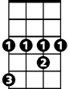

Eb

C

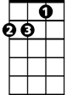

Am



F



G

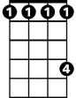

Ab

Where did I go wrong

**Eb F**

Well, I guess I'm stan - ding

**C Am F**

in the hall of broken dreams

**G C**

That's the way it sometimes goes

**Eb F C**

Whenever a new love never turns out

**Am F**

like it seems

**G F G**

Guess the feeling comes and goes

**C F C**

Faithless love like a river flows

**Am G F**

Raindrops fal - ling on a broken rose

**C F**

Down in some valley where nobody goes

**C F**

Faithless love has found me

**C F**

Thrown it's chilly arms around me

**C Eb Ab G**

Faithless love

**C Eb Ab G C**

Like a ri - ver flows

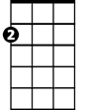

Am

F



Ab

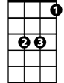

Eb



C