**Fare Away (Michael John Mckean / Annette O'toole / Jeffery Lynn Vanston)**

**(Performed by The Main Street Singers from 'A Mighty Wind’)**

**Intro: G / C Cmaj7 D G (Chorus 1 melody)**

**G C G**

Sun breaks over the sprits'l yard,

**C Cmaj7 A7 D**

Jib sheet's haulin' to lee-ward hard.

**G C G**

Crosstree's hummin' a mornin' hymn,

**C Cmaj7 D G D G**

I'm the cabin boy; call me Jim. (His name's Jim).

**G**

Fare away, fare away, under main top sail,

**C Cmaj7 D G**

To the fur-be-low of the wily wha...le.

**G C G**

Captain's stalking the quarter-deck,

**C Cmaj7 A7**  **D**

Tells the tale of his first ship-wreck.

**G C G**

Castaway with a case of rum,

**C Cmaj7 D G**

Hoped that rescue would never come, (never come).



C

**G**

Fare away, fare away, under main top sail,

**C Cmaj7 D G**

To the fur-be-low of the wily whale.

**C Cmaj7 D**

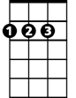

D

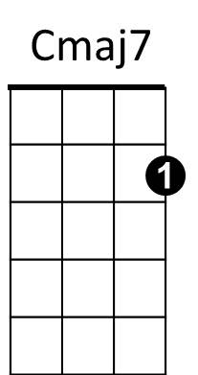To the fur-be-low of the wi-ly, wi-ly...

**(Verse melody)**

**G C G**

First mate Adam's a hardened man,

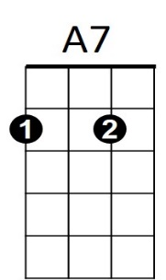**C Cmaj7**  **A7 D**

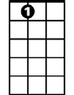

A7

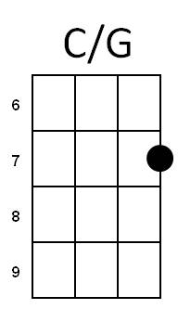 Says the captain's a charla-tan.

**G C G**

Don't know tackle from futtock plates,

**C Cma7 D G**

He'll sail us into the Pear...ly Gates.

**G**

Fare away, fare away, under main top sail,

**C Cmaj7 D G**

To the fur-be-low of the wily wha...le.

**G C G**

I been sailin' these seven seas,

**C Cmaj7 A7 D**

Since I's nigh high to a mermaid's knees.

**G C G**

Come next April I'm sixty-three,

**C G C G**

I can't ad-vance! (I like short pants!)

**Am Em D G**

Safe in the cabin on the open sea.

**C Cmaj7 D G**

Safe in the cabin on the open sea.

**G**

Fare away, fare away, under main top sail,

**C Cmaj7 D G**

To the fur-be-low of the wily wha...le.

**C Cmaj7 C Cmaj7**

To the fur-be-low of, to the fur-be-low of.

**C Cmaj7 D C/G G**

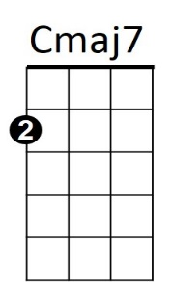To the fur-be-low of the wily, wi-ly wha...le.



D

**BARITONE**

C



G



G