Fire (Bruce Springsteen) (C)

Intro: C / F // C/ - C // F // C/ - C / F // C/  TACET G C// G/ C// G/  I'm driving in my car, I turn on the radio  Dm C F// C/  I'm pulling you close, you just say no  Dm Am  You say you dont like it, but girl I know you're a liar  C D G C G - G // C // G/ - G / C // G/ (pause)  `Cause when we kiss - ooh, - Fi - re  TACET G C// G/ C// G/  Late at night - I'm takin you home  Dm C F// C/  I say I wanna stay, you say you wanna be alone  Dm Am  You say you don't love me, girl - you can't hide your desire  F G C F C - C // F // C/ - C / F // C/ - ////  `Cause when we kiss - ooh, - Fi - re  F C  You had a hold on me, right from the start  G C  A grip so tight I couldn't tear it apart  F C  My nerves all jumpin' actin' like a fool  D G G7  Well your kisses they burn but your heart - stays - cool  TACET G C// G/ C G  Romeo and Juliet, Samson and Deli - lah  Dm C F// C/  Baby you can bet - their love, they didn't deny  Dm Am  Your words say split - but your words they lie  F G  `Cause when we kiss - ooh  C / F // C/ - C // F // C/ - C / F // C/ - C // F // C/ (REPEAT TO FADE)  F - i - re F - i- re |  |  |  |  |  |  | 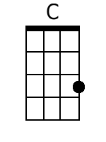
 |  |  |  |  |  |  | 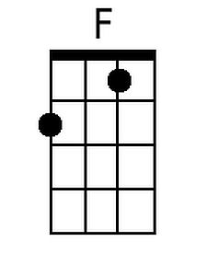
 |  |  |  |  |  |  | 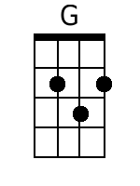
 |  |  |  |  |  |  | 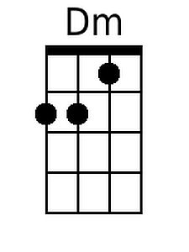
 |  |  |  |  |  |  | 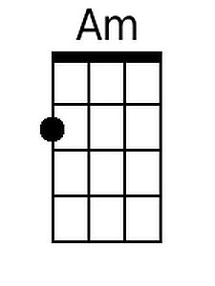
Bari
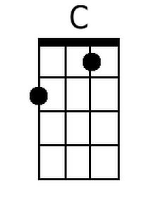 | 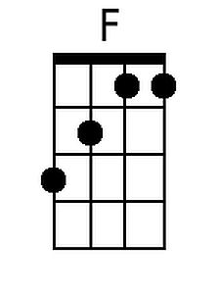 | 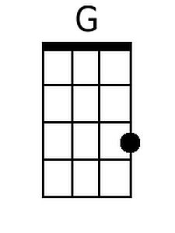 | 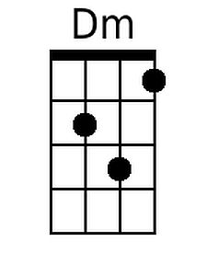 | 