**Fire (Bruce Springsteen)**

**Intro: G / C // G/ - G // C // G/ - G / C // G/**



G



C

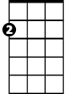

Am

**TACET G C// G/ C// G/**

I’m driving in my car, I turn on the radio

**Am G C// G/**

I’m pulling you close, you just say no

**Am Em**

You say you dont like it, but girl I know you’re a liar

**C D G C G - G // C // G/ - G / C // G/ (pause)**

`Cause when we kiss - ooh, - Fi - re

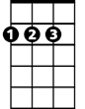

D

Em

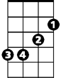

**TACET G C// G/ C// G/**

Late at night - I’m takin you home

**Am G C// G/**

I say I wanna stay, you say you wanna be alone

**Am Em**

You say you don’t love me, girl - you can’t hide your desire

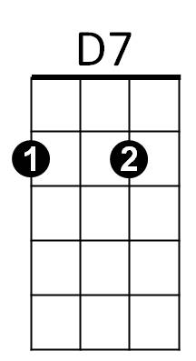 **C D G C G - G // C // G/ - G / C // G/ - ////**

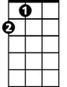

A

`Cause when we kiss - ooh, - Fi - re

**C G**

You had a hold on me, right from the start

**D G**

A grip so tight I couldn't tear it apart

**C G**

My nerves all jumpin’ actin’ like a fool

**BARITONE**

**A D D7**



A



Em

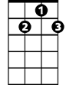

D7



D

C

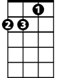

Am



G

Well your kisses they burn but your heart – stays - cool

**TACET G C// G/ C G**

Romeo and Juliet, Samson and Deli - lah

**Am G C// G/**

Baby you can bet - their love, they didn’t deny

**Am Em**

Your words say split - but your words they lie

**C D**

`Cause when we kiss - ooh

**G / C// G / G// C // G/ - G / C// G / G// C // G/ (REPEAT TO FADE)**

F – i - re F - i- re