Fire and Rain (James Taylor) (C)

Intro: C Gm F C / C G Bb  C Gm  Just yesterday morning  F C  They let me know you were gone.  G  Susanne, the plans they made,  Bb  Put an end to you.  C Gm  I walked out this morning  F C  And I wrote down this song,  G Bb  I just can't remember who to send it to.  Chorus  F G C  I've seen fire and I've seen rain,  F  I've seen sunny days  G C  That I thought would never end.  F  I've seen lonely times  Dm G C  When I could not find a friend,  Bb Gm C  But I always thought that I'd see you again.  C Gm  Won't you look down upon me, Jesus  F C  You got to help me make a stand,  G Bb  You just got to see me through another day.  C Gm F C  My body's aching and my time is at hand,  G Bb  I won't make it any other way. Chorus. |  |  |  | C Gm  I've been walking my mind to an easy time,  F C  My back turned towards the sun.  G  Lord knows when the cold wind blows  Bb  It'll turn your head around.  C  Well, there's hours of time  Gm  On the telephone line  F C  To talk about things to come,  G  Sweet dreams and flying machines  Bb  In pieces on the ground.  F G C  Oh, I've seen fire and I've seen rain,  F  I've seen sunny days  G C  That I thought would never end.  F  I've seen lonely times  Dm G C  When I could not find a friend,  Bb Gm  But I always thought that I'd see you, baby,  C C7  One more time again.  F Gm C  Thought I see - you one more time again.  F Gm  There's just a few things coming my way  C  This time around now.  F Gm  Thought I see, thought I see you  C Gm F C  Fire and rain, now |  |  |  | 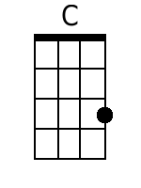
 |  |  |  |  |  |  |  | 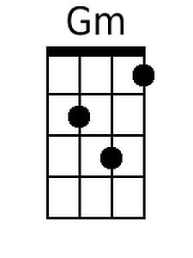
 |  |  |  |  |  |  |  | 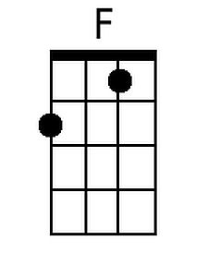
 |  |  |  |  |  |  |  | 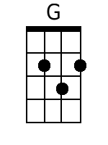
 |  |  |  |  |  |  |  | 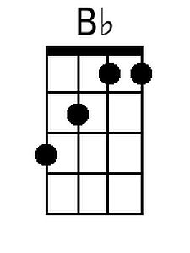
Bari
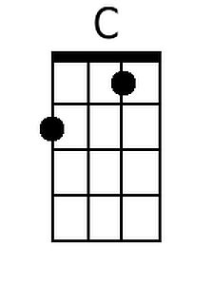 | 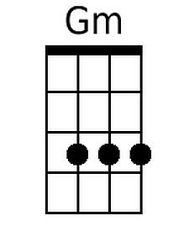 | 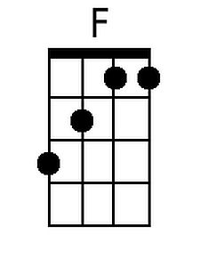 | 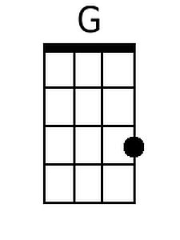 |  | 