**Fish Song (Nitty Gritty Dirt Band) Key C**

**C Am F**

Sat here by this stony brook until the grey day turned to dusk

**C F G**

When up swam a fish with a children's book thought that I was lost.

**C Am F**

He was on his way to the salmon hop, that's where they go to breed

**C G F C**



C

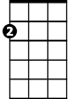

Am

F



Saw me sitting on this log and thought I'd like to read.

**Refrain:**

**F C F C**

The night was cloudy but the moon he found a hole

**F C Am G G7**

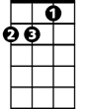

Dm

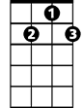

G7



G

Said that he felt bad for me ‘cause I had no place to go

**TACET**

The moon started talkin’ ~

**Dm Am F C**

Why aren't you at the harvest ball with some sweet young gal

**Am F G G7**

You just sit like a bump on the log and call that fish your pal.

**C Am F**

**BARITONE**

Well, I told him I was an orphan and lived here all alone



F

C



Am

**C G F C**

But many people have often tried to catch and take me home

**TACET**

They never caught me!

**Instrumental Refrain**

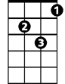

Dm

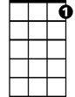

G7



G

**C Am F**

Thought that I was a-hiding, call this log my home

**C G**

But the fish and the moon and a sweet young gal

**F C**

All want me for their own.

**(Refrain)**

**Dm Am F C**

So I met that gal at the harvest ball, she took me to her room

**Am F C**

While I slept in children's dreams, the fish ran away with the moon.

**F C**

The fish ran away with the moon

**F C**

The fish ran away with the moon

**F C**

Na-na-na-na-hee (repeat to fade)

**Fish Song (Nitty Gritty Dirt Band) Key G**

**G Em C**

Sat here by this stony brook until the grey day turned to dusk

**G C D**

When up swam a fish with a children's book thought that I was lost.

**G Em C**

He was on his way to the salmon hop, that's where they go to breed

**G D C G**

Em

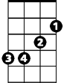

G



C

Saw me sitting on this log and thought I'd like to read.

**Refrain:**

**C G C G**

The night was cloudy but the moon he found a hole

**C G Em D D7**

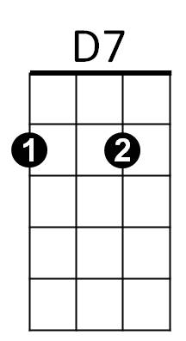Said that he felt bad for me ‘cause I had no place to go



Am

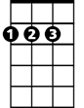

D

**TACET**

The moon started talkin’ ~

**Am Em C G**

Why aren't you at the harvest ball with some sweet young gal

**Em C D D7**

You just sit like a bump on the log and call that fish your pal.

**G Em C**

Well, I told him I was an orphan and lived here all alone

**BARITONE**

**G D C G**

C



G



Em

But many people have often tried to catch and take me home

**TACET**

They never caught me!

**Instrumental Refrain**



Am



D7

**G Em C**



D

Thought that I was a-hiding, call this log my home

**G D**

But the fish and the moon and a sweet young gal

**C G**

All want me for their own.

**(Refrain)**

**Am Em C G**

So I met that gal at the harvest ball, she took me to her room

**Em C G**

While I slept in children's dreams, the fish ran away with the moon.

**C G**

The fish ran away with the moon

**C G**

The fish ran away with the moon

**C G**

Na-na-na-na-hee (repeat to fade)