**Fish and Poi (Hula Tempo)**

**VAMP: D7 G7 C (2X)**

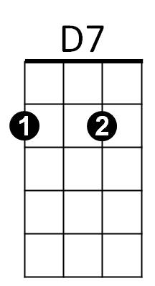**C G7**

Mama don't scold me, I no go work today

**C**

Down in Iwalei in a pineapple cannery *(Ee-wah-lay)*

**G7**

Mama don't scold me, I bring a lei for you

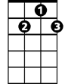

G7



C

**C D7 G7 C**

I sing all day for you, the song of Hawaii

**G7**

Fish and poi, fish and poi, all I need is fish and poi

**C**

Sunshine free, Waikiki, no care tomorrow

**G7**

Sister Bell dress up swell, dance the hula in a big hotel

**C D7 G7 C**Shake this way, shake that way, no care tomorrow

**G7**

**BARITONE**

Mama don't scold her, someday she catch a boy



D7

**C**

She bring him fish and poi at the pineapple cannery

**G7**

Mama no feel bad, someday I sure make good

**C D7 G7 C**

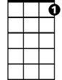

G7

Hawaii get statehood, me Presi-dent maybe

**G7**

Fish and poi, fish and poi, all I need is fish and poi

**C**

C



Need no more from the store, no care tomorrow

**G7**

Fish and poi, fish and poi, all day long eats fish and poi

**C D7 G7 C (2X)**

Big opu, no huhu, no care tomorrow