Five Foot Two, Eyes of Blue (C) (Ver. 1)
504
(Ray Henderson, Sam Lewis and Joseph Young, 1925) (Eb)
Ukulele arrangement by May Singh Breen, except Outro (Key of D, capo 1)

Intro Chords for last line of verse  C E7  Five foot two, eyes of blue  A7  But oh, what those five feet could do  D7 G7 G+ C G7  Has anybody seen my girl?  C E7  Turned up nose, turned down hose,  A7  Flapper? Yes sir! One of those!  D7 G7 G+ C  Has anybody seen my girl?  Reprise  E7 A7  Now if you run into a five foot two, covered in fur.  D7 G7  Diamond rings, all those things, bet-cha’ life it isn’t her!  C E7  But, could she love, could she woo  A7  Could she, could she, could she coo?  D7 G7 G+ C D7  Has anybody seen my girl?  (Repeat From Top) Drop D7 2nd time  Outro  D7 G7  Has anybody seen,  D7 G7  Has anybody seen,  D7 G7 C G7 G+ C  Has anybody seen my girl? | 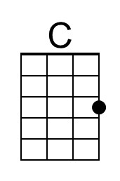 | 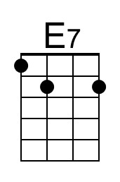
 | 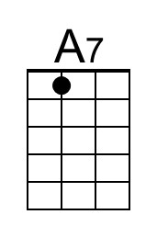 | 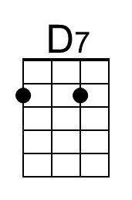
 | 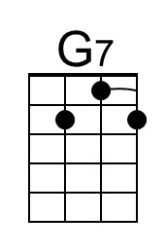 | 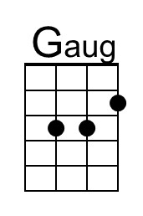
 | Bari
 | 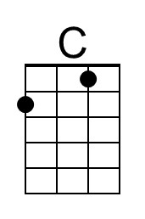 | 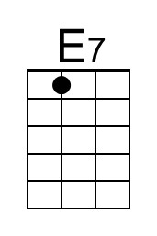
 | 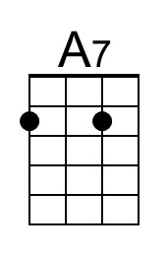 | 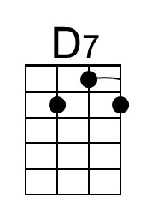
 | 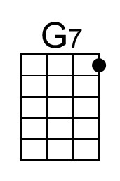 | 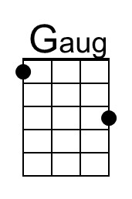

Also known as “Has Anybody Seen My Girl?”
Five Foot Two Eyes of Blue (D) (Ver. 1)
504
(Ray Henderson, Sam Lewis and Joseph Young, 1925) (Eb)
Ukulele arrangement by May Singh Breen, except Outro (Key of D, capo 1)

Intro Chords for last line of verse  D F#7  Five foot two, eyes of blue  B7  But oh, what those five feet could do  E7 A7 A+ D A7  Has anybody seen my girl?  D F#7  Turned up nose, turned down hose,  B7  Flapper? Yes sir! One of those!  E7 A7 A+ D  Has anybody seen my girl?  F#7 B7  Now if you run into a five foot two, covered in fur. Reprise  E7 A7  Diamond rings, all those things, bet-cha’ life it isn’t her!  D F#7  But, could she love, could she woo  B7  Could she, could she, could she coo?  E7 A7 A+ D E7  Has anybody seen my girl?  (Repeat From Top) Drop E7 2nd time  Outro  E7 A7  Has anybody seen,  E7 A7  Has anybody seen,  E7 A7 D A7 A+ D  Has anybody seen my girl? | 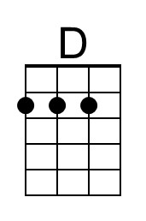 | 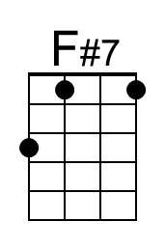
 | 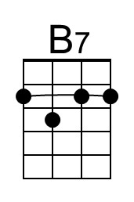
 |  | 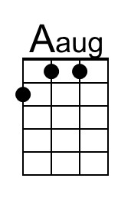
 | Bari
 | 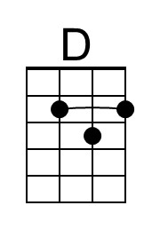 | 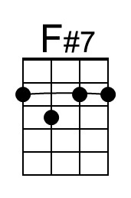
 | 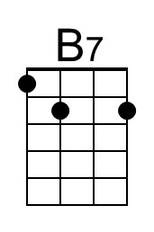
 |  | 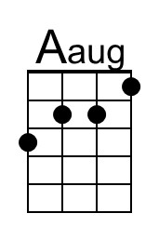

Also known as “Has Anybody Seen My Girl?”

Five Foot Two Eyes of Blue (F) (Ver. 1)
504
(Ray Henderson, Sam Lewis and Joseph Young, 1925) (Eb)
Ukulele arrangement by May Singh Breen, except Outro (Key of D, capo 1)

Intro Chords for last line of verse  F A7  Five foot two, eyes of blue  D7  But oh, what those five feet could do  G7 C7 C+ F C7  Has anybody seen my girl?  F A7  Turned up nose, turned down hose,  D7  Flapper? Yes sir! One of those!  G7 C7 C+ F  Has anybody seen my girl?  Reprise  A7 D7  Now if you run into a five foot two, covered in fur.  G7 C7  Diamond rings, all those things, bet-cha’ life it isn’t her!  F A7  But, could she love, could she woo  D7  Could she, could she, could she coo?  G7 C7 C+ F G7  Has anybody seen my girl?  (Repeat From Top) Drop G7 2nd time  Outro  G7 C7  Has anybody seen,  G7 C7  Has anybody seen,  G7 C7 F C7 C+ F  Has anybody seen my girl? | 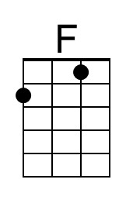
 | 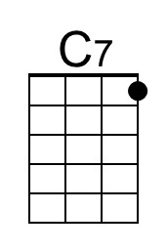 | 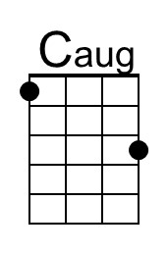
 | Bari
 | 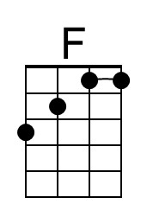
 | 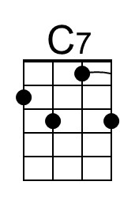 | 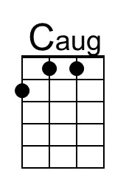

Also known as “Has Anybody Seen My Girl?”
Five Foot Two, Eyes of Blue (G) (Ver. 1)
504
(Ray Henderson, Sam Lewis and Joseph Young, 1925) (Eb)
Ukulele arrangement by May Singh Breen, except Outro (Key of D, capo 1)

Intro Chords for last line of verse  G B7  Five foot two, eyes of blue  E7  But oh, what those five feet could do  A7 D7 D+ G D7  Has anybody seen my girl?  G B7  Turned up nose, turned down hose,  E7  Flapper? Yes sir! One of those!  A7 D7 D+ G  Has anybody seen my girl?  Reprise  B7 E7  Now if you run into a five foot two, covered in fur.  A7 D7  Diamond rings, all those things, bet-cha’ life it isn’t her!  G B7  But, could she love, could she woo  E7  Could she, could she, could she coo?  A7 D7 D+ G A7  Has anybody seen my girl?  (Repeat From Top) Drop A7 at end  Outro  A7 D7  Has anybody seen,  A7 D7  Has anybody seen,  A7 D7 G D7 D+ G  Has anybody seen my girl? | 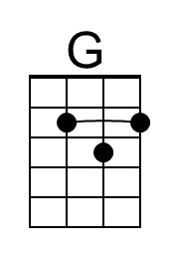
 |  | 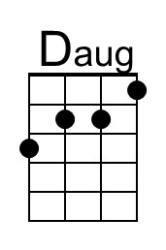
 | Bari
 | 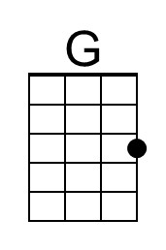
 |  | 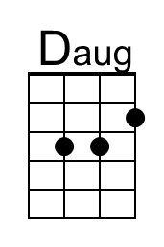

Also known as “Has Anybody Seen My Girl?”

