Five Foot Two Eyes of Blue (D) (Ver. 1)
(Ray Henderson, Sam Lewis and Joseph Young, 1925) (Eb)
Ukulele arrangement by May Singh Breen, except Outro (Key of D, capo 1)

Intro Chords for last line of verse  D F#7  Five foot two, eyes of blue  B7  But oh, what those five feet could do  E7 A7 A+ D A7  Has anybody seen my girl?  D F#7  Turned up nose, turned down hose,  B7  Flapper? Yes sir! One of those!  E7 A7 A+ D  Has anybody seen my girl?  F#7 B7  Now if you run into a five foot two, covered in fur. Reprise  E7 A7  Diamond rings, all those things, bet-cha’ life it isn’t her!  D F#7  But, could she love, could she woo  B7  Could she, could she, could she coo?  E7 A7 A+ D E7  Has anybody seen my girl?  (Repeat From Top) Drop E7 2nd time  Outro  E7 A7  Has anybody seen,  E7 A7  Has anybody seen,  E7 A7 D A7 A+ D  Has anybody seen my girl? | 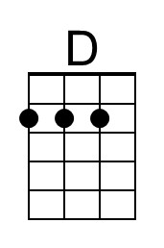 | 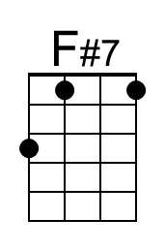
 | 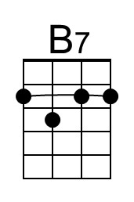 | 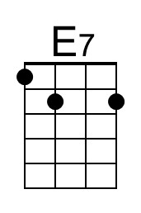
 | 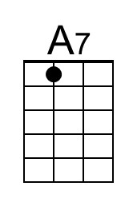 | 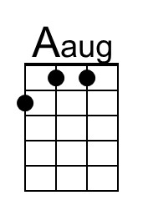
 | Bari
 | 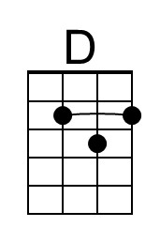 | 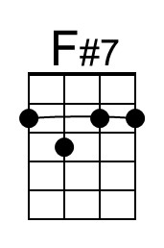
 | 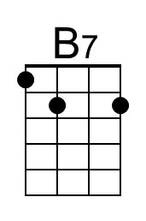 | 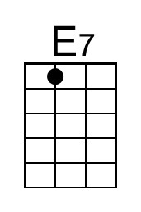
 | 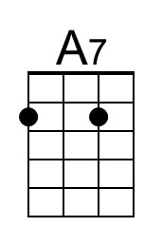 | 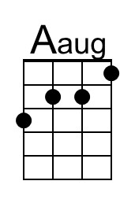

Also known as “Has Anybody Seen My Girl?”

