**The Flintstones Theme (Hoyt Curtin / William Hanna / Joseph Barbera)**

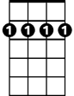

Bm7

**G Am7 G Bm7**



G

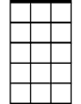

Am7

Flintstones, ...meet the Flintstones,

**G Am7 D7 G Am7 D7**

They're the modern Stone Age fam - i - ly,

**G Am7 G**

From the ...town of Bedrock,

**D7 G Am7 D7 G**

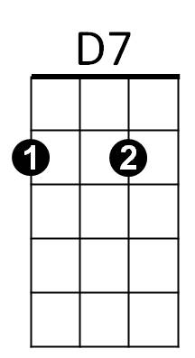They're a page right out of his - tor - y!

E7

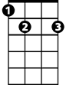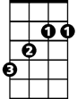

B

**B E7**

Let's ride ...with the family down the street,

**A A7 Am7 D D7**

Through the ...courte - sy of Fred's two feet!

**G Am7 G**

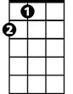

A

Em7

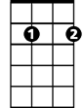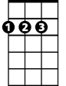

D

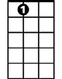

A7

When you're ...with the Flintstones,

**D7 G Am7 D7**

Have a yabba -dabba -doo time,

**G Am7 D7**

A dabba - doo tim e,

**G Am7 D7 G**

We'll have a gay old time!

**G Am7 G Bm7**

Flintstones, ...meet the Flintstones,

**G Am7 D7 G Am7 D7**

They're the modern Stone Age fam - i - ly,

**G Am7 G**

From the ...town of Bedrock,

**D7 G Am7 D7 G**

They're a page right out of his - tor - y!

**B E7**

Someday, ...maybe Fred will win the fight,

**BARITONE**

**A A7 Am7 D D7**



G

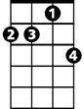

Am7

Bm7

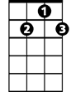

D7

Then that ...cat will stay out for the night!

B

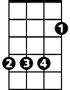

**G Am7 G**

When you're ...with the Flintstones,

**D7 G Am7 D7**

Have a yabba -dabba -doo time,

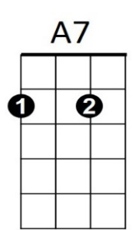**G Am7 D7**



Em7



D



A

A dabba - doo time,



E7

**G Am7 D7 G**

We'll have a gay old time!

**G Em7 Am7 D7 G**

**Am7 D7 G G**

We'll have a gay old time--------------!