Flowers on The Wall (De Witt Lewis, 1965) (G)

Intro Em  G Em  I keep hearing your concern a-bout my happiness  Am D  All that thought you’ve given me is conscience I guess  G Em  If I were walking in y our shoes I wouldn’t worry none  Am D  You and your friends are worried about me I’m having lots of fun  Chorus  Em  Counting flowers on the wall. That don’t bother me at all  Playing solitaire till dawn with a deck of fifty one  F  Smoking cigarettes and watching Captain Kangaroo.  G G7 G  Now don’t tell me I have nothing to do.  G Em  Last night I dressed in tails --- pretended I was on the town  Am D  As long as I can dream it’s hard to slow this swinger down  G Em  So please don’t give a thought to me I’m really doing fine  Am D  You can always find me here -- having quite a time. Chorus  G Em  Well it’s good to see you. I must go. I know I look affright.  Am D  Anyway my eyes are not accustomed to this light  G Em  And my shoes are not accustomed to this hard concrete  Am D  I must go back to my room and make my day complete. Chorus | 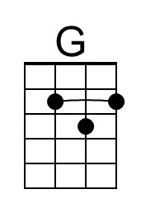 | 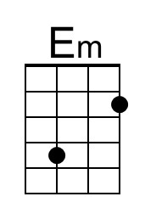
 | 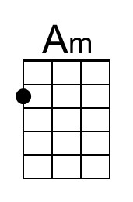 | 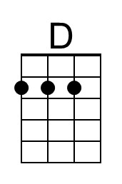
 | 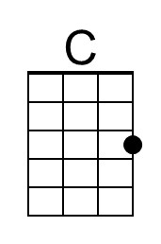 | 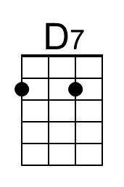
 | Bari
 | 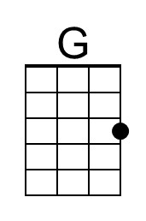 | 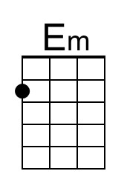
 | 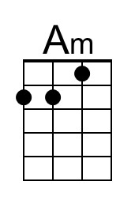 | 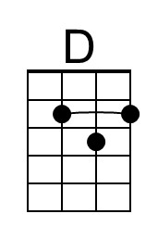
 | 