**Fly Me To The Moon (In Other Words) (Bart Howard 1954)**

**Am/B Dm7 G7 Cmaj7 C7**

Fly me to the moon, and let me play among the stars

**F Dm6 E7 Am A7**

Let me s ee what spring is like on Jupiter and Mars

**Dm7 G7 Cmaj7 A7 Dm7 G7 Dm6 C E7**

In other words, hold my hand In other words, darling, kiss me

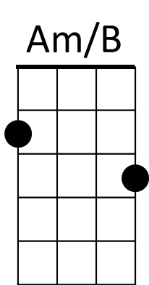

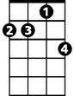

Dm7

**Am/B Dm7 G7 Cmaj7 C7**

Fill my heart with song and let me sing for ever more

**F Dm6 E7 Am A7**

You are all I long for, all I worship and adore

**Dm7 G7 C9 A7 Dm7 G7 C E7**

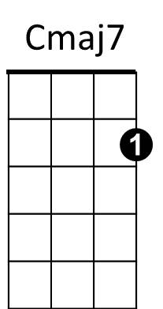In other words, please be true, In other words, I love you

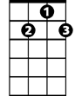

G7

**Am/B Dm7 G7 Cmaj7 C7**

Fill my heart with song and let me sing for ever more

**F Dm6 E7 Am A7**

You are all I long for, all I worship and adore

**Dm7 G7 C9 A7 Dm7 D7**

F

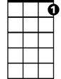

C7

In other words, please be true, In other words, In other words,

**Dm7 G7/ C Dm7 Cmaj7 (slow arpeggio)**

in other words, I love you.

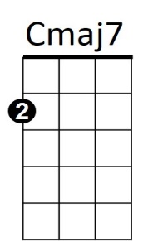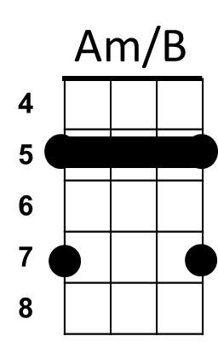

**BARITONE**



G7

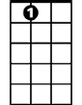

A7

E7

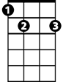

F

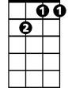

Dm7

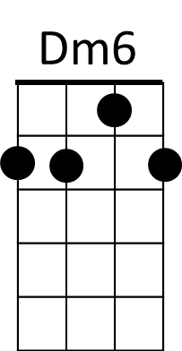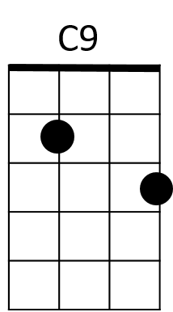

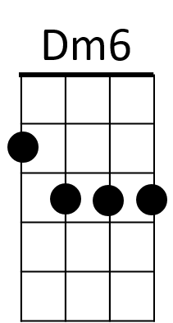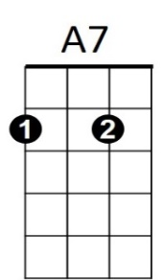



E7

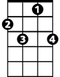

C7

