Follow The Drinking Gourd
Version from Unknown Printed Source - “African American Spiritual”
Ukulele Chords – G C E A

        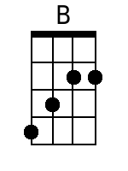  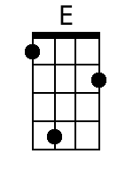 | Chorus:  Am Em  Follow the drinking gourd,  Am Em  Follow the drinking gourd,  G D/F# Em D  For the old man is a-waitin' for to carry you to freedom,  Em B Em  Follow the drinking gourd.  Em  1. When the sun comes back and the first quail calls,  Am Em  Follow the drinking gourd.  G D/F# Em D  The old man is a-waitin' for to carry you to freedom, if you  Em B E  Follow the drinking gourd. Chorus.  Em  2. The river bank make a mighty good road,  Am Em  Dead trees will show you the way.  G D /F# Em D  And the left foot, peg foot, travelin' on,  Em B E  Follow the drinking gourd. Chorus.  Em  3. The river ends between two hills,  Am Em  Follow the drinking gourd.  G D/F# Em D  There's a-nother river on the other side, just you  Em B E  Follow the drinking gourd. Chorus.  Em  4. Where the great big river meets the little river,  Am Em  Follow the drinking gourd.  G D/F# Em D  The old man is a-waitin' for to carry you to freedom, if you  Em B E  Follow the drinking gourd. Chorus.



