Follow The Drinking Gourd

Randy Sparks Version
Recorded by the New Christy Minstrels
Ukulele Chords – G C E A

        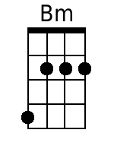 | Em  1. When the sun comes up and the first quail calls,  (A) Em  Follow the drinking gourd.  G D Em Bm  The old man is a waitin' for to carry you to freedom,  Em Bm Em  Follow the drinking gourd.  Chorus:  A Em  Follow the drinking gourd,  A Em  Follow the drinking gourd,  G D Em Bm  For the old man is a waitin' for to carry you to freedom,  Em Bm Em  Follow the drinking gourd.  Em  2. Now the river bank'll make a mighty good road,  (A) Em  The dead trees will show you the way.  G D Em Bm  Left foot, peg foot, travelin' on,  Em Bm Em  Follow the drinking gourd. Chorus.  Em  3. Now the river ends between two hills,  (A) Em  Follow the drinking gourd.  G D Em Bm  There's another river on the other side,  Em Bm Em  Follow the drinking gourd. Chorus.

