Folsom Prison (Johnny Cash) (C)
Folsom Prison by Johnny Cash

C  I hear the train a comin', it's rolling round the bend  C7  And I ain't seen the sunshine since I don't know when  F C  I'm stuck in Folsom prison, and time keeps draggin' on  G7 C  But that train keeps a rollin' on down to San An-tone  C  When I was just a baby my mama told me. Son  C7  Always be a good boy, don't ever play with guns  F C  But I shot a man in Reno just to watch him die  G7 C  When I hear that whistle blowing, I hang my head and cry  A7 (Key Change)  D  I bet there's rich folks eating in a fancy dining car  D7  They're probably drinkin' coffee and smoking big cigars  G D  Well I know I had it coming, I know I can't be free  A7 D  But those people keep a movin, and that's what tortures me  D  Well if they'd free me from this prison, if that railroad train was mine  D7  I bet I'd move on over a little further down the line  G D  Far from Folsom prison, that's where I want to stay  A7 D  And I'd let that lonesome whistle blow my blues a-way  D  I hear the train a comin', it's rolling round the bend  D7  And I ain't seen the sunshine since I don't know when  G D  I'm stuck in Folsom prison, and time keeps draggin' on  A7 D  But that train keeps a rollin' on down to San An-tone.  Repeat line slowly. | 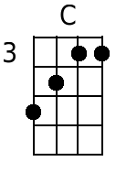 | 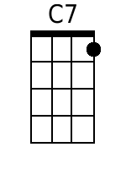
 | 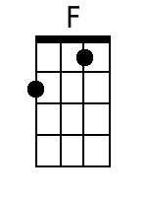 | 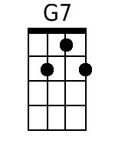
 | 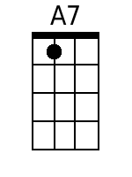 | 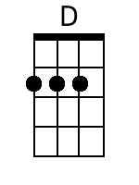
 | 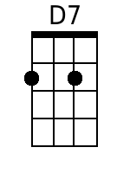 | 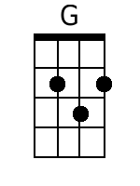
 | Baritone
 | 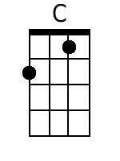 | 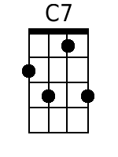
 | 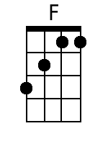 | 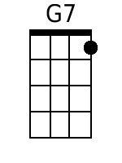
 | 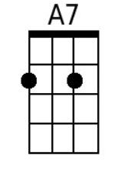 | 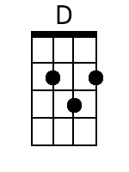
 | 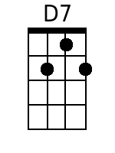 | 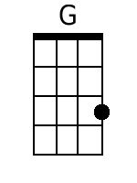

Folsom Prison (Johnny Cash) (G)
Folsom Prison by Johnny Cash

G
I hear the train a comin', it's rolling round the bend
G7
And I ain't seen the sunshine since I don't know when
C G
I'm stuck in Folsom prison, and time keeps draggin' on
D7 G
But that train keeps a rollin' on down to San An-tone

G
When I was just a baby my mama told me. Son
G7
Always be a good boy, don't ever play with guns
C G
But I shot a man in Reno just to watch him die
D7 G
When I hear that whistle blowing, I hang my head and cry

E7 .. (Key Change)
A
I bet there's rich folks eating in a fancy dining car
A7
They're probably drinkin' coffee and smoking big cigars
D A
Well I know I had it coming, I know I can't be free
E7 A
But those people keep a movin, and that's what tortures me

A
Well if they'd free me from this prison, if that railroad train was mine
A7
I bet I'd move on over a little further down the line
D A
Far from Folsom prison, that's where I want to stay
E7 A
And I'd let that lonesome whistle blow my blues a-way

A
I hear the train a comin', it's rolling round the bend
A7
And I ain't seen the sunshine since I don't know when
D A
I'm stuck in Folsom prison, and time keeps draggin' on
E7 A
But that train keeps a rollin' on down to San An-tone.
Repeat line slowly.

 | 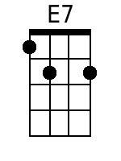 | 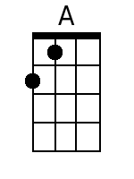
 | Baritone
 | 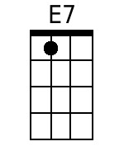 | 