**Fools Rush In (Johnny Mercer and Ruby Bloom)**

**Key G**

**Intro: Chords for last 2 lines of second verse**

**Am D7 G**

Fools rush in where angels fear to tread

**Em Am D7**

And so I come to you my love

**G**

My heart above my head

**C Am D7 G**

Though I see the danger there

**D7 Am A7 D7**

If there's a chance for me then I don't care

**A** **m D7 G**

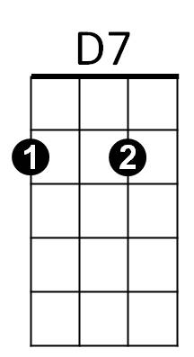Fools rush in where wise men never go

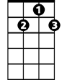

**Em Am D7**

But wise men never fall in love

**G G7**

So how are they to kn-ow

**Am G Em**

When we met I felt my life begin

**BARITONE**

**Am D7 Am G**

So open up your heart and let this fool rush in

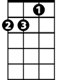

Am



G

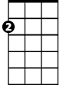

Em

**Repeat entire song**

**Em Am D7 Am G**

Just open up your heart and let this fool rush in

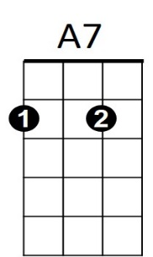

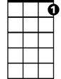

G7



D7G7

C



**Fools Rush In (Johnny Mercer and Ruby Bloom)**

**Key C**

**Intro: Chords for last 2 lines of second verse**

**Dm G7 C**

Fools rush in where angels fear to tread

**Am Dm G7**



C7

And so I come to you my love

**C**

My heart above my head

**F Dm G7 C**

Though I see the danger there

**G7 Dm D7 G7**

If there's a chance for me then I don't care

**Dm G7 C**

Fools rush in where wise men never go

**Am Dm G7**

But wise men never fall in love

**C C7**

So how are they to kn-ow

**Dm C Am**

When we met I felt my life begin

**Dm G7 Dm C**

**BARITONE**

So open up your heart and let this fool rush in



G7

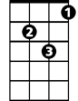

Dm

C



**Repeat entire song**

**Am Dm G7 Dm C**

Just open up your heart and let this fool rush in



D7

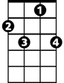

C7



Am



F