For You A Lei (John Noble & Oscar Hyatt, 1929) (C)

Intro Vamp (2x): D7 G7 C  Gdim7 G7 C  For you a lei of flowers rare  Gdim7 G7 C  For you a lei to hold and wear  Gm A7 D7  For you a lei to caress while you are away  D7  And thru each lonely day  Dm7 G - G7  Make you happy and gay  Gdim7 G7 C  A lei of love I give to you  C7 Caug F | F  To think of me when you are blue  G#7  Where ever you may be  C Gm A7  Over land or on the sea  Gdim7 G7 C | C [Intro Vamp]  For you a lei to remember me. |  |  |  |  |  |  | 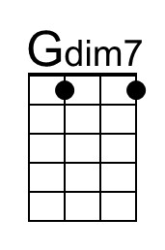 |  | 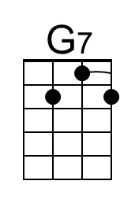
 |  |  |  |  |  |  | 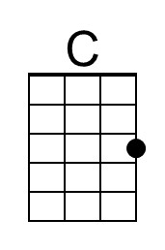 |  | 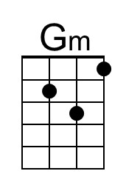
 |  |  |  |  |  |  | 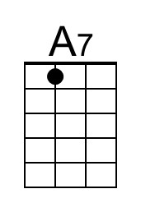 |  | 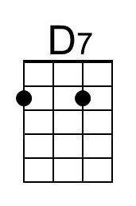
 |  |  |  |  |  |  | 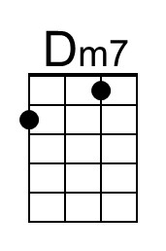 |  | 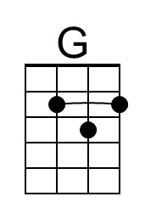
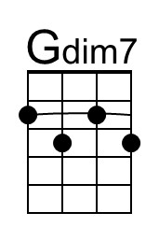 | 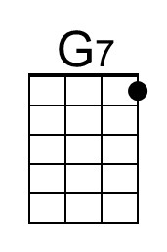 | 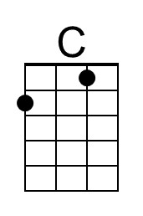 | 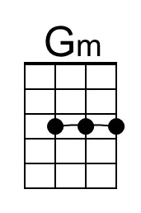 | 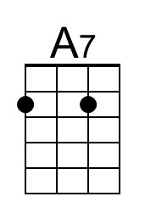 | 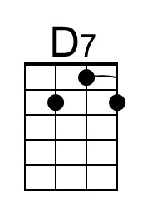 | 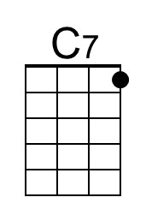 |  | 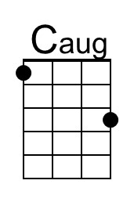
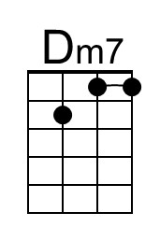 | 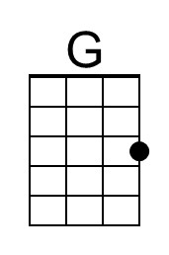 | 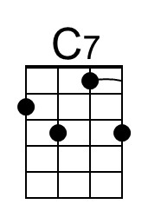 | 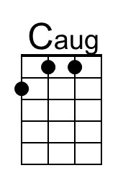 | 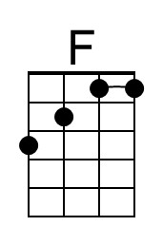 | 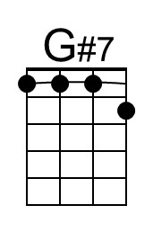 | 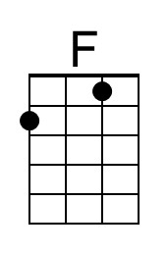 |  | 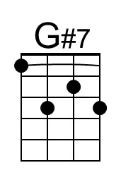

For You A Lei (John Noble & Oscar Hyatt, 1929) (G)

Intro Vamp (2x) A7 D7 G  Ddim7 D7 G  For you a lei of flowers rare  Ddim7 D7 G  For you a lei to hold and wear  Dm E7 A7  For you a lei to caress while you are away  A7  And thru each lonely day  Am7 D - D7  Make you happy and gay  Ddim7 D7 G  A lei of love I give to you  G7 Gaug C | C  To think of me when you are blue  Eb7  Where ever you may be  G Dm E7  Over land or on the sea  Ddim7 D7 G | G [Intro Vamp]  For you a lei to remember me. |  |  |  |  |  |  | 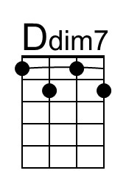
 |  |  |  |  |  |  |  |  | 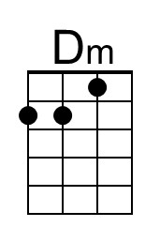
 |  |  |  |  |  |  | 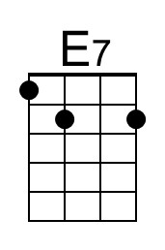
 |  |  |  |  |  |  | 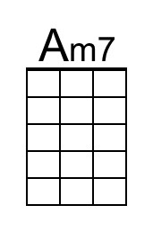 |  | 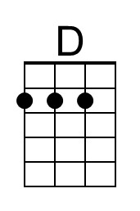
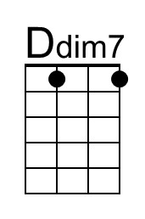 |  |  | 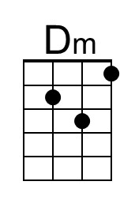 | 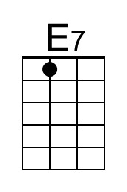 |  |  |  | 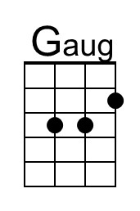
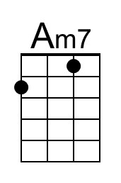 | 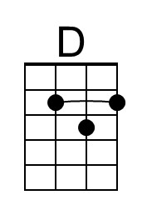 |  | 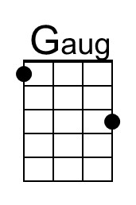 |  | 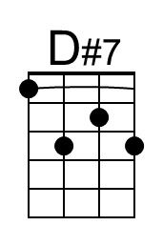 |  |  | 