**From Me to You (John Lennon / Paul McCartney)**

**Intro: C G Am (2x)**

Da da da da da dum dum da

**C Am**

If there's anything that you want,

**C G7**

If there's anything I can do,

**F7 Am**

Just call on me and I'll send it along

**C G7 C**

With love from me to you

**C Am**

I’ve got everything th at you want,

**C G7**

Like a heart that's oh, so true,

F

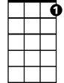

C7

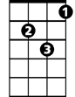

Gm

**F7 Am**

Just call on me and I'll send it along

**C G7 C**

With love from me to you

**Bridge:**

**Gm C7**

**BARITONE**



G7

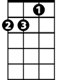

Am



G

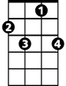

C7

I got arms that long to hold you

C



**F**

And keep you by my side.

**D7**

I got lips that long to kiss you



F

**G Gaug G7**

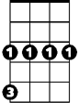

Gm

And keep you satisfied - oooo

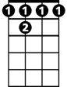

F 7

**(Repeat Verse 1)**

**C Am**

Da da da da da dum dum da (Call on me)

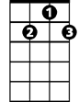

D7

**C G7**

Da da da da da dum dum da (To you)

**F Am**

Just call on me and I'll send it along

**C G C**

With love from me to you

**(Bridge, Verse 1)**

**C7**

To you, to you, to you,

**C G Am**

Da da da da da dum dum da

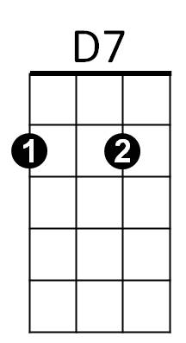



C



F7



G7

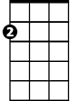

Am



G