
Frosty the Snowman
C05 C
(Steve Nelson & Jack Rollins, 1950) – Frosty the Snowman by Jimmy Durante (1950) (C)
Frosty the Snowman by Gene Autry and the Cass County Boys (1950) (Ab)
2/2 Time – 175 BPM
Intro: (Last line of verse) C↓ ↓ | F | C A7 | F G7 | C G7 |  C F C  Frosty the Snow Man was a jolly happy soul  F C A7 G7 C - G7  With a corn-cob pipe and a button nose and two eyes made out of coal.  C F C  Frosty the Snow Man is a fairy tale they say  F C A7 F G7 C – C7  He was made of snow but the children know how he came to life one day.  F C F G7 C  There must have been some magic in that old silk hat they found,  G G7 Am D7 G - G7  For when they put it on his head he be-gan to dance a-round.  C F C  Frosty the Snow Man was alive as he could be,  F C A7 F G7 C  And the children say he could laugh and play, just the same as you and me.  Chorus  C G7  Thumpety thump thump, thumpety thump thump, look at Frosty go.  C  Thumpety thump thump, thumpety thump thump, over the hills of snow  C F C  Frosty the Snow Man knew the sun was hot that day,  F C A7 G7 C - G7  So he said, "Let's run and we'll have some fun, now be-fore I melt a-way."  C F C  Down to the village with a broomstick in his hand,  F C A7 F G7 C–C7  Running here and there all a-round the square, saying "Catch me if you can!"  F C F G7 C  He led them down the streets of town right to the traffic cop,  G G7 Am D7 G - G7  And he only paused a moment when he heard him holler, "Stop!"  C F C  Frosty the Snow Man had to hurry on his way,  F C A7 F G7 C  But he waved good-bye saying, "Don't you cry, I'll be back a-gain some-day."  Outro: Chorus | 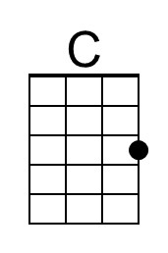 | 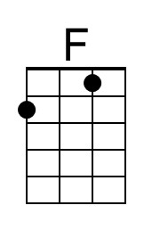
 | 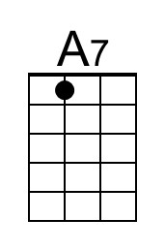 | 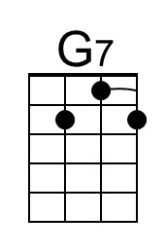
 | 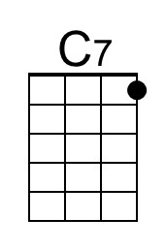 | 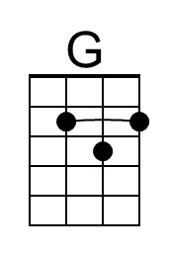
 | 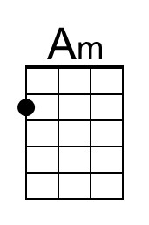 | 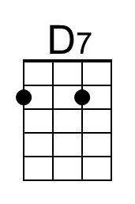
 | Baritone
 | 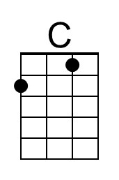 | 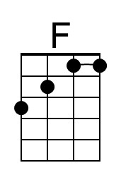
 | 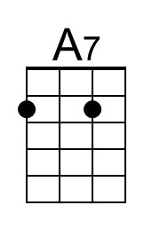 | 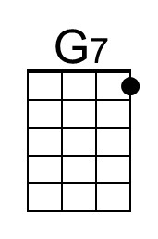
 | 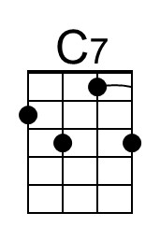 | 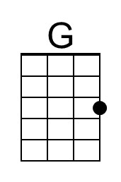
 | 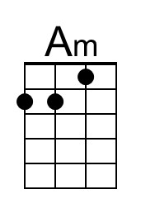 | 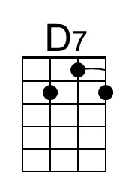

Frosty the Snowman
C05 G
(Steve Nelson & Jack Rollins, 1950) – Frosty the Snowman by Jimmy Durante (1950) (C)
Frosty the Snowman by Gene Autry and the Cass County Boys (1950) (Ab)
2/2 Time – 175 BPM
Intro: (Last line of verse) G↓ ↓ | C | G E7 | C D7 | G D7 |

G C G
Frosty the Snow Man was a jolly happy soul
C G E7 D7 G - D7
With a corn-cob pipe and a button nose and two eyes made out of coal.
G C G
Frosty the Snow Man is a fairy tale they say
C G E7 C D7 G – G7
He was made of snow but the children know how he came to life one day.
C G C D7 G
There must have been some magic in that old silk hat they found,
D D7 Em A7 D - D7
For when they put it on his head he be-gan to dance a-round.
G C G
Frosty the Snow Man was alive as he could be,
C G E7 C D7 G
And the children say he could laugh and play, just the same as you and me.

Chorus
G D7
Thumpety thump thump, thumpety thump thump, look at Frosty go.
G
Thumpety thump thump, thumpety thump thump, over the hills of snow

G C G
Frosty the Snow Man knew the sun was hot that day,
C G E7 D7 G - D7
So he said, "Let's run and we'll have some fun, now be-fore I melt a-way."
G C G
Down to the village with a broomstick in his hand,
C G E7 C D7 G–G7
Running here and there all a-round the square, saying "Catch me if you can!"
C G C D7 G
He led them down the streets of town right to the traffic cop,
D D7 Em A7 D - D7
And he only paused a moment when he heard him holler, "Stop!"
G C G
Frosty the Snow Man had to hurry on his way,
C G E7 C D7 G
But he waved good-bye saying, "Don't you cry, I'll be back a-gain some-day."

Outro: Chorus
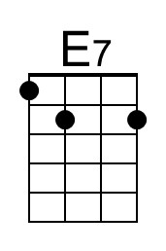
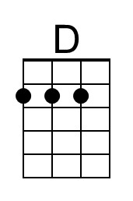
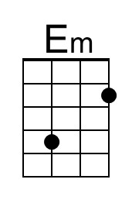
Baritone
