Galaxy Song (Eric Idle & John DuPrez, ca. 1983) (F) GCEA

Spoken with single strum:  Fdim7 F  Whenever life gets you down, Mrs. Brown  Fdim7 C7  And things seem hard or tough  Fdim7 F D7  And people are stupid, ob-noxious or daft  G7 C C7  And you feel that you've had quite e-nough  C7 F Caug  Just re-member that you're standing  Dm F  on a planet that's e-volving  Fdim7 C7  And revolving at nine hundred miles an hour  C Gm7 C7  And orbiting at nineteen miles a second,  Gm7  so it's reckoned  C C7 F C7  A sun that is the source of all our power  F Caug  The sun and you and me  Dm F  and all the stars that we can see  D7 Bb  Are moving at a million miles a day  Bb F hour  In an outer spiral arm, at forty thousand miles an  C7 F C7  Of the galaxy we call the 'milky way'  F Caug Dm F  Our galaxy itself contains a hundred billion stars  Fdim7 C7  It's a hundred thousand light years side to side  C Gm7  It bulges in the middle,  C7 Gm7  sixteen thousand light years thick  C  But out by us, it's just  C7 F C7  three thousand light years wide  F Caug  We're thirty thousand light years  Dm F  from galactic central point  D7 Bb  We go 'round every two hundred million years  Bb F  And our galaxy is only one of millions of billions  C7 F C7  In this amazing and expanding uni-verse. | C7 F Caug  The uni-verse it-self keeps on  Dm F  ex-panding and ex-panding  Fdim7 C7  In all of the directions it can whiz  C Gm7 C7 Gm7  As fast as it can go, the speed of light, you know  C C7  Twelve million miles a minute  F C7  and that's the fastest speed there is  F Caug  So remember, when you're feeling  Dm F  very small and insecure  D7 Bb  How amazingly unlikely is your birth  Bb  And pray that there's intelligent life  F  somewhere up in space  C7 F C7 F  'Cause it's bugger all down here on Earth
 | 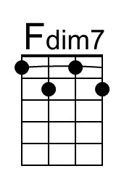 | 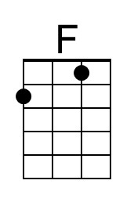 | 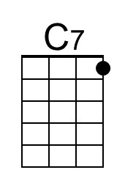 | 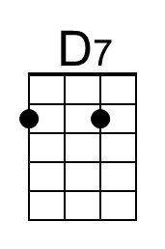
 | 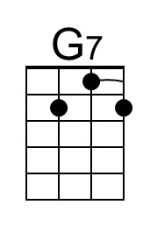 | 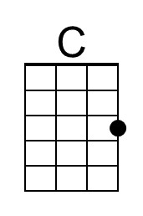 | 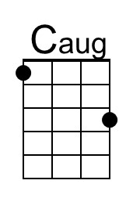 | 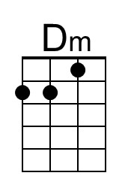
 | 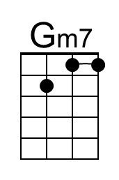 | 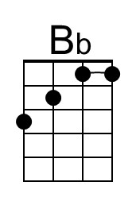

Galaxy Song (Eric Idle & John DuPrez, ca. 1983) (F) DGBE

Spoken with single strum:  Fdim7 F  Whenever life gets you down, Mrs. Brown  Fdim7 C7  And things seem hard or tough  Fdim7 F D7  And people are stupid, ob-noxious or daft  G7 C C7  And you feel that you've had quite e-nough  C7 F Caug  Just re-member that you're standing  Dm F  on a planet that's e-volving  Fdim7 C7  And revolving at nine hundred miles an hour  C Gm7 C7  And orbiting at nineteen miles a second,  Gm7  so it's reckoned  C C7 F C7  A sun that is the source of all our power  F Caug  The sun and you and me  Dm F  and all the stars that we can see  D7 Bb  Are moving at a million miles a day  Bb F hour  In an outer spiral arm, at forty thousand miles an  C7 F C7  Of the galaxy we call the 'milky way'  F Caug Dm F  Our galaxy itself contains a hundred billion stars  Fdim7 C7  It's a hundred thousand light years side to side  C Gm7  It bulges in the middle,  C7 Gm7  sixteen thousand light years thick  C  But out by us, it's just  C7 F C7  three thousand light years wide  F Caug  We're thirty thousand light years  Dm F  from galactic central point  D7 Bb  We go 'round every two hundred million years  Bb F  And our galaxy is only one of millions of billions  C7 F C7  In this amazing and expanding uni-verse. | C7 F Caug  The uni-verse it-self keeps on  Dm F  ex-panding and ex-panding  Fdim7 C7  In all of the directions it can whiz  C Gm7 C7 Gm7  As fast as it can go, the speed of light, you know  C C7  Twelve million miles a minute  F C7  and that's the fastest speed there is  F Caug  So remember, when you're feeling  Dm F  very small and insecure  D7 Bb  How amazingly unlikely is your birth  Bb  And pray that there's intelligent life  F  somewhere up in space  C7 F C7 F  'Cause it's bugger all down here on Earth
 | 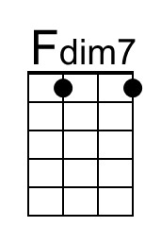 | 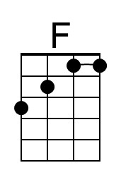 | 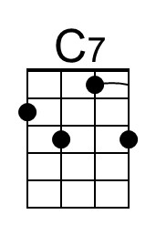 | 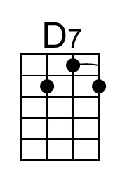
 | 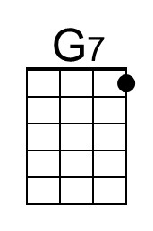 | 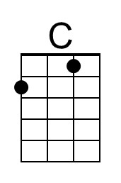 | 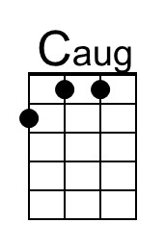 | 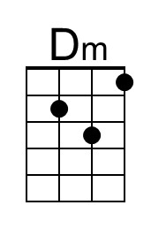
 | 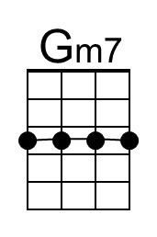 | 