Galaxy Song (Eric Idle & John DuPrez, ca. 1983) (C)
Galaxy Song - Monty Python's The Meaning of Life (Official Video) - GCEA

Intro: Spoken with single strum  Cdim7 C  Whenever life gets you down, Mrs Brown  Cdim7 C  And things seem hard or tough  Cdim7 C A7  And people are stupid, obnoxious or daft  D7 G7  And you feel that you've had quite enough  G7 C CMaj7  Just re-member that you're standing  C6 CMaj7  on a planet that's evolving  C F#dim7 G7  revolving at nine hundred miles an hour  G7 Dm G7  And orbiting at nineteen miles a second,  Dm  so it's reckoned  G G7 C G7  A sun that is the source of all our power.  C  The sun and you and me,  and all the stars that we can see  A7 F  Are moving at a million miles a day  Cdim7  In an outer spiral arm,  C  at forty thousand miles an hour  G7 C G7 C  Of the galaxy we call the Milky Way.  C  Our galaxy itself contains a hundred billion stars  F#dim7 G  It's a hundred thousand light-years side-to-side  G7 Dm  It bulges in the middle,  G7 Dm  sixteen thousand light-years thick  G C  But out by us it's just three thousand light-years wide  C  We're thirty thousand light-years  from galactic central point  A7 Dm  We go round every two hundred million years | Cdim7 C  And our galaxy itself is one of millions of billions  G7 C G7 C  In this amazing and expanding uni-verse  C  The universe itself keeps  on expanding and expanding  G7  In all of the directions it can whiz  G7  As fast as it can go, at the speed of light you know  Twelve million miles a minute  C  and that's the fastest speed there is  C  So remember, when you're feeling  very small and insecure  A7 F  How amazingly unlikely is your birth  Cdim7  And pray that there's intelligent life  C  somewhere up in space,  G7 C G7 C  Because there's bugger all down here on Earth.
 | 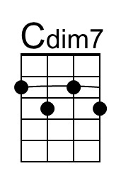 | 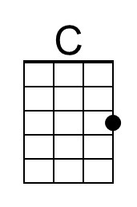 | 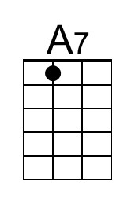 | 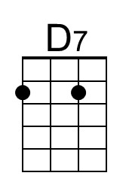
 | 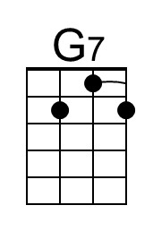 | 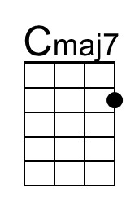 | 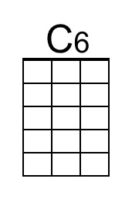 | 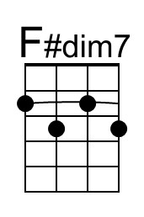
 | 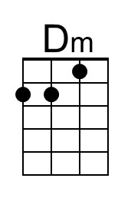 | 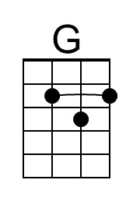

Galaxy Song (Eric Idle & John DuPrez, ca. 1983) (C)
Galaxy Song - Monty Python's The Meaning of Life (Official Video) - DGBE

Intro: Spoken with single strum  Cdim7 C  Whenever life gets you down, Mrs Brown  Cdim7 C  And things seem hard or tough  Cdim7 C A7  And people are stupid, obnoxious or daft  D7 G7  And you feel that you've had quite enough  G7 C CMaj7  Just re-member that you're standing  C6 CMaj7  on a planet that's evolving  C F#dim7 G7  revolving at nine hundred miles an hour  G7 Dm G7  And orbiting at nineteen miles a second,  Dm  so it's reckoned  G G7 C G7  A sun that is the source of all our power.  C  The sun and you and me,  and all the stars that we can see  A7 F  Are moving at a million miles a day  Cdim7  In an outer spiral arm,  C  at forty thousand miles an hour  G7 C G7 C  Of the galaxy we call the Milky Way.  C  Our galaxy itself contains a hundred billion stars  F#dim7 G  It's a hundred thousand light-years side-to-side  G7 Dm  It bulges in the middle,  G7 Dm  sixteen thousand light-years thick  G C  But out by us it's just three thousand light-years wide  C  We're thirty thousand light-years  from galactic central point  A7 Dm  We go round every two hundred million years | Cdim7 C  And our galaxy itself is one of millions of billions  G7 C G7 C  In this amazing and expanding uni-verse  C  The universe itself keeps  on expanding and expanding  G7  In all of the directions it can whiz  G7  As fast as it can go, at the speed of light you know  Twelve million miles a minute  C  and that's the fastest speed there is  C  So remember, when you're feeling  very small and insecure  A7 F  How amazingly unlikely is your birth  Cdim7  And pray that there's intelligent life  C  somewhere up in space,  G7 C G7 C  Because there's bugger all down here on Earth.
 | 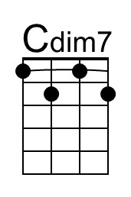 | 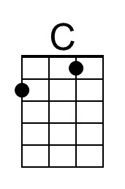 | 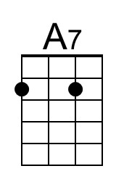 | 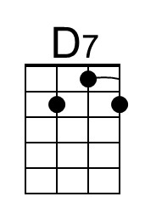
 | 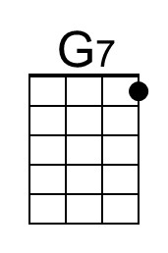 | 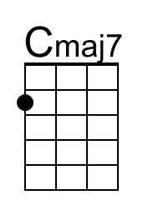 | 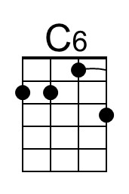 | 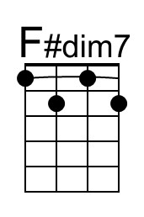
 | 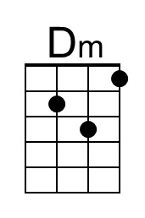 | 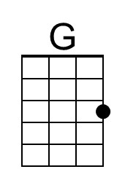

Galaxy Song (Eric Idle & John DuPrez, ca. 1983) (F)
Galaxy Song - Monty Python's The Meaning of Life (Official Video) – GCEA

Intro: Spoken with single strum  Fdim7 F  Whenever life gets you down, Mrs Brown  Fdim7 F  And things seem hard or tough  Fdim7 F D7  And people are stupid, obnoxious or daft  G7 C7  And you feel that you've had quite enough  C7 F FMaj7  Just re-member that you're standing  F6 FMaj7  on a planet that's evolving  F Bdim7 C7  revolving at nine hundred miles an hour  C7 Gm C7  And orbiting at nineteen miles a second,  Gm  so it's reckoned  C C7 F C7  A sun that is the source of all our power.  F  The sun and you and me,  and all the stars that we can see  D7 Bb  Are moving at a million miles a day  Fdim7  In an outer spiral arm,  F  at forty thousand miles an hour  C7 F C7 F  Of the galaxy we call the Milky Way.  F  Our galaxy itself contains a hundred billion stars  Bdim7 C7  It's a hundred thousand light-years side-to-side  C7 Gm  It bulges in the middle,  C7 Gm  sixteen thousand light-years thick  C  But out by us it's just  F  three thousand light-years wide.  F  We're thirty thousand light-years  from galactic central point  D7 Gm  We go round every two hundred million years | Fdim7 F  And our galaxy itself is one of millions of billions  C7 F C7 F  In this amazing and expanding uni-verse  F  The universe itself keeps on  expanding and expanding  C7  In all of the directions it can whiz  C7  As fast as it can go, at the speed of light you know  Twelve million miles a minute  F  and that's the fastest speed there is  F  So remember, when you're feeling  very small and insecure  D7 Bb  How amazingly unlikely is your birth  Fdim7  And pray that there's intelligent life  F  somewhere up in space  C7 F C7 F  Because there's bugger all down here on Earth
 | 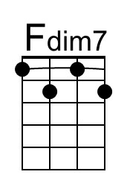 | 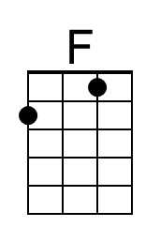
 | 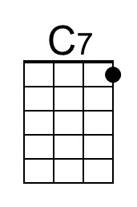 | 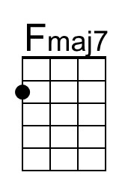 | 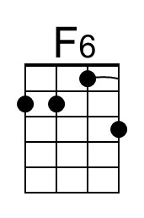 | 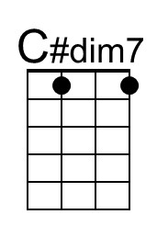
 | 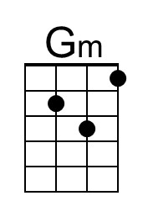

Galaxy Song (Eric Idle & John DuPrez, ca. 1983) (F)
Galaxy Song - Monty Python's The Meaning of Life (Official Video) – DGBE

Intro: Spoken with single strum  Fdim7 F  Whenever life gets you down, Mrs Brown  Fdim7 F  And things seem hard or tough  Fdim7 F D7  And people are stupid, obnoxious or daft  G7 C7  And you feel that you've had quite enough  C7 F FMaj7  Just re-member that you're standing  F6 FMaj7  on a planet that's evolving  F Bdim7 C7  revolving at nine hundred miles an hour  C7 Gm C7  And orbiting at nineteen miles a second,  Gm  so it's reckoned  C C7 F C7  A sun that is the source of all our power.  F  The sun and you and me,  and all the stars that we can see  D7 Bb  Are moving at a million miles a day  Fdim7  In an outer spiral arm,  F  at forty thousand miles an hour  C7 F C7 F  Of the galaxy we call the Milky Way.  F  Our galaxy itself contains a hundred billion stars  Bdim7 C7  It's a hundred thousand light-years side-to-side  C7 Gm  It bulges in the middle,  C7 Gm  sixteen thousand light-years thick  C  But out by us it's just  F  three thousand light-years wide.  F  We're thirty thousand light-years  from galactic central point  D7 Gm  We go round every two hundred million years | Fdim7 F  And our galaxy itself is one of millions of billions  C7 F C7 F  In this amazing and expanding uni-verse  F  The universe itself keeps on  expanding and expanding  C7  In all of the directions it can whiz  C7  As fast as it can go, at the speed of light you know  Twelve million miles a minute  F  and that's the fastest speed there is  F  So remember, when you're feeling  very small and insecure  D7 Bb  How amazingly unlikely is your birth  Fdim7  And pray that there's intelligent life  F  somewhere up in space  C7 F C7 F  Because there's bugger all down here on Earth
 | 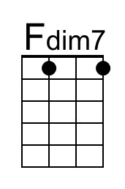 | 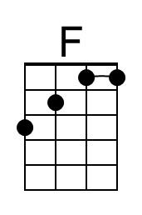
 | 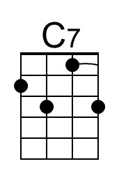 | 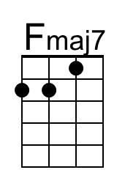 | 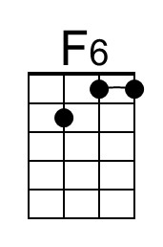 | 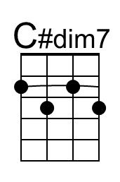
 | 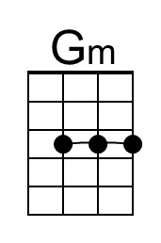

Galaxy Song (Eric Idle & John DuPrez, ca. 1983) (G)
Galaxy Song - Monty Python's The Meaning of Life (Official Video) – GCEA

Intro: Spoken with single strum  Gdim7 G  Whenever life gets you down, Mrs Brown  Gdim7 G  And things seem hard or tough  Gdim7 G E7  And people are stupid, obnoxious or daft  A7 D7  And you feel that you've had quite enough  D7 G GMaj7  Just re-member that you're standing  G6 GMaj7  on a planet that's evolving  G C#dim7 D7  revolving at nine hundred miles an hour  D7 Am D7  And orbiting at nineteen miles a second,  Am  so it's reckoned  D D7 G D7  A sun that is the source of all our power.  G  The sun and you and me,  and all the stars that we can see  E7 C  Are moving at a million miles a day  Gdim7  In an outer spiral arm,  G  at forty thousand miles an hour  D7 G D7 G  Of the galaxy we call the Milky Way.  G  Our galaxy itself contains a hundred billion stars  C#dim7 D7  It's a hundred thousand light-years side-to-side  D7 Am  It bulges in the middle,  D7 Am  sixteen thousand light-years thick  D  But out by us it's just  G  three thousand light-years wide  G  We're thirty thousand light-years  from galactic central point  E7 Am  We go round every two hundred million years | Gdim7 G  And our galaxy itself is one of millions of billions  D7 G D7 G  In this amazing and expanding uni-verse  G  The universe itself keeps on  expanding and expanding  D7  In all of the directions it can whiz  D7  As fast as it can go, at the speed of light you know  Twelve million miles a minute and  G  that's the fastest speed there is  G  So remember, when you're feeling  very small and insecure  E7 C  How amazingly unlikely is your birth  Gdim7  And pray that there's intelligent life  G  somewhere up in space  D7  Because there's bugger  G D7 G  all down here on Earth
 | 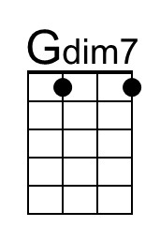 |  | 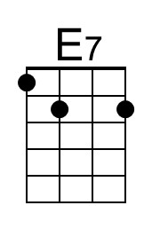
 |  | 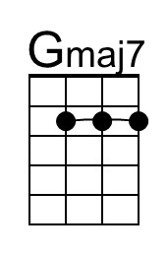 | 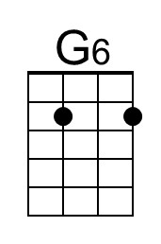 | 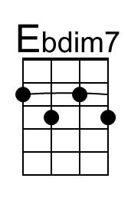
 | 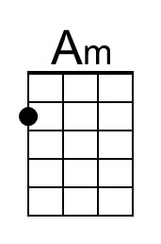 | 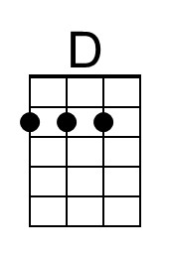

Galaxy Song (Eric Idle & John DuPrez, ca. 1983) (G)
Galaxy Song - Monty Python's The Meaning of Life (Official Video) – DGBE

Intro: Spoken with single strum  Gdim7 G  Whenever life gets you down, Mrs Brown  Gdim7 G  And things seem hard or tough  Gdim7 G E7  And people are stupid, obnoxious or daft  A7 D7  And you feel that you've had quite enough  D7 G GMaj7  Just re-member that you're standing  G6 GMaj7  on a planet that's evolving  G C#dim7 D7  revolving at nine hundred miles an hour  D7 Am D7  And orbiting at nineteen miles a second,  Am  so it's reckoned  D D7 G D7  A sun that is the source of all our power.  G  The sun and you and me,  and all the stars that we can see  E7 C  Are moving at a million miles a day  Gdim7  In an outer spiral arm,  G  at forty thousand miles an hour  D7 G D7 G  Of the galaxy we call the Milky Way.  G  Our galaxy itself contains a hundred billion stars  C#dim7 D7  It's a hundred thousand light-years side-to-side  D7 Am  It bulges in the middle,  D7 Am  sixteen thousand light-years thick  D  But out by us it's just  G  three thousand light-years wide  G  We're thirty thousand light-years  from galactic central point  E7 Am  We go round every two hundred million years | Gdim7 G  And our galaxy itself is one of millions of billions  D7 G D7 G  In this amazing and expanding uni-verse  G  The universe itself keeps on  expanding and expanding  D7  In all of the directions it can whiz  D7  As fast as it can go, at the speed of light you know  Twelve million miles a minute and  G  that's the fastest speed there is  G  So remember, when you're feeling  very small and insecure  E7 C  How amazingly unlikely is your birth  Gdim7  And pray that there's intelligent life  G  somewhere up in space  D7  Because there's bugger  G D7 G  all down here on Earth
 | 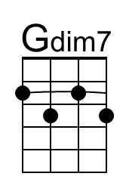 |  | 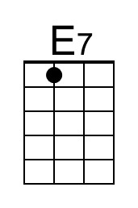
 |  | 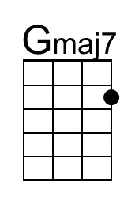 | 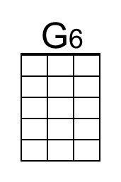 | 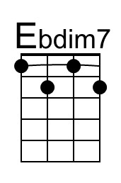
 | 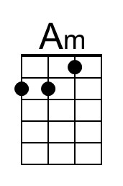 | 